وزارة التعليم العالي والبحث العلمي  كلية الرشيد الجامعة  قسم هندسة تقنيات الاجهزة الطبية |  | Ministry of Higher Education & Scientific Research  Al-Rasheed University College  Department of Medical Instruments Techniques Engineering

حقيبة تعليمية

بعنوان:
Medical physics

إعداد
التدريسي الرئيسي :م.م. علي عقيل محمود
التدريسي الثانوي : م.د ايهم عاصي

2022 - 2023

المقدمة

تتعامل الفيزياء الطبية مع تطبيق مفاهيم وأساليب الفيزياء للوقاية من الأمراض التي تصيب الإنسان وتشخيصها وعلاجها بهدف محدد هو تحسين صحة الإنسان ورفاهه.

تعليم متخصص وتدريب في مفاهيم وتقنيات تطبيق الفيزياء في الطب.

تتضمن الفيزياء الطبية للأشعة التشخيصية والتداخلية تقنيات التصوير الطبي مثل التصوير بالرنين المغناطيسي والموجات فوق الصوتية والتصوير المقطعي والأشعة السينية. سيشمل الطب النووي التصوير المقطعي بالإصدار البوزيتروني والعلاج بالنويدات المشعة.

Medical physics deals with the application of the concepts and methods of physics to the prevention, diagnosis and treatment of human diseases with a specific goal of improving human health and well-being.

Specialist education and training in the concepts and techniques of applying physics in medicine.

Medical physics of diagnostic and interventional radiology involves medical imaging techniques such as magnetic resonance imaging, ultrasound, computed tomography and x-ray. Nuclear medicine will include positron emission tomography and radionuclide therapy.

فهرس المحتويات
م | الموضوع | الصفحة
1 | المقدمة | 2
2 | فهرست المحتويات | ,43
3 | وصف المقرر الدراسي | 5
4 | ارشادات للطلبة | 9
5 | المحاضرة الاولى: Introduction of Medical Physics | 10
6 | المحاضرة الثانية: Types of Forces | 12
7 | المحاضرة الثالثة: Force on and in the Body | 16
8 | المحاضرة الرابعة:Energy | 19
9 | المحاضرة الخامسة: Blood Pressure | 23
10 | المحاضرة السادسة:Physics of lungs and Breathing | 26
11 | المحاضرة السابعة:The Physics of cardiovascular | 28
12 | المحاضرة الثامنة:The Heart | 32
13 | المحاضرة التاسعة: Terminology | 36
14 | المحاضرة العاشرة: Measurement | 44
15 | المحاضرة الحادية عشر: Human Skeleton | 48
16 | المحاضرة الثانية عشر : Heat and Cold | 61
17 | المحاضرة الثالثة عشر: Radio wave Heating | 74
 | المحاضرة الرابعة عشر: Energy and Metabolism | 80
 | المحاضرة الخامسة عشر : Electrical activity | 86
 | المحاضرة السادسة عشر: Diffusion | 92
 | المحاضرة السابعة عشر: Sound | 95
 | المحاضرة الثامنة عشر : Light | 101
 | المحاضرة التاسعة عشر: The eye and the Vision | 107
 | المحاضرة العشرون: The Vision | 113
 | المحاضرة الحادية والعشرون: X-Ray | 117
 | المحاضرة الثانية والعشرون: X-Ray Spectrum | 130
 | المحاضرة الثالثة والعشرون : Nuclear Radiation | 138
 | المحاضرة الرابعة والعشرون : Physics of Radioactivity Therapy | 151
 | المحاضرة الخامسة والعشرون : Application of electricity and magnetism in medicine | 154
 | المحاضرة السادسة والعشرون: Radioactivity Decay | 158
 | المحاضرة السابعة والعشرون: Radioactivity | 166
 | المحاضرة الثامنة والعشرون: Radioactivity Isotopes | 179
 | المحاضرة التاسعة والعشرون: Laser | 189
 | المحاضرة الثلاثون: Laser in medicine | 193

وصف المقرر الدراسي

AL-Rasheed University College/ Department of Medical Laboratory Technique
- Basic information
1-Subject title | Medical Physics
2-Number of credits | Theory:4 | Laboratory:2
3-Number of contact hours | Theory:2h/wk. | Laboratory:2h/wk.
4-Subject time | First Year

Number | Title of the lectures | Hours
1 | Terminology | 2
2 | Force on &in body:  Static forces :( type of levers with medical examples).  Dynamic forces *(Centrifuge). | 2
3 | Physics of the skeleton:  Bones: (Function of bones, Composition of bone, bone remodeling, compact and trabecular bone)  Stress-strain curve : ( compressive and tensile stress, young modulus).  Bone joints :( Synovial fluid, coefficient of a joint). | 2
4 | Heat and cold in medicine:  Temperature scales, thermograph, cold in medicine and cryosurgery | 2
5 | Energy, work and power of the body:  First law of thermodynamic.  Energy change in the body (Met, Basal metabolic rate (BMR).  Work and power. Efficiency heat losses from the body.  Anaerobic phase and aerobic phase.  Hypothalamus (body's thermostat).  Heat lost by (radiation, convection, evaporation of sweat and respiration). | 2
6 | Pressure: Definition, absolute pressure, gauge pressure, negative pressure, unit of pressure. Measurement of pressure in the body (Manometer).  Pressure inside the skull. Eye pressure | 2
7 | Pressure in the skeleton.  Pressure in the urinary bladder.  Boyle's law: (pressure while diving).  HOT (hyperbaric oxygen therapy). | 2
8 | Physics of the lung and breathing: Function of the breathing system. The airways (the alveoli, the function of airways.  Gases exchange in the lungs (ventilation, perfusion, Dalton law, Henry law, diffusion of gases, oxygen saturation curve). | 2
9 | Measurement of lung volumes (spirometer).  Pressure airflow volume relationship of the lungs. Compliance.  Surface tension (physics of alveoli, Laplace law).  Breathing mechanism, airways resistance, work of breathing.  Physics of lung diseases. | 2
10 | Physics of cardiovascular system: Work done by the heat Blood pressure and its measurement (indirect measurement, sphygmomanometer). | 2
11 | Pressure across the blood vessel wall (Laplace wall). Bernoulli's principle applied to the cardiovascular system. Poiseuilles equation, laminar and turbulent flow, viscosity, Reynolds number.
12 | Physics of cardiovascular diseases. | 2
13 | Electricity within the body:  Electrical potential of nerves (resting potential, action potential in myelinated and unmyelinated nerves) | 2
14 | Electromyogram (EMG).  Electrical potential in the heart (electrocardiogram ECG). | 2
15 | Electroencephalogram (EEG). | 2
16 | Biofeedback:  Cardiovascular instrumentation (electrodes, amplifiers, monitoring, defibrillators, pace makers). | 2
17 | Application of electricity (macro and micro electrical shock, high frequency electricity in medicine).  Short wave diathermy (capacitance and inductance method).  Microwave diathermy (characteristics, interaction with tissues). | 2
18 | Sound in medicine:  Properties of sound. Stethoscope (including heart sound). | 2
19 | Ultrasound (A-scan, B-scan, M-scan and Doppler effect).  Physiological effect of ultrasound in therapy. | 2
20 | Physics of the ear and hearing:  Structure of the ear (outer ear, middle ear, inner ear). Sensitivity of the ear. | 2
21 | Light in medicine:  Properties of light, measurement of light and its units. Application of visible light in medicine (endoscope). | 2
22 | Application of ultraviolet and infrared light in medicine. Laser in medicine. Application of microscopes in medicine. | 2
23 | Physics of eye and vision:  Focusing element of the eye (cornea, lens).  Element of the eye (pupil, aqueous humor, vitreous humor, sclera).  Visual acuity, snellen chart, optical density. | 2
24 | Defective vision, audits correlation (short and long sight, Astigmatism, contact lenses, glasses prescription. | 2
25 | Color vision and chromatic aberration (color blindness, purkinje effect, and ocular chromatic aberration). Ophthalmoscope. | 2
26 | Physics of diagnostic X-ray:  Properties of X-ray, production of X-ray.  Absorption of X-ray, contrast media. | 2
27 | X-ray image (penumbra, grid, intensifying screens).  Radiation to patients from X-ray (filters). | 2
28 | Physics of nuclear medicine:  Radioactivity decay, half-life, units.  Basic instrumentation and its medical application (GM-tube, | 2
29 | Photomultiplier tube, scintillation detector, solid state detector).  Therapy with radioactivity.  Radiation doses in nuclear medicine. | 2
30 | Physics of radiation therapy:  The dose units (Rad and Gray).  Principles of radiation therapy.  Brach therapy, quality factor (QF). | 2
TOTAL |  | 60

Laboratory sessions
Number | Study unit title | Hours
1 | Focal length of a concave mirror | 2
2 | Laser application for measurements of single slit width | 2
3 | Laser application for measurements of laser wavelength | 2
4 | Divergence of laser beam | 2
5 | Intensity of laser beam | 2
6 | Widening the bundle of laser rays | 2
7 | Cathode ray oscilloscope to measure D.C voltage | 2
8 | Cathode ray oscilloscope to measure A.C voltage | 2
9 | Viscosity of a liquid using small sphere | 2
10 | Viscosity of a liquid using different small sphere weight | 2
11 | Viscosity of different kind of liquids using small sphere | 2
12 | Ohm's law to calculate unknown resistance | 2
13 | Ohm's law for metal wire with different length | 2
14 | Ohm's law for metal wire with different section area | 2
15 | The focal length of a convex lens | 2
16 | Pendulum Measuring the acceleration of free fall | 2
17 | Pendulum Measuring the acceleration of free fall of different spheres | 2
18 | Semiconductors (Junction diode). | 2
19 | Boyle's law | 2
20 | Hook's law to determine the force constant of the spring | 2
21 | Hook's law to determine the work done by the stretching the spring | 2
22 | Velocity of the sound using tube of water | 2
23 | Velocity of the sound using tube of different liquids | 2
24 | The focal length of a converging lens | 2
25 | Measuring the intensity of radiation | 2
26 | Specific heat capacity of water | 2
27 | Specific heat capacity of solid | 2
28 | Latent heat of vaporization | 2
29 | Archimedes principle | 2
30 | Thermal conductivity | 2
TOTAL |  | 60

The grading system
Number | Assessment measurement | %
1 | First term | 12.5
2 | Midyear examination | 25
3 | Second term | 12.5
4 | Final examination | 35
5 | Laboratory | 15
TOTAL |  | 100

Technology Support
Number | Subject | YES | NO
1 | Online Authoring systems |  | NO
2 | Internet access and E-mail |  | NO
3 | A data show projector | YES
4 | Microsoft power point for lecture presentations | YES
5 | Digital camera |  | NO
6 | Video and audio media equipment's |  | NO
7 | Others (specify) | YES

إرشادات للطلبة

- الرغبة والحماس للتعليم
- كن مشاركاً في جميع الأنشطة
- احترم أفكار المدرس والزملاء
- أنقد أفكار المدرس والزملاء بأدب إن كانت هناك حاجة.
- احرص على استثمار الوقت
- تقبل الدور الذي يسند إليك في المجموعة
- حفز أفراد مجموعتك في المشاركة في النشاطات
- احرص على بناء علاقات طيبة مع المدرس والزملاء أثناء المحاضرة
- احرص على ما تعلمته في المحاضرة وطبقه في الميدان .
- ركز ذهنك بالتعليم واحرص على التطبيق المباشر
- تغلق الموبايل قبل الشروع بالمحاضرة

الوحدة الأولى - المحاضرة الأولى - الزمن: 120 دقيقة

أهداف المحاضرة الاولى:

يتوقع في نهاية الجلسة أن يكون الطالب قادراً على معرفة ماهي الفيزياء الطبية بصورة عامة وماهي مجالات استخدامها.

موضوعات المحاضرة الاولى:

Introduction of Medical Physics

الأساليب والأنشطة والوسائل التعليمية

م | الأساليب والأنشطة التدريبية | الوسائل التدريبية
1 | - نشاط التعارف  - محاضرة  - مناقشة  - سؤال وجواب | - جهاز حاسوب  - جهاز عرض  - سبورة  - اوراق واقلام

Medical physics deals with the application of the concepts and methods of physics to the prevention, diagnosis and treatment of human diseases with a specific goal of improving human health and well-being. Since 2008, medical physics has been included as a health profession according to International Standard Classification of Occupation of the Organization. Although medical physics may sometimes also be referred to as biomedical physics, medical biophysics, applied physics in medicine, physics applications in medical science, radiological physics or hospital radio-physics, however a "medical physicist" is specifically a health professional with specialist education and training in the concepts and techniques of applying physics in medicine and competent to practice independently in one or more of the subfields of medical physics. Traditionally, medical physicists are found in the following healthcare specialties: radiation oncology (also known as radiotherapy or radiation therapy), diagnostic and interventional radiology (also known as medical imaging), nuclear medicine, and radiation protection. Medical physics of radiation therapy can involve work such as dosimetry, linac quality assurance, and brachytherapy. Medical physics of diagnostic and interventional radiology involves medical imaging techniques such as magnetic resonance imaging, ultrasound, computed tomography and x-ray. Nuclear medicine will include positron emission tomography and radionuclide therapy.

الوحدة الثانية - المحاضرة الثانية - الزمن: 120 دقيقة

أهداف المحاضرة الثانية:

يتوقع في نهاية الجلسة أن يكون الطالب قادراً على معرفة :
1-الوضائف الجسدية لجسم النسان في الصحة والمرض
2-التطبيقات الفيزيائية في ممارسة الطب

موضوعات المحاضرة الثانية:

Types of Forces

الأساليب والأنشطة والوسائل التعليمية

م | الأساليب والأنشطة التدريبية | الوسائل التدريبية
1 | - نشاط التعارف (1/1/1)  - محاضرة  - مناقشة  - سؤال وجواب | - جهاز حاسوب  - جهاز عرض  - سبورة  - اوراق واقلام

1- Some effect of Gravity on the Body The force of gravity on the surface of the Earth, normally denoted (g), has remained constant in both direction and magnitude since the formation of the planet As a result, both plant and animal life have evolved to rely upon and cope with it in various ways. Gravity hurts: you can feel it hoisting a loaded backpack or pushing a bike up a hill. But lack of gravity hurts, too: when astronauts (رواد الفضاء )return from long-term stints in space, they sometimes need to be carried away in stretchers)نقاله (When a person becomes “weightless,” such as1- in an orbiting satellite, he or she loses some bone mineral. This may be a serious problem on very long space journeys.2- Long-term bed rest is similar in that it removes much of the force of body weight from the bones which can lead to serious bone loss. One of the important medical effects of gravity is the formation of varicose veins (الدوالي) in the legs as the venous blood travels against the force of gravity on its way to the heart. Yet gravitational force on the skeleton also contributes in some way to healthy bones. Blood feels gravity, too. On Earth, blood pools in the feet. When people stand, the blood pressure in their feet can be high -- about 200 mmHg (millimeters of mercury). In the brain, though, it's only 60 to 80 mmHg. In space, where the familiar pull of gravity is missing, the head-to-toe gradient vanishes. Blood pressure equalizes and becomes about 100 mmHg throughout the body. That's why astronauts can look odd: their faces, filled with fluid, puff up, and their legs, which can lose about a liter of fluid each, thin out.Oure bodies expect a blood pressure gradient .Higher blood pressure in head raises an alarm .The body has too much blood within two or three days of weightlessness astronauts can lose as much as 22% of their blood volume as a result of that errant message .This change effects heart too, if you have less blood then your heart doesn't need to pump as hard ,it's going to atrophy. 2- Electrical Forces in the Body Electric Force: force exerted by two charged objects. Positive/Negative Charges: two unlike charges will exert a force that attracts each other while two like charges will exert repelling forces on each other. Protons/Electrons: positive & negative particles inside atoms. Control and action of our muscles is primarily electrical. The forces produced by muscles are caused by electrical charges attracting opposite electrical charges. Each of the trillions of living cells in the body has an electrical potential difference across the cell membrane. This is a result of an imbalance of the positively and negatively charged ions on the inside and outside of the cell wall. The resultant potential difference is about 0.1 V, but because of the very thin cell wall it may produce an electric field as large as 107 V/m, an electric field that is much larger than the electric field near a high voltage power line. Only the gravitational and electrical forces are of importance in our study of the forces affecting the human body. The electrical force is important at the molecular and cellular levels, e.g., affecting the binding together of our bones and controlling the contraction of our muscles. The gravitational force, though very much weaker than the electrical force by a factor of 1039, is important as a result of the relatively large mass of the human body (at least as compared to its constituent parts, the cells). For example, in the bones there are many crystals of bone mineral (calcium hydroxyapatite) that require calcium. A calcium atom will become part of the crystal if it gets close to a natural place for calcium and the electrical forces are great enough to trap it. It will stay in that place until local conditions have changed and the electrical forces can no longer hold it in place. This might happen if the bone crystal is destroyed by cancer. We do not attempt to consider all the various forces in the body in this chapter; it would be an impossible task. Medical specialists who deal with forces are (a) physiatrists (specialists in physical medicine) who use physical methods to diagnose and treat disease, (b) orthopedic specialists who treat and diagnose diseases and abnormalities of the musculoskeletal system, (c) physical therapists, (d) chiropractors who treat the spinal column and nerves, (e) rehabilitation specialists, and (f) orthodontists who deal with prevention and treatment of irregular teeth. Electric eels and some other marine animals are able to add the electrical potential from many cells to produce a stunning voltage of several hundred volts. This special “cell battery” occupies up to 80% of an eel’s body length! Since the eel is essentially weightless in the water, it can afford this luxury. Land animals have not developed biological electrical weapons for defense or attack. 3. Frictional Forces Frictional force refers to the force generated by two surfaces that contacts and slide against each other.

A few factors affecting the frictional force: • These forces are mainly affected by the surface texture and amount of force impelling them together. • The angle and position of the object affect the amount of frictional force. • If an object is placed flat against an object, then the frictional force will be equal to the weight of the object. • If an object is pushed against the surface, then the frictional force will be increased and becomes more than the weight of the object. Types of Frictional Forces • Dry Friction • Static Friction • Kinetic Friction • Rolling Friction • Sliding Friction • Fluid Friction Dry friction describes the reaction between two solid bodies in contact when they are in motion (kinetic friction) and when they are not (static friction). Both static and kinetic friction is proportional to the normal force exerted between the solid bodies. The interaction of different substances is modeled with different coefficients of friction. By this, we mean that certain substances have a higher resistance to movement than others for the same normal force between them. Each of these values is experimentally determined. Fluid Friction Is the force that obstructs the flow of fluid? It is a situation where the fluid provides resistance between the two surfaces. If both the surfaces offer high resistance then it is known as high viscous and, generally, we call them greasy. For example to avoid creaking sounds from doors, we lubricate the door hinges which leads to the smooth functioning of door hinges. Q/ A large block of ice are being pulled across a frozen lake. The block of ice has a mass of 300 kg. The coefficient of friction between two ice surfaces is small: μk = 0.05. What is the force of friction that is acting on the block of ice? Ff = μN Where N is a normal force and μ is the coefficient of friction between the two surfaces. N = mg. Where m is the mass, g=9, 8 m/s2 Ff = μN Ff = μmg Ff =0.05 × 300 kg × 9.8 m/s2 = 147 kg-m/s2 or 147 N. The force of friction acting in the opposite direction as the block of ice is pulled across the lake is 147 N. Some diseases of the body, such as arthritis, increase the friction in bone joints. Friction plays an important role when a person is walking. A force is transmitted from the foot to the ground as the heel touches the ground .This force can be resolved into vertical and horizontal components. The vertical reaction force, supplied by the surface, is labeled N (a force perpendicular to the surface). The horizontal reaction component, FH, must be supplied by frictional forces.
الوحدة الثالثة - المحاضرة الثالثة - الزمن: 120 دقيقة

أهداف المحاضرة الثالثة:

يتوقع في نهاية الجلسة أن يكون الطالب قادراً على معرفة :
1-الوضائف الجسدية لجسم النسان في الصحة والمرض
2-التطبيقات الفيزيائية في ممارسة الطب

موضوعات المحاضرة الثالثة:

Force on and in the Body

الأساليب والأنشطة والوسائل التعليمية

م | الأساليب والأنشطة التدريبية | الوسائل التدريبية
1 | - نشاط التعارف (1/1/1)  - محاضرة  - مناقشة  - سؤال وجواب | - جهاز حاسوب  - جهاز عرض  - سبورة  - اوراق واقلام

Forces, Muscles, and joints Skeletal muscles have small fibers with alternating dark and light bands, called striations—hence the name striated muscle. The fibers are smaller in diameter than a human hair and can be several centimeters long. The other muscle form, which does not exhibit striations, is called smooth muscle. The fibers in the striated muscles connect to tendons and form bundles. 4.1-Muscle Forces Involving Levers For the body to be at rest and in equilibrium (static), the sum of the forces acting on it in any direction and the sum of the torques about any axis must both equal zero. Many of the muscle and bone systems of the body act as levers. Levers are classified as first-, second-, and third-class systems. Third-class levers are most common in the body, while first-class levers are least common. first- class Second - class third - Class W is a force that is usually the weight, F is the force at the fulcrum point, and M is the muscular force. Example: If w = 10N, H = 20N the effort exerted by the biceps muscle (M), and the reaction due to the upper arm (R), calculate M and R? M x 4 = H x 14 + W x 30 = 20 x 15 + 10 x 30 = 280 + 300 = 580 M = 580 / 4 = 145N the Effort Resolving vertically gives R + 20 + 10 = 145 →R = 114N Reaction due to upper arm Notes • The mechanical advantage of a system is defined by In the example above the effort has to be bigger than the load, because it acts closer to the fulcrum than the load does. Although this makes the mechanical advantage less than one, it means that large movements of the arm are produced by only small contractions of the muscles. • Most of the joint in body are third – class levers. Since all third – class levers have a mechanical advantage which is less than one, it follows that most of joints are designed for speed of movement rather than for lifting heavy loads. Static equilibrium is a state where bodies are at rest; dynamic equilibrium is a state where bodies are moving at a constant velocity (rectilinear motion). In both cases the sum of the forces acting on them is zero. If only two forces (the weight of body acts downward, and reaction force of the ground acts upward) act on a body in the state of either static or dynamic equilibrium, they have equal magnitude but opposite direction. DYNAMICS Forces on the body where acceleration, the Newton's second low, force equals mass times acceleration. F = ma The force equals the change of momentum Δ (mv) over a short internal of time Δt or F = (Δ (mv))/Δt Accelerations can produce a number of effects such as 1-An apparent increase or decrease in body weight 2-Changes in internal hydrostatic pressure 3-Distortion of the elastic tissues of the body 4-the tendency of the solids with different densities suspended in a liquid to separate. A-If the acceleration become large may pool in various regions of the body, the location of the pooling depends upon the direction of acceleration. If a person is accelerated head first the lack of blood flow to the brain can cause blackout. B -Tissue can be distorted by acceleration, if the forces are large, tearing or rupture can take place

الوحدة الرابعة - المحاضرة الرابعة - الزمن: 120 دقيقة

أهداف المحاضرة الرابعة:

يتوقع في نهاية الجلسة أن يكون الطالب قادراً على معرفة :
1-الوضائف الجسدية لجسم النسان في الصحة والمرض
2-التطبيقات الفيزيائية في ممارسة الطب

موضوعات المحاضرة الرابعة:

Energy

الأساليب والأنشطة والوسائل التعليمية

م | الأساليب والأنشطة التدريبية | الوسائل التدريبية
1 | - نشاط التعارف (1/1/1)  - محاضرة  - مناقشة  - سؤال وجواب | - جهاز حاسوب  - جهاز عرض  - سبورة  - اوراق واقلام

Energy expenditure Lech 2 Dr. Jaafar M. Moosa 2.1 Basal Metabolic Rate The body requires a regular intake of energy, from carbohydrates, fats and proteins, in order to perform its normal functions. Metabolic rate: The rate at which the body uses energy. Basal metabolic rate: The rate at which the body uses energy when it is completely at rest. (BMR). Kj h -1 m -2 . From the fig. above we can notes that: 1- Children have high values of BMR because of the energy required for growing. 2- Men have slightly higher values than women, because men have less body fat and therefore use more energy in maintaining body temperature. Ex-If a man found to consuming energy at 82.1 W, and surface area of 1.92 m2. What is his BMR expressed in KJ h-1 m-2 ? W = J / S →KJ/h→10-3 /1/3600 = 3.6 KJ/h Power = 82.1 x 3.6 KJ h-1 =295.56 KJh-1 BMR = 295.56 / 1.92 = 153.93 KJ h-1 m-2 2.2 Daily Energy Requirement We have to expend energy in order to maintain normal body temperature, both to keep warm when we are cold, and to keep cool when we are hot. The daily energy requirement of an individual depends on: 1- BMR 2- The ambient temperature. 3- The amount of clothing worn. 4- The surface area of the body. 5- The amount of exercise undertaken. *The daily energy requirement of an adult is usually in the range .

tissue volume, whereas the rate at which energy is lost depends on body surface area. The smaller the body, the greater the ratio of surface area to volume S/V. So babies are more at risk of hypothermia than adults. The small people need to eat more per kilogram of body mass than large people. Metabolism: can refer to all chemical reactions that occur in living organisms, including digestion and the transport of substances into and between different cells, in which case the set of reactions within the cells is called intermediary. BMR formula: The Harris-Benedict Equation has for a long time been the standard formula and is widely used for estimating BMR. Use the calculations below to calculate BMR, where: Wt = weight in kg, Ht = height in cm, A = age in years.

Types of Energy Kinetic Energy = Energy of Motion = 1/2 mv2 Potential Energy = Stored Energy = mgh Forms of Energy Solar Radiation -- Infrared Heat, Radio Waves, Gamma Rays, Microwaves, Ultraviolet Light Atomic/Nuclear Energy: energy released in nuclear reactions. When a neutron splits an atom's nucleus into smaller pieces it is called fission. When two nuclei are joined together fewer than millions of degrees of heat it is called fusion. Electrical Energy: The generation or use of electric power over a period of time expressed in kilowatt-hours (kWh), megawatt-hours (MWh) or gigawatt-hours (GWh). Chemical Energy: Chemical energy is a form of potential energy related to the breaking and forming of chemical bonds. It is stored in food, fuels and batteries, and is released as other forms of energy during chemical reactions. Mechanical Energy: Energy of the moving parts of a machine. Also refers to movements in humans. Heat Energy: a form of energy that is transferred by a difference in temperature. What is Power? Power is the work done in a unit of time. In other words, power is a measure of how quickly work can be done. The unit of power is the Watt = 1 Joule/ 1 second. One common unit of energy is the kilowatt-hour (kWh). If we are using one kW of power, a kWh of energy will last one hour. Calculating Work, Energy and Power WORK = W= F X d Because energy is the ability to do work, we measure energy and work in the same units (N m or joules). POWER (P) is the rate of work done over time p = Fxd / t Power's SI unit of measurement is the Watt, representing the generation or absorption of energy at the rate of 1 Joule/sec. Power's unit of measurement in the English system is the horsepower, which is equivalent to 735.7 Watts. How does the energy work with muscles during any physical work or exercise? Does body loses energy or gains energy by doing work and how? The muscle actually uses chemical energy. How this works in detail is not physics but a biology question. The chemical reaction will create heat and cause your muscle to contract. Consequently, your body loses chemical energy, that's why you have to eat, drink and breathe, to keep these reactions going. In return your body loses heat energy to its environment, as well as kinetic energy, which will be the actual movement of your arm. If you do exercises, long term speaking, your body will not gain or lose any energy; it will become more efficient and capable of converting chemical energy to kinetic energy, potential energy, etc

الوحدة الخامسة - المحاضرة الخامسة - الزمن: 120 دقيقة

أهداف المحاضرة الخامسة:

يتوقع في نهاية الجلسة أن يكون الطالب قادراً على معرفة :
1-الوضائف الجسدية لجسم النسان في الصحة والمرض والضغط
2-التطبيقات الفيزيائية في ممارسة الطب

موضوعات المحاضرة الخامسة:

Blood pressure

الأساليب والأنشطة والوسائل التعليمية

م | الأساليب والأنشطة التدريبية | الوسائل التدريبية
1 | - نشاط التعارف (1/1/1)  - محاضرة  - مناقشة  - سؤال وجواب | - جهاز حاسوب  - جهاز عرض  - سبورة  - اوراق واقلام

Blood pressure (BP) is the pressure of circulating blood against the walls of blood vessels. Most of this pressure results from the heart pumping blood through the circulatory system. When used without qualification, the term "blood pressure" refers to the pressure in the large arteries. Blood pressure is usually expressed in terms of the systolic pressure (maximum pressure during one heartbeat) over diastolic pressure (minimum pressure between two heartbeats) in the cardiac cycle. It is measured in millimeters of mercury (mmHg) above the surrounding atmospheric pressure.
Blood pressure is one of the vital signs—together with respiratory rate, heart rate, oxygen saturation, and body temperature—that healthcare professionals use in evaluating a patient's health. Normal resting blood pressure, in an adult is approximately 120 millimetres of mercury (16 kPa) systolic over 80 millimetres of mercury (11 kPa) diastolic, denoted as "120/80 mmHg". Globally, the average blood pressure, age standardized, has remained about the same since 1975 to the present, at approx. 127/79 mmHg in men and 122/77 mmHg in women, although these average data mask significantly diverging regional trends.
Traditionally, a health-care worker measured blood pressure non-invasively by auscultation (listening) through a stethoscope for sounds in one arm's artery as the artery is squeezed, closer to the heart, by an aneroid gauge or a mercury-tube sphygmomanometer. Auscultation is still generally considered to be the gold standard of accuracy for non-invasive blood pressure readings in clinic.^{[3]} However, semi-automated methods have become common, largely due to concerns about potential mercury toxicity, although cost, ease of use and applicability to ambulatory blood pressure or home blood pressure measurements have also influenced this trend. Early automated alternatives to mercury-tube sphygmomanometers were often seriously inaccurate, but modern devices validated to international standards achieve an average difference between two standardized reading methods of 5 mm Hg or less, and a standard deviation of less than 8 mm Hg. Most of these semi-automated methods measure blood pressure using oscillometry (measurement by a pressure transducer in the cuff of the device of small oscillations of intra-cuff pressure accompanying heartbeat-induced changes in the volume of each pulse).
Blood pressure is influenced by cardiac output, systemic vascular resistance, blood volume, arterial stiffness and varies depending of patient's situation, emotional state, activity, and relative health or disease state. In the short term, blood pressure is regulated by baroreceptors, which act via the brain to influence the nervous and the endocrine systems.
Blood pressure that is too low is called hypotension, pressure that is consistently too high is called hypertension, and normal pressure is called normotension. Both hypertension and hypotension have many causes and may be of sudden onset or of long duration. Long-term hypertension is a risk factor for many diseases, including stroke, heart disease, and kidney failure. Long-term hypertension is more common than long-term hypotension.

الوحدة السادسة - المحاضرة السادسة - الزمن: 120 دقيقة

أهداف المحاضرة السادسة:

يتوقع في نهاية الجلسة أن يكون الطالب قادراً على معرفة :
1-الوضائف الجسدية لجسم النسان في الصحة والمرض
2-التطبيقات الفيزيائية في ممارسة الطب

موضوعات المحاضرة السادسة:

Physics of the Lungs and Breathing

الأساليب والأنشطة والوسائل التعليمية

م | الأساليب والأنشطة التدريبية | الوسائل التدريبية
1 | - نشاط التعارف (1/1/1)  - محاضرة  - مناقشة  - سؤال وجواب | - جهاز حاسوب  - جهاز عرض  - سبورة  - اوراق واقلام

Work of breathing (WOB) is the energy expended to inhale and exhale a breathing gas. It is usually expressed as work per unit volume, for example, joules/litre, or as a work rate (power), such as joules/min or equivalent units, as it is not particularly useful without a reference to volume or time. It can be calculated in terms of the pulmonary pressure multiplied by the change in pulmonary volume, or in terms of the oxygen consumption attributable to breathing.
In a normal resting state the work of breathing constitutes about 5% of the total body oxygen consumption. It can increase considerably due to illness or constraints on gas flow imposed by breathing apparatus, ambient pressure , or breathing gas composition.

Mechanism of breathing

The normal relaxed state of the lung and chest is partially empty. Further exhalation requires muscular work. Inhalation is an active process requiring work.^{[4]} Some of this work is to overcome frictional resistance to flow, and part is used to deform elastic tissues, and is stored as potential energy, which is recovered during the passive process of exhalation, Tidal breathing is breathing that does not require active muscle contraction during exhalation. The required energy is provided by the stored elastic energy

الوحدة السابعة - المحاضرة السابعة - الزمن: 120 دقيقة

أهداف المحاضرة السابعة:

يتوقع في نهاية الجلسة أن يكون الطالب قادراً على معرفة :
1-الوضائف الجسدية لجسم النسان في الصحة والمرض
2-التطبيقات الفيزيائية في ممارسة الطب

موضوعات المحاضرة السابعة:

The physics of Cardiovascular system

الأساليب والأنشطة والوسائل التعليمية

م | الأساليب والأنشطة التدريبية | الوسائل التدريبية
1 | - نشاط التعارف (1/1/1)  - محاضرة  - مناقشة  - سؤال وجواب | - جهاز حاسوب  - جهاز عرض  - سبورة  - اوراق واقلام

The blood circulatory system is a system of organs that includes the heart, blood vessels, and blood which is circulated throughout the entire body of a human or other vertebrate. It includes the cardiovascular system, or vascular system, that consists of the heart and blood vessels (from Greek kardia meaning heart, and from Latin vascula meaning vessels). The circulatory system has two divisions, a systemic circulation or circuit, and a pulmonary circulation or circuit. Some sources use the terms cardiovascular system and vascular system interchangeably with the circulatory system.
The network of blood vessels are the great vessels of the heart including large elastic arteries, and large veins; other arteries, smaller arterioles, capillaries that join with venules (small veins), and other veins. The circulatory system is closed in vertebrates, which means that the blood never leaves the network of blood vessels. Some invertebrates such as arthropods have an open circulatory system. Diploblasts such as sponges, and comb jellies lack a circulatory system.
Blood is a fluid consisting of plasma, red blood cells, white blood cells, and platelets that is circulated around the body carrying oxygen and nutrients to the tissues, and waste materials away. Circulated nutrients include proteins and minerals, other components transported are gases such as oxygen, and carbon dioxide, hormones, and hemoglobin; providing nourishment, help in the immune system to fight diseases, and in maintaining homeostasis by stabilizing temperature and natural pH.
In vertebrates, complementary to the circulatory system is the lymphatic system. This system carries excess plasma filtered from the capillaries as interstitial fluid between cells, away from the body tissues in an accessory route to return the excess fluid back to the blood circulation as lymph. The passage of lymph takes much longer than that of blood. The lymphatic system is a subsystem that is essential for the functioning of the blood circulatory system; without it the blood would become depleted of fluid. The lymphatic system works together with the immune system. Unlike the closed circulatory system, the lymphatic system is an open system. Some sources describe it as a secondary circulatory system.
The circulatory system can be affected by many cardiovascular diseases. Cardiologists are medical professionals which specialise in the heart, and cardiothoracic surgeons specialise in operating on the heart and its surrounding areas. Vascular surgeons focus on disorders of the blood vessels, and lymphatic vessels.

Structure
The circulatory system includes the heart, blood vessels, and blood. The cardiovascular system in all vertebrates, consists of the heart and blood vessels. The circulatory system is further divided into two major circuits – a pulmonary circulation, and a systemic circulation. The pulmonary circulation is a circuit loop from the right heart taking deoxygenated blood to the lungs where it is oxygenated and returned to the left heart. The systemic circulation is a circuit loop that delivers oxygenated blood from the left heart to the rest of the body, and returns deoxygenated blood back to the right heart via large veins known as the venae cavae. The systemic circulation can also be defined as two parts – a macrocirculation and a microcirculation. An average adult contains five to six quarts (roughly 4.7 to 5.7 liters) of blood, accounting for approximately 7% of their total body weight. Blood consists of plasma, red blood cells, white blood cells, and platelets. The digestive system also works with the circulatory system to provide the nutrients the system needs to keep the heart pumping.

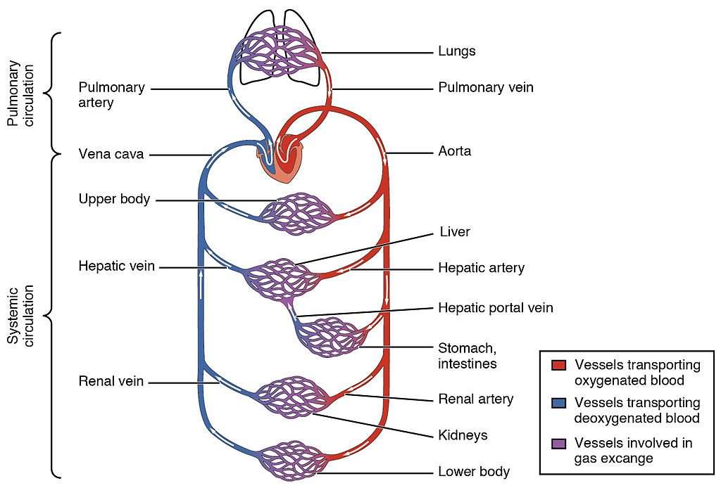

الوحدة الثامنة - المحاضرة الثامنة - الزمن: 120 دقيقة

أهداف المحاضرة الثامنة:

يتوقع في نهاية الجلسة أن يكون الطالب قادراً على معرفة :
1-الوضائف الجسدية لجسم النسان في الصحة والمرض
2-التطبيقات الفيزيائية في ممارسة الطب

موضوعات المحاضرة الثامنة:

The Heart

الأساليب والأنشطة والوسائل التعليمية

م | الأساليب والأنشطة التدريبية | الوسائل التدريبية
1 | - نشاط التعارف (1/1/1)  - محاضرة  - مناقشة  - سؤال وجواب | - جهاز حاسوب  - جهاز عرض  - سبورة  - اوراق واقلام

The heart pumps blood to all parts of the body providing nutrients and oxygen to every cell, and removing waste products. The left heart pumps oxygenated blood returned from the lungs to the rest of the body in the systemic circulation. The right heart pumps deoxygenated blood to the lungs in the pulmonary circulation. In the human heart there is one atrium and one ventricle for each circulation, and with both a systemic and a pulmonary circulation there are four chambers in total: left atrium, left ventricle, right atrium and right ventricle. The right atrium is the upper chamber of the right side of the heart. The blood that is returned to the right atrium is deoxygenated (poor in oxygen) and passed into the right ventricle to be pumped through the pulmonary artery to the lungs for re-oxygenation and removal of carbon dioxide. The left atrium receives newly oxygenated blood from the lungs as well as the pulmonary vein which is passed into the strong left ventricle to be pumped through the aorta to the different organs of the body.

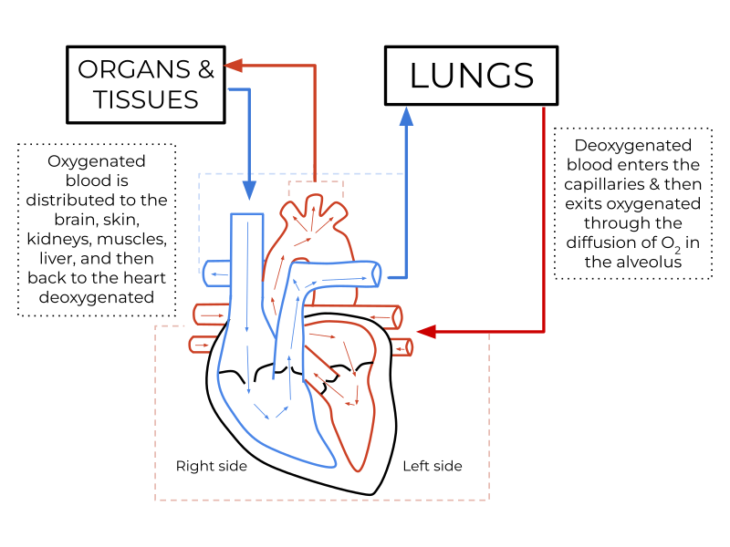

Systemic circulation
The systemic circulation is a circuit loop that delivers oxygenated blood from the left heart to the rest of the body through the aorta. Deoxygenated blood is returned in the systemic circulation to the right heart via two large veins, the inferior vena cava and the superior vena cava, where it is pumped from the right atrium into the pulmonary circulation for oxygenation. The systemic circulation can also be defined as having two parts – a macrocirculation and a microcirculation

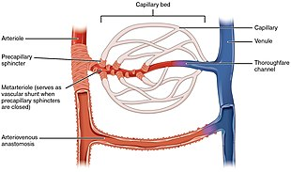

Blood vessels
The blood vessels of the circulatory system are the arteries, veins, and capillaries. The large arteries and veins that take blood to, and away from the heart are known as the great vessels.

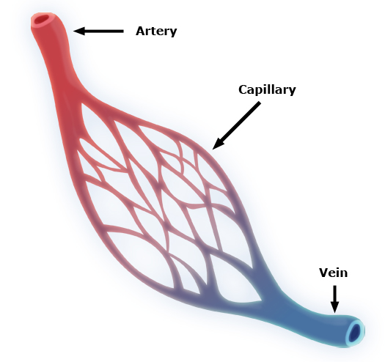

الوحدة التاسعة - المحاضرة التاسعة - الزمن: 120 دقيقة

أهداف المحاضرة التاسعة:

يتوقع في نهاية الجلسة أن يكون الطالب قادراً على معرفة :
1-الوضائف الجسدية لجسم النسان في الصحة والمرض
2-التطبيقات الفيزيائية في ممارسة الطب

موضوعات المحاضرة التاسعة:

Terminology

الأساليب والأنشطة والوسائل التعليمية

م | الأساليب والأنشطة التدريبية | الوسائل التدريبية
1 | - نشاط التعارف (1/1/1)  - محاضرة  - مناقشة  - سؤال وجواب | - جهاز حاسوب  - جهاز عرض  - سبورة  - اوراق واقلام

The term medical physics refers to two major areas: -
- The physical functions of the human body in health and disease.
- The physical applications in the practice of medicine.
The first of these could be called the physics of physiology; the second includes such things as the physics of the stethoscope, the tapping of the chest (percussion), and the medical applications of lasers, ultrasound, MRI, X-ray and so forth.
The word physical appears in a number of medical contexts. Only a generation ago in England a professor of physics was actually a professor of medicine.
The branch of medicine referred to as physical medicinedeals with the diagnosis and treatment of disease and injury by means of physical agents such as manipulation, massage, exercise, heat, and water.
Physical therapy is the treatment of disease or bodily weakness by physical means such as massage and gymnastics rather than by drugs.
The field of medical physics has several subdivisions: -
- Most medical physicists in the United States work in the field of radiological physics. This involves the applications of physics to radiological problems and includes the use of radiation in the diagnosis and treatment of disease as well as the use of radionuclides in medicine (nuclear medicine).
- Another major subdivision of medical physics involves radiation protection of patients, workers, and the general public. In the United States this field is often called health physics. Health physics also includes radiation protection outside of the hospital such as around nuclear power plants and in industry.
- Very often an applied field of physics( included design and instrumentation) is called engineering. Thus, medical physics could be called medical engineering.
- The word medical is sometimes replaced with the word clinical if the job is closely connected with patient problems in hospitals, i.e., clinical engineering or clinical physics.
• Modeling
Even though physicists believe that the physical world obeys the laws of physics, they are also aware that the mathematical descriptions of some physical situations are too complex to permit solutions.
If you tore a small corner off this page and let it fall to the floor, it would go through various gyrations. Its path would be determined by the laws of physics, but it would be almost impossible to write the equation describing this path. Physicists would agree that the force of gravity would cause it to go in the general direction of the floor if some other force did not interfere. Air currents and static electricity would affect its path.
n trying to understand the physical aspects of the body, we often resort to analogies; physicists often teach and think by analogy. Keep in mind that analogies are never perfect.
In many ways the eye is analogous to a camera; however, the analogy is poor when the film, which must be developed and replaced, is compared to the retina, the light detector of the eye.
Some models involve physical phenomena that appear to be completely unrelated to the subject being studied.
A model in which the flow of blood is represented by the flow of electricity is often used in the study of the body's circulatory system. Also, all analogies have their limitations.
Blood is made up of red blood cells and plasma, and the percentage of the blood occupied by the red blood cells (the hematocrit) changes as the blood flows toward the extremities. This phenomenon is difficult to simulate with the electrical model.
Other models are mathematical; equations are mathematical models that can be used to describe and predict the physical behavior of some systems. In the everyday world of physics we have many such equations. Some are of such general use that they are referred to as laws.
• Measurement
One of the main characteristics of science is its ability to reproducibly measure quantities of interest. The growth of science is closely related to the growth of the ability to measure. In the practice of medicine, early efforts to measure quantities of clinical interest were often scorned as detracting from the skill of the physician.
Even though body temperature and pulse rate could be measured during the seventeenth century, these measurements were not routinely made until the nineteenth century. In this century there has been a steady growth of science in medicine as the number and accuracy of quantitative measurements used in clinical practice have increased. The following figure illustrates a few of the common measurements used in the practice of medicine. Some of these measurements are more reproducible than others.
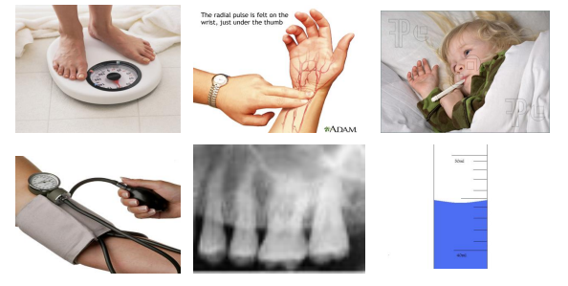

For Example: -
An x-ray gives only qualitative information about the inside of the body; a repeat x-ray taken with a different machine may look quite different to the ordinary observer.
There are many other physical measurements involving the body and time. We can divide them into two groups: -
- Measurements of the repetitive processes usually involve the number of repetitions per second, minute, hour, and so forth, such as the pulse rate which is about 70/min and the breathing rate which is about 15/min.
- Measurements of nonrepetitive processes, such as how long it takes the kidneys to remove a foreign substance from the blood. Nonrepetitive time processes in the body range from the action potential of a nerve cell (1msec) to more time.
In science accuracy and precision have different meanings: -
Accuracy
Refers to how close a given measurement is to an accepted standard.
For Example: -
For example, if in lab you obtain a mass measurement of 3.2 kg for a given substance, but the actual or known weight is 10.5 kg, then your measurement is not accurate. In this case, your measurement is not close to the known value. But if the measurement is 10.505 kgm, then the measurement may be accurate to 0.005 kgm 0r 5gm
Precision
Precision is how close the measured values are to each other. It refers to the reproducibility of a measurement and is not necessarily related to the accuracy of the measurement.
For Example: -
An ill person measured her temperature ten times in a row and got the following values in degrees Celsius: 36.1, 36.0, 36.1, 36.2, 36.4, 36.0, 36.3, 36.3, 36.4, and 36.2. The precision was fairly good, with a variation of 0.2°C from the average value of 36.2°C.
It is an accepted fact in science that the process of measurement may significantly alter the quantity being measured. This is especially true in medicine.
The process of measuring the blood pressure may introduce errors (uncertainties). Although the data are scarce, it is generally believed that when an attractive woman is performing the measurement, the blood pressure of a young man will increase. Similarly, a handsome man may affect the blood pressure measurement of a female patient.
When the physician decides if the patient is ill or not?
After he or she has reviewed a patient's: -
- Medical history.
- The findings of the physical examination.
- The results of clinical laboratory measurements.
Medical history. 2. The findings of the physical examination. 3. The results of clinical laboratory measurements.
- False Positives.
- False Negatives.
A false positive error occurs when a patient is diagnosed to have a particular disease when he or she does not have it.
A false negative error occurs when a patient is diagnosed to be free of a particular disease when he or she does have it.
Note: - In some situations a diagnostic error can have a great impact on a patient's life.
For Example:
A young woman was thought to have a rheumatic heart condition and spent several years in complete bed rest before it was discovered that a false positive diagnosis had been made-she really had arthritis.
In the early stages of many types of cancer it is easy to make a false negative diagnostic error because the tumor is small. Since the probability of cure depends on early detection of the cancer, a false negative diagnosis can greatly reduce the patient's chance of survival.
Diagnostic errors (false positives and false negatives) can be reduced by: -
- Research into the causes of misleading laboratory test values.
- Development of new clinical tests and better instrumentation.
Errors or uncertainties from measurements can be reduced by: -
- Using care in taking the measurement
- Repeating measurements.
- Using reliable instruments.
- Properly calibrating the instruments.
In summary: -
- All measurements are uncertain and inaccurate
- With special effort we can reduce the error and the uncertainty.
- In many cases there is no need to improve the measurement because the quantity being measured is variable.

الوحدة العاشرة - المحاضرة العاشرة - الزمن: 120 دقيقة

أهداف المحاضرة العاشرة:

يتوقع في نهاية الجلسة أن يكون الطالب قادراً على معرفة :
1-الوضائف الجسدية لجسم النسان في الصحة والمرض
2-التطبيقات الفيزيائية في ممارسة الطب

موضوعات المحاضرة العاشرة:

Measurement

الأساليب والأنشطة والوسائل التعليمية

م | الأساليب والأنشطة التدريبية | الوسائل التدريبية
1 | - نشاط التعارف (1/1/1)  - محاضرة  - مناقشة  - سؤال وجواب | - جهاز حاسوب  - جهاز عرض  - سبورة  - اوراق واقلام

The term medical physics refers to two major areas: -
- The physical functions of the human body in health and disease.
- The physical applications in the practice of medicine.
The first of these could be called the physics of physiology; the second includes such things as the physics of the stethoscope, the tapping of the chest (percussion), and the medical applications of lasers, ultrasound, MRI, X-ray and so forth.
The word physical appears in a number of medical contexts. Only a generation ago in England a professor of physics was actually a professor of medicine.
The branch of medicine referred to as physical medicinedeals with the diagnosis and treatment of disease and injury by means of physical agents such as manipulation, massage, exercise, heat, and water.
Physical therapy is the treatment of disease or bodily weakness by physical means such as massage and gymnastics rather than by drugs.
The field of medical physics has several subdivisions: -
- Most medical physicists in the United States work in the field of radiological physics. This involves the applications of physics to radiological problems and includes the use of radiation in the diagnosis and treatment of disease as well as the use of radionuclides in medicine (nuclear medicine).
- Another major subdivision of medical physics involves radiation protection of patients, workers, and the general public. In the United States this field is often called health physics. Health physics also includes radiation protection outside of the hospital such as around nuclear power plants and in industry.
- Very often an applied field of physics( included design and instrumentation) is called engineering. Thus, medical physics could be called medical engineering.
- The word medical is sometimes replaced with the word clinical if the job is closely connected with patient problems in hospitals, i.e., clinical engineering or clinical physics.
• Modeling
Even though physicists believe that the physical world obeys the laws of physics, they are also aware that the mathematical descriptions of some physical situations are too complex to permit solutions.
If you tore a small corner off this page and let it fall to the floor, it would go through various gyrations. Its path would be determined by the laws of physics, but it would be almost impossible to write the equation describing this path. Physicists would agree that the force of gravity would cause it to go in the general direction of the floor if some other force did not interfere. Air currents and static electricity would affect its path.
n trying to understand the physical aspects of the body, we often resort to analogies; physicists often teach and think by analogy. Keep in mind that analogies are never perfect.
In many ways the eye is analogous to a camera; however, the analogy is poor when the film, which must be developed and replaced, is compared to the retina, the light detector of the eye.
Some models involve physical phenomena that appear to be completely unrelated to the subject being studied.
A model in which the flow of blood is represented by the flow of electricity is often used in the study of the body's circulatory system. Also, all analogies have their limitations.
Blood is made up of red blood cells and plasma, and the percentage of the blood occupied by the red blood cells (the hematocrit) changes as the blood flows toward the extremities. This phenomenon is difficult to simulate with the electrical model.
Other models are mathematical; equations are mathematical models that can be used to describe and predict the physical behavior of some systems. In the everyday world of physics we have many such equations. Some are of such general use that they are referred to as laws.
• Measurement
One of the main characteristics of science is its ability to reproducibly measure quantities of interest. The growth of science is closely related to the growth of the ability to measure. In the practice of medicine, early efforts to measure quantities of clinical interest were often scorned as detracting from the skill of the physician.
Even though body temperature and pulse rate could be measured during the seventeenth century, these measurements were not routinely made until the nineteenth century. In this century there has been a steady growth of science in medicine as the number and accuracy of quantitative measurements used in clinical practice have increased. The following figure illustrates a few of the common measurements used in the practice of medicine. Some of these measurements are more reproducible than others.

الوحدة الحادية عشر - المحاضرة الحادية عشر - الزمن: 120 دقيقة

أهداف المحاضرة الحادية عشر:

يتوقع في نهاية الجلسة أن يكون الطالب قادراً على معرفة اجزاء الهيكل العظمي البشري

موضوعات المحاضرة الحادية عشر:

Human Skeleton

الأساليب والأنشطة والوسائل التعليمية

م | الأساليب والأنشطة التدريبية | الوسائل التدريبية
1 | - نشاط التعارف (1/1/1)  - محاضرة  - مناقشة  - سؤال وجواب | - جهاز حاسوب  - جهاز عرض  - سبورة  - اوراق واقلام

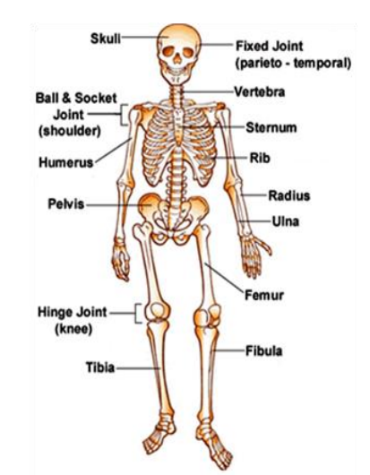

Bones and Joints:
The human skeleton consists of about 206 bones. Junctions between neighboring bones are called Joints. Although some joints like those in the skull allow little or no movement, the majority enable for bones to move freely. These are known as Synovial joints, and different types allow different types of movement. The elbow, for example, is a simple hinge, whereas the shoulder and the hip, which have a greater range of movement, are ball-and-socket joint.

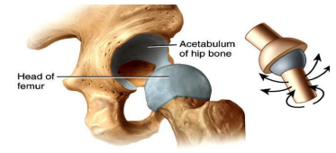

The bones on either side of a synovial joint are held together by ligaments. The parts of the bones that form the joint are covered with cartilage-a tough, slightly elastic material that protects the bones from damage. Friction between the layers of cartilage is minimized by the presence of a lubricant known as synovial fluid.
Muscles:
Bones are moved by muscles which are attached to them by tendons. When a muscle contract (under the action of nerve impulses from the brain) it pulls on the bones on each side of it and causes one of them to move. Muscles cannot push and therefore to return the bone to its original position, the first muscle relaxes and a second muscle, acting in opposition to the first, contract Figure below. The two muscles are known as an antagonistic pair.
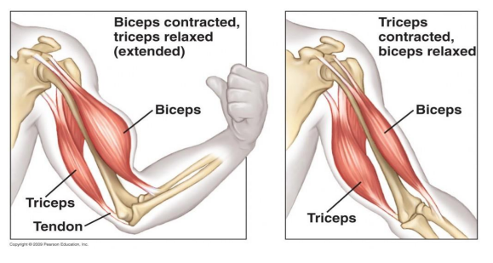

Q/What is bone made of?
- The outer surface of bone is called the periosteum. It's a thin, dense membrane that contains nerves and blood vessels that nourish the bone.
- The next layer is made up of compact bone. This part is smooth and very hard. It's the part you see when you look at a skeleton.
- Within the compact bone are many layers ofcancellous (spongy) bone, which looks a bit like a sponge. Cancellous bone is not quite as hard as compact bone, but it is still very strong.
- In many bones, the cancellous bone protects the innermost part of the bone, the bone marrow. Bone marrow is sort of like a thick jelly, and its job is to make blood cells.
There are two kinds of bones Compact bone & cancellous (sponge) bone
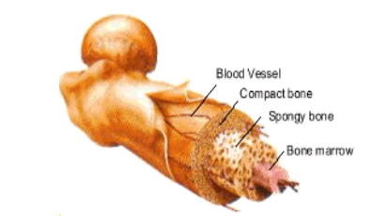

What is the advantage of sponge over compact bones?
- Sponge bone under compressive forces gives the strength necessary with less material than compact.
- Sponge bones are relatively flexible and can absorb more energy when large forces are involved such as walking, raining and jumping.
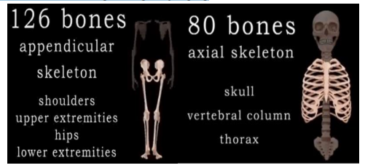
The all bones could be divided into two parts axial & appendicular Skelton

Bone remolding: A continues process of destroying old bone and building new one. There are two types of cell in bone remolding.
- Osteoblasts are mononucleate bone-forming cells. They are located on the surface of osteoid seams and make a protein mixture known as osteoid, which mineralizes to become bone.
- Osteoclasts are the cells responsible for bone resorption, thus they break down bone. New bone is then formed by the osteoblasts. Bone is constantly remodeled by the resorption of osteoclasts and created by osteoblasts. Bones has about (1000g of Ca). Each day the osteoclast destroying bones containing 0.5 g of Ca, while osteoblast builds new bone using the same amount of Ca. So we have a new Skelton about every seven years.
Osteoporosis
Osteoporosis is a disease of bone where there is reduced bone mineral density, increasing the likelihood of fractures. Osteoporosis is most common in women especially in spine and hip. Osteoporosis usually has no symptoms until a fracture occur. Up to 35 – 40 years old the activity of the osteoblast is greater than osteoclast. Over that age the process is reversed causing a gradual decrease in bone mass that continues until death.
Osteoporosis treatment includes advice to1- stop smoking, 2- decrease alcohol consumption, 3- exercise regularly, 4- and have a healthy diet. 5- Calcium supplements may also be advised, as May Vitamin D.
Here are five types of bones in the human body: long, short, flat, irregular, and sesamoid.
Types of Bones
- Long bones are characterized by a shaft, the diaphysis that is much longer than its width; and by an epiphysis, a rounded head at each end of the shaft. They are made up mostly of compact bone, with lesser amounts of marrow, located within the medullary cavity, and spongy, cancellous bone. Most bones of the limbs, including those of the fingers and toes, are long bones femur, tibia.
- Short bones are roughly cube-shaped, and have only a thin layer of compact bone surrounding a spongy interior. The bones of the wrist and ankle are short bones.
- Flat bones are thin and generally curved, with two parallel layers of compact bones sandwiching a layer of spongy bone. Most of the bones of the skull are flat bones, as is the sternum.
- Sesamoid bones are bones embedded in tendons. Since they act to hold the tendon further away from the joint, the angle of the tendon is increased and thus the leverage of the muscle is increased. Examples of sesamoid bones are the patella and the pisiform.
- Irregular bones do not fit into the above categories. They consist of thin layers of compact bone surrounding a spongy interior. As implied by the name, their shapes are irregular and complicated. Often this irregular shape is due to their many centers of ossification or because they contain bony sinuses. The bones of the spine, pelvis, and some bones of the skull are irregular bones. Examples include the ethmoid and sphenoid bones.
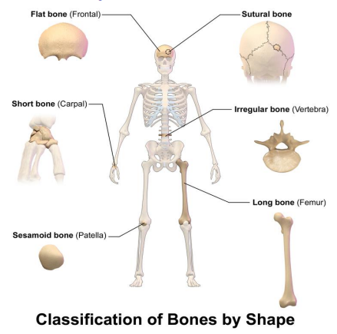

Q/ What could determine the bone function?
- The bone shape.
- The interval construction of bone.
- The type of material to be formed

Bones have many functions, including the following:

Shape
Bone structure gives shape to the body. This shape changes as you grow, and your skeletal system determines your height, width and other factors, such as the size of your hands and feet. Body shape or type is genetically inherited. There are three main body shapes : ectomorphs (tall and thin), mesomorphs (shorter and muscular) and endomorphs (apple or pear-shaped).

Support
The skeleton provides support to the body and keeps your internal organs in their proper place. The vertebral column allows you to stand erect, while cavities hollow spaces in the skeleton are designed to hold your organs. For example, the skull holds the brain; the chest cavity holds your lungs and heart while the abdominal cavity holds your gastrointestinal organs. Additionally, the pelvis and leg bones are strong and thick to support the weight of the entire skeleton.
Movement
The skeletal bones are held together by ligaments. Tendons attach your muscles to the bones of your skeleton. The muscular and skeletal systems work together to carry out bodily movement, and together they are called the musculoskeletal system. When muscles contract, the skeleton moves. The shape of the skeletal system also impacts movement. The small bones of the foot allow for adaptation to all sorts of terrain, while the small bones in the hands allow for precise and detailed movement.
Protection
His skeleton protects vital organs from damage, encasing them within hard bones. The cranium bone --skull -- houses the brain, while the vertebral, or spinal, column protects the delicate spinal cord, which controls all bodily functions through communication with your brain. The bony thorax, comprised of the ribs and sternum, protects your heart and lungs.
Blood Cell Production and Storage
The spongy tissue inside long bones, such as the femur, or thigh bone, has two types of marrow responsible for blood cell production. On average, 2.6 million red blood cells are produced each second by the bone marrow. Red bone marrow gives rise to blood cells while yellow bone marrow stores fat, which turns into red bone marrow in case of severe red blood cell depletion or anemia. Skeletal bones also function as a storage bank for minerals, such as calcium and phosphorus. These minerals are necessary for vital body functions, such as nerve transmission and metabolism.
Vertebral column (Spine)

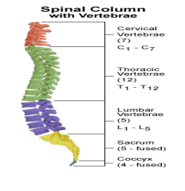
The spine consists of (33 vertebrae) and provides the main support for the body. Nine of the vertebrae at the base of the spin are fused, five to form the sacrum and four to form the coccyx. The top 24 are covered with cartilage and are separated from each other by tough fibrous known as discs. The discs allow the spine to bend and to twist. They also protect the vertebrae from wear and cushion them from shock.
Note: R force on lumbosacral disc, is over times body weight and nearly six times the force on it when standing upright. Lifting heavy weight with the back in this position puts even greater stress on the disc and might even cause it to rupture. Damage is much less likely to occur if heavy objects are lifted with the knees bent and the back vertical
Stress–strain curve
Stress strain curve is a behavior of material when it is subjected to load. In this diagram stresses are plotted along the vertical axis and as a result of these stresses, corresponding strains are plotted along the horizontal axis.
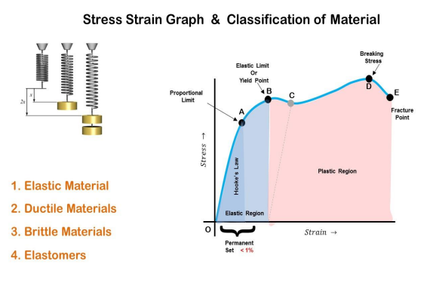

From the diagram one can see the different mark points on the curve. It is because, when a ductile material like mild steel is subjected to tensile test, then it passes various stages before fracture. These stages are;
- Proportional Limit
- Elastic Limit
- Yield Point
- Ultimate Stress Point
- Breaking Point

1- PROPORTIONAL LIMIT
Proportional limit is point on the curve up to which the value of stress and strain remains proportional. From the diagram point A is the called the proportional limit point or it can also be known as limit of proportionality. The stress Up to this point can be also being known as proportional limit stress.
Hook’s law of proportionality from diagram can be defined between point OA. It is so, because OA is a straight line which shows that Hook’s law of stress strain is followed up to point A.
2- ELASTIC LIMIT
Elastic limit is the limiting value of stress up to which the material is perfectly elastic. From the curve, point B is the elastic limit point. Material will return back to its original position, if it is unloaded before the crossing of point B. This is so, because material is perfectly elastic up to point B.
3- YIELD STRESS POINT
Yield stress is defined as the stress after which material extension takes place more quickly with no or little increase in load. Point B is the yield point on the graph and stress associated with this point is known as yield stress.
4- ULTIMATE STRESS POINT
Ultimate stress point is the maximum strength that material has to bear stress before breaking. It can also be defined as the ultimate stress corresponding to the peak point on the stress strain graph. On the graph point D is the ultimate stress point. After point D material have very minute or zero strength to face further stress.
5- BREAKING STRESS (POINT OF RUPTURE)
Breaking point or breaking stress is point where strength of material breaks. The stress associates with this point known as breaking strength or rupture strength. On the stress strain curve, point E is the breaking stress point.
Consider a bar of cross sectional area (A) being subjected to equal and opposite forces (F) pulling at the ends so the bar is under tension. The material is experiencing a stress defined to be the ratio of the force to the cross sectional area of the bar:
Stress = $\frac{F }{A}$ Nm² = Pa
Now consider a force that is applied tangentially to an object. The ratio of the shearing force to the area A is called the shear stress. Or the ratio between changing in length (∆𝒍) to the original length (l).
Strain = $\frac{∆ι }{ι}$

Finally, the shear modulus Y of a material is defined as the ratio of shear stress to shear strain at any point in an object made of that material. The shear modulus is also known as the torsion modulus.
Y = 𝑆𝑡𝑟𝑒𝑠𝑠 𝑆𝑡𝑟𝑎𝑖𝑛 = 𝐹∗𝑙 𝐴∗∆𝑙 Pa
6- Strength of material = its ability of material to withstand an applied load without failure or plastic deformation.
- Compressive stress = is the stress state caused by an applied load that acts to reduce the length of the material along the axis of the applied load, example pushing forces. (a)
- Tensile stress is the stress state caused by an applied load that tends to elongate the material along the axis of the applied load, example by pulling the material. (b)
- Shear stress is the stress state caused by the combined energy of a pair of opposing forces acting along parallel lines of action through the material , example tress caused by faces of the material sliding relative to one another. (c)

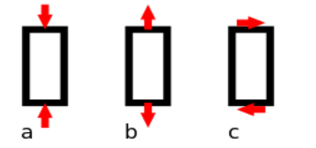

Elasticity is the ability of a material to return to its previous shape after stress is released.
Plasticity or plastic deformation is the opposite of elastic deformation and is defined as unrecoverable strain.

الوحدة الثانية عشر – المحاضرة الثانية عشر - الزمن: 120 دقيقة

أهداف المحاضرة الثانية عشر:

يتوقع في نهاية الجلسة أن يكون الطالب قادراً على معرفة درجات الحرارة وطرق قياسها والخصائص الفيزيائية التي تتغير مع درجة الحرارة

موضوعات المحاضرة الثانية عشر:

Heat and Cold

الأساليب والأنشطة والوسائل التعليمية

م | الأساليب والأنشطة التدريبية | الوسائل التدريبية
1 | - نشاط التعارف (1/1/1)  - محاضرة  - مناقشة  - سؤال وجواب | - جهاز حاسوب  - جهاز عرض  - سبورة  - اوراق واقلام

Heat and Cold in Medicine
As molecules of all materials are moving so they have kinetic energy. The average kinetic energy of an ideal gas can be shown to be directly proportional with temperature. An increase of temperature of any material means an increase in the energy of molecules of that material. If enough heat added to a solid, it melts, forming a liquid. The liquid may be changed to a gas by adding more heat. Adding still more heat converts gas to ions. While adding heat to substance increase its molecular kinetic energy, which increase its temp., the reverse is also true, heat can be removed from a substance to lower the temp.
Thermometry and temperature scales
Thermometry is instrument to measurement heat while temperature scales represented unit of measuring the temperature.
Temperature is difficult to measure directly, so we usually measure it indirectly by measuring one of many physical properties that change with temp.
- Fahrenheit scale (°F): in this scale the freezing temp. is 32°F and boiling point is 212°F ,and normal body temp. is about 98.6°F .
- The Celsius scale (°C): the freezing point is 0°C and the boiling point is 100°C, in between is divided into 100 divisions. normal body temp. is about 37°C
- The Kelvin scale (°K): or the absolute scale this scale has the same divisions as the Celsius but takes the 0° K at the absolute zero which is=- 273.15°C.( this temperature scale is not used in medicine)
To change °C to °F
[°C= (°F-32) 5/9] or [°F=°C (9/5)+32]
Also °C=°K-273 (or °K=°C+273).

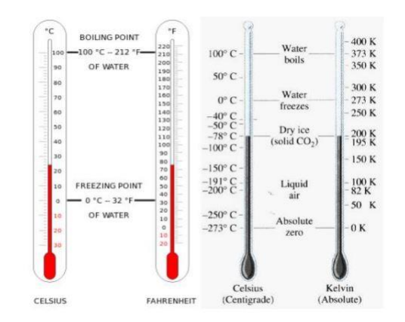
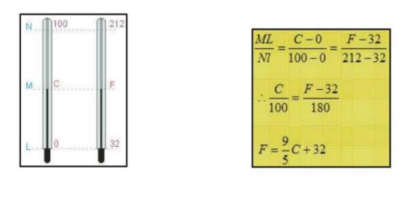

Temperature Measurement Devices :
- Glass Fever Thermometer
This thermometer composed of glass capillary tube ends with a bulb a store for liquid, the liquid can be mercury or alcohol for low temperature measurement and It used to know the temp of the body.
The most common way to measure a temperature is within the glass fever thermometer containing mercury or alcohol.
Temperature Measurement Devices :
- Glass Fever Thermometer
This thermometer composed of glass capillary tube ends with a bulb a store for liquid, the liquid can be mercury or alcohol for low temperature measurement and It used to know the temp of the body.
The most common way to measure a temperature is within the glass fever thermometer containing mercury or alcohol.
Input fever thermometer ,a temperature increase causes the alcohol or mercury to expand more than the glass and thus produces an increase in the level of the liquid(mercury or alcohol). for mercury it expands 1.8% from(0- 1000 - C)
That it would be very difficult to read if it were not designed for visibility. Two things increase the visibility of the capillary: the glass case acts as a magnifying glass and an opaque white backing is used. The temp. usually taken underneath the tongue or in the rectum.
- Thermistor
It's composed from a bridge of four resistances with a source of electricity. It’s a special resistor that changes it’s resistance rapidly with temp ( o ≈ 5% C ).

* The principle behind this thermistor is that a temperature change causes the thermistor resistance to change.
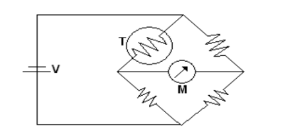
Because it is very sensitive and very fast for measuring temp change . Thermistors are placed in the nose to monitor the breathing rate of the patient → This is called “pneumograph” . thermistor is easy to measure temperature changes of 0.01°C, therefore are used quite often in medicine because it sensitive large from glass fever.
- Thermocouple
A thermocouple consists of two junctions of two different metals . If the two junctions are at different temperature, a voltage is produce that depend on the temperature difference.
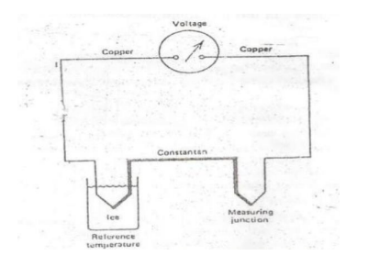
The copper-constantan thermocouple can be used to temp. from -190 to 300°C. For 100°C temp. difference, the voltage produced is only about 0.004V. Thermocouple can be made small enough to measure the temp of individual cells.
Thermograph
It is a simple method for obtaining a surface temp “mapping”. The surface of the body temp. is slightly different in different parts depending on
- external physical factors and internal metabolic.
- blood supply to the skin.
By using this principle the thermograph instrument was designed to measure the radiation emitted from a part of the body. For our purposes the Stefan – Boltzmann law for total radioactive power per surface W is more useful. It is:
W= e σT⁴
T: is the absolute temp. of the body
e: is the emissivity depends upon the emitter material and its temp. for radiation from body e is almost (e=1).
σ: is the Stefan –Boltzmann constant =5.7×10⁻¹² W/cm2K 4
k : Kelvin or absolute, scale=273kº. 0 kº = absolute zero= -273 Cº normal body temp =(T Cº+273) k º (this temperature scale is not used in medicine).
Thermograph is useful in:
- It has been used to detect other type of cancer not only breast cancer.
- It used to study the circulation of the blood in the head.
- It used to study the blood in the diabetics leg.

Ex:
A person of skin temp. of 36Cº and body surface area 1.75m2 .find :
1. net total power if he receives radioactive power from the surrounding walls 20Co would be about 735w. (σ = 5.7 * 10⁻¹² w/cm2 )
2. The emissivity of surrounding walls.
For the Breast Cancer Detection:
- Thermography to detect the elevated temp. area
- 2- To detect the area by smooth touching (palpation or feeling).
- 3- Use of low voltage X-ray (mammography).
- 4- To be sure of the type of Breast tissue of the specific area ,biopsy examination for histopathology is done.
Heat therapy
Heat was recognized as therapeutic agent several thousand years ago. It has two primary therapeutic effects take place in heated area:
- An increase in metabolism resulting in relaxation of the Capillary system (vasodilation).
- An increase in blood flow as blood moves in to cool the heated area.
Physical Methods of Producing Heat in the Body
- Conductive heating.
- 2- Infrared radiant heating (IR).
- 3- Radio wave heating (Electromagnetic Wave).
- 4- Micro wave diathermy .
- 5- Ultrasonic wave heating.

- The conductive method
The conductive method is based on physical fact that if two objects at different temperature are placed in contact, heat will transfer by conduction from the warm object to the cooler one. The total of heat transferred will depend upon the temp. difference, the time of contact, the area of contact, and the thermal conductivity of the materials. This can be done by several ways such as hot baths, hot packs, and electric heating pads. This can lead to local surface heating and using in the treatment of arthritis, neuritis, strains, sinusitis and back pain.
- Radiant heat (IR)
Radiant heat (IR) is also used for surface heating of the body. This is the same form of heat we feel from the sun or from an open flame. Heat radiation can be achieved by using infrared radiation (IR), it penetrates about 3mm in the skin. It can be produced glowing coils and by 250 watts incandescent lamps. The IR wavelengths used are between (800- 40000nm) an excessive exposures can cause reddening and sometimes swelling (edema). Very prolonged (longer) exposure can cause skin browning or hardening of the skin. It is considered to be more effective than conductive heating because heat penetrates deeper.
- Radio wave heating (Diathermy):
Short wave diathermy utilizes electromagnetic waves in the radio range(wavelength~ 10m),and microwave diathermy uses waves in the radar range (wavelength~ 12cm).Heat from diathermy penetrates deeper into the body than radiant and conductive heat. It is useful for internal heating and has been used in the treatment of inflammation of the skeleton, bursitis, and neuralgia.

Different methods are used for transferring the electromagnetic energy into the body in short wave diathermy:-
- The part of the body to be treated is placed between two plates (electrodes) connected with high frequency power supply. The charged particles of the tissue will be attracted to one plate and to other depending upon the sign of the alternating voltage on the plate. This movement will produce resistive (joule) heating.
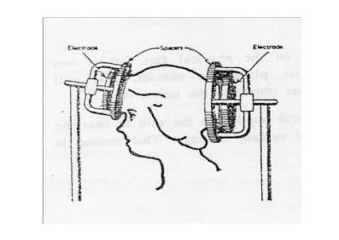
- By transferring short wave energy into the body by magnetic induction. This can be done by either placing a coil around the region to be treated or by (pancake) coil placed near the part of the body to be treated. The alternating current in the coil produces an alternating magnetic field in the tissue, consequently an alternating (eddy) currents are induced , producing joule heating in the region treated. Short wave diathermy can penetrate deep into tissue. It can be used in relieving muscle spasms, protruded intervertebral disc pain, joints with minimal soft tissue coverage such as knee, elbow.
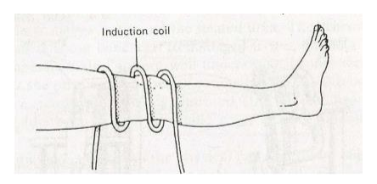
- Microwave diathermy
can be produced in special tube called (magnetron) and emitted from the applicator (antenna) which can be placed several inches from the region to be treated. Microwave can penetrate deeper into the tissue causing heating. It is used in fractures, sprains, strains, bursitis, and injuries to tendons. The frequency used is 900MHz, which is found more effective than other frequencies in therapy. It causes more uniform heating around bony region.
- Ultrasonic waves
These waves are different from electromagnetic waves. It produces mechanical vibration inside tissue. It is the same as the sound waves but it has much higher frequencies about 1MHz with power of several watts per centimeter. It can move the tissue particles backward and forward with high frequency, in doing so it can increase the kinetic energy consequently it heats the tissue. Ultrasound can be produced by special transducers placed in direct contact with the skin. It is used for reliving tightness and scarring occurring in joint disease. It can deposit more heat in bones because they absorber ultrasound energy more effectively than dose soft tissue. It is also used for deep heating of the body. Heat therapy has also been used in cancer treatment in combination with radiotherapy. The tumor is heated about 42°C for approximately 30 minutes, and the radiation treatment is given after heat treatment.
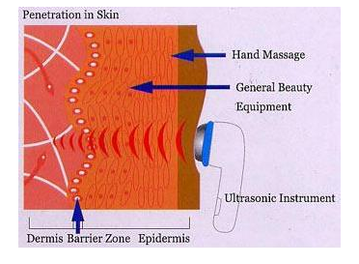
Use of Cold in Medicine
Cryogenics: is the science and technology of producing and using very low temp. in medicine to preserve blood, sperm, bone marrow and soft tissue. Cells & Tissues which is sorted for long term should be :
  - Stored at a very low temp. (-196 Co ) since biochemical & physical processes are temp. dependents → then lowing temp. will reduce the rate of these two processes .
  - Cooled at the optium cooling rate of the tissue to be stored and the % of survival is more dependent on the cooling rate than on the warming rate.
  - Stored with adding protective agent (glycerol or dimethyle solfoxide) before cooling
* Survival behavior as a function of colling Rate for blood RBCs and Bone marrow:
Cooling rate = ΔT / time interval
= (T2 -T1) / time interval ( Cº/min )
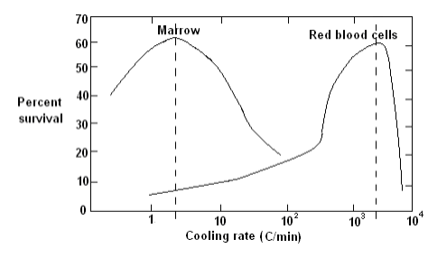
cooling rate of Bone marrow = 3 ( Cº/min )
cooling rate of RBCs = 3000 ( Cº/min )
Blood Storage
  - Convential Method: It is non - cryogenics method & it is done by mixing the whole blood with anticoagulant then stored at 4Cº at this method about 1% of the RBCs hemolyzed or breaked , then the maximum expired is 21 days because at this period 20% of RBCs are break.
  - Long term storage : It is cryogenics method .It divides into two ways:
A. Thin - walled containers : The container is filled with blood then is quickly inserted into a liquid Nitrogen bath . The frozen blood can be stored at - 196 Co .
B. Blood sand Method : The blood is sprayed into a liquid Nitrogen surface which freezes into small droplets grains of sand .The droplets are collected & stored in special containers at - 196 Co .
Cryosurgery: It is the application of using cryogenics methods to destroy cells.
* The advantages:
  - There is little bleeding in the destroyed area.
  - The volume of tissue destroyed can be controlled by the temp. of cryosurgical prob.
  - There is little pain sensation because low temp. tend to desensitize the nerves.
* Uses of Cryosurgery In treatment of " Parkinson
    - Disease or Shaking Palsy . It is a disease that associated with the basal ganglion of the brain which causes un controlled tremor in the arms and legs - Treatment is done by destroying the part of the thalamus in the brain that controls the transmission of nerve impulses to other parts of nervous system .
    - Treatment of tumors by cutting it.
    - In several of types of eye surgery :
- Repair of detached retina.
- Cataract surgery removal of a darkened lens.

الوحدة الثالثة عشر - المحاضرة الثالثة عشر - الزمن: 120 دقيقة

أهداف المحاضرة الثالثة عشر:

يتوقع في نهاية الجلسة أن يكون الطالب قادراً على معرفة درجات الحرارة وطرق قياسها والخصائص الفيزيائية التي تتغير مع درجة الحرارة

موضوعات المحاضرة الثالثة عشر:

Radio wave heating (Diathermy)

الأساليب والأنشطة والوسائل التعليمية

م | الأساليب والأنشطة التدريبية | الوسائل التدريبية
1 | - نشاط التعارف (1/1/1)  - محاضرة  - مناقشة  - سؤال وجواب | - جهاز حاسوب  - جهاز عرض  - سبورة  - اوراق واقلام

Short wave diathermy utilizes electromagnetic waves in the radio range(wavelength~ 10m),and microwave diathermy uses waves in the radar range (wavelength~ 12cm).Heat from diathermy penetrates deeper into the body than radiant and conductive heat. It is useful for internal heating and has been used in the treatment of inflammation of the skeleton, bursitis, and neuralgia.

Different methods are used for transferring the electromagnetic energy into the body in short wave diathermy:-
- The part of the body to be treated is placed between two plates (electrodes) connected with high frequency power supply. The charged particles of the tissue will be attracted to one plate and to other depending upon the sign of the alternating voltage on the plate. This movement will produce resistive (joule) heating.
- By transferring short wave energy into the body by magnetic induction. This can be done by either placing a coil around the region to be treated or by (pancake) coil placed near the part of the body to be treated. The alternating current in the coil produces an alternating magnetic field in the tissue, consequently an alternating (eddy) currents are induced , producing joule heating in the region treated. Short wave diathermy can penetrate deep into tissue. It can be used in relieving muscle spasms, protruded intervertebral disc pain, joints with minimal soft tissue coverage such as knee, elbow.
- Microwave diathermy
can be produced in special tube called (magnetron) and emitted from the applicator (antenna) which can be placed several inches from the region to be treated. Microwave can penetrate deeper into the tissue causing heating. It is used in fractures, sprains, strains, bursitis, and injuries to tendons. The frequency used is 900MHz, which is found more effective than other frequencies in therapy. It causes more uniform heating around bony region.
- Ultrasonic waves
These waves are different from electromagnetic waves. It produces mechanical vibration inside tissue. It is the same as the sound waves but it has much higher frequencies about 1MHz with power of several watts per centimeter. It can move the tissue particles backward and forward with high frequency, in doing so it can increase the kinetic energy consequently it heats the tissue. Ultrasound can be produced by special transducers placed in direct contact with the skin. It is used for reliving tightness and scarring occurring in joint disease. It can deposit more heat in bones because they absorber ultrasound energy more effectively than dose soft tissue. It is also used for deep heating of the body. Heat therapy has also been used in cancer treatment in combination with radiotherapy. The tumor is heated about 42°C for approximately 30 minutes, and the radiation treatment is given after heat treatment.
Use of Cold in Medicine
Cryogenics: is the science and technology of producing and using very low temp. in medicine to preserve blood, sperm, bone marrow and soft tissue. Cells & Tissues which is sorted for long term should be :
  - Stored at a very low temp. (-196 Co ) since biochemical & physical processes are temp. dependents → then lowing temp. will reduce the rate of these two processes .
  - Cooled at the optium cooling rate of the tissue to be stored and the % of survival is more dependent on the cooling rate than on the warming rate.
  - Stored with adding protective agent (glycerol or dimethyle solfoxide) before cooling
* Survival behavior as a function of colling Rate for blood RBCs and Bone marrow:
Cooling rate = ΔT / time interval
= (T2 -T1) / time interval ( Cº/min )
cooling rate of Bone marrow = 3 ( Cº/min )
cooling rate of RBCs = 3000 ( Cº/min )
Blood Storage
  - Convential Method: It is non - cryogenics method & it is done by mixing the whole blood with anticoagulant then stored at 4Cº at this method about 1% of the RBCs hemolyzed or breaked , then the maximum expired is 21 days because at this period 20% of RBCs are break.
  - Long term storage : It is cryogenics method .It divides into two ways:
A. Thin - walled containers : The container is filled with blood then is quickly inserted into a liquid Nitrogen bath . The frozen blood can be stored at - 196 Co .
B. Blood sand Method : The blood is sprayed into a liquid Nitrogen surface which freezes into small droplets grains of sand .The droplets are collected & stored in special containers at - 196 Co .

الوحدة الرابعة عشر - المحاضرة الرابعة عشر - الزمن: 120 دقيقة

أهداف المحاضرة الرابعة عشر:

يتوقع في نهاية الجلسة أن يكون الطالب قادراً على معرفة معدل الاستقلاب الاساسي من اجل ان يقوم الجسم بأداء وظائفه الطبيعية

موضوعات المحاضرة الرابعة عشر:

Energy & Metabolism

الأساليب والأنشطة والوسائل التعليمية

م | الأساليب والأنشطة التدريبية | الوسائل التدريبية
1 | - نشاط التعارف (1/1/1)  - محاضرة  - مناقشة  - سؤال وجواب | - جهاز حاسوب  - جهاز عرض  - سبورة  - اوراق واقلام

Energy expenditure
Basal Metabolic Rate :
The body requires a regular intake of energy, from carbohydrates, fats and proteins, in order to perform its normal functions. Metabolic rate: The rate at which the body uses energy. Basal metabolic rate: The rate at which the body uses energy when it is completely at rest. (BMR). Kj h -1 m -2 .
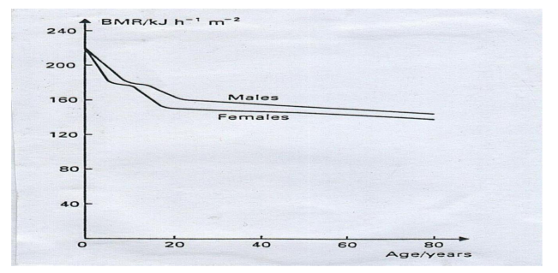
From the fig. above we can notes that:
- Children have high values of BMR because of the energy required for growing.
- Men have slightly higher values than women, because men have less body fat and therefore use more energy in maintaining body temperature.
Daily Energy Requirement :
We have to expend energy in order to maintain normal body temperature, both to keep warm when we are cold, and to keep cool when we are hot
The daily energy requirement of an individual depends on:
- BMR
- The ambient temperature.
- The amount of clothing worn.
- The surface area of the body.
- The amount of exercise undertaken.
*The daily energy requirement of an adult is usually in the range (1 – 1.6) MJ. The rates at which the average person consumes energy whilst performing various activities are shown in table.
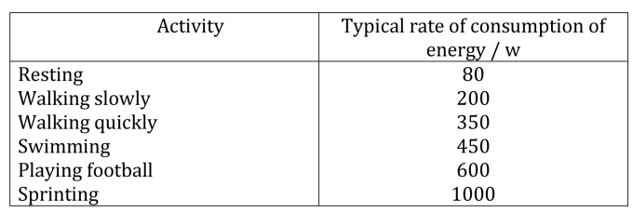

* The rate at which the body produces energy depends largely on tissue volume, whereas the rate at which energy is lost depends on body surface area.
The smaller the body, the greater the ratio of surface area to volume S/V. So babies are more at risk of hypothermia than adults. The small people need to eat more per kilogram of body mass than large people.
Work can be defined as transfer of energy. In physics we say that work is done on an object when you transfer energy to that object. If one objects transfers (gives) energy to a second object, then the first object does work on the second object.
Work is the application of a force over a distance.
The force is equal to the weight of the object, and the distance is equal to the height of the shelf (W= Fxd).
Work-Energy Principle: The change in the kinetic energy of an object is equal to the net work done on the object.
Energy can be defined as the ability for doing work. The simplest case of mechanical work is when an object is standing still and we force it to move. The energy of a moving object is called kinetic energy. For an object of mass m, moving with velocity of magnitude v, this energy can be calculated from the formula
E= 1/2 mv² .
Types of Energy Kinetic Energy = Energy of Motion = 1/2 mv2 Potential Energy = Stored Energy = mgh Forms of Energy Solar Radiation -- Infrared Heat, Radio Waves, Gamma Rays, Microwaves, Ultraviolet Light Atomic/Nuclear Energy: energy released in nuclear reactions. When a neutron splits an atom's nucleus into smaller pieces it is called fission. When two nuclei are joined together fewer than millions of degrees of heat it is called fusion. Electrical Energy: The generation or use of electric power over a period of time expressed in kilowatt-hours (kWh), megawatt-hours (MWh) or gig watt-hours (GWh). Chemical Energy: Chemical energy is a form of potential energy related to the breaking and forming of chemical bonds. It is stored in food, fuels and batteries, and is released as other forms of energy during chemical reactions. Mechanical Energy: Energy of the moving parts of a machine. Also refers to movements in humans. Heat Energy: a form of energy that is transferred by a difference in temperature.
What is Power?
Power is the work done in a unit of time. In other words, power is a measure of how quickly work can be done. The unit of power is the Watt = 1 Joule/ 1 second.
One common unit of energy is the kilowatt-hour (kWh). If we are using one kW of power, a kWh of energy will last one hour.
Calculating Work, Energy and Power
WORK = W= F X d
Because energy is the ability to do work, we measure energy and work in the same units (N m or joules).
POWER (P) is the rate of work done over time p = F×d / t.
Power's SI unit of measurement is the Watt, representing the generation or absorption of energy at the rate of 1 Joule/sec. Power's unit of measurement in the English system is the horsepower, which is equivalent to 735.7 Watts.
How does the energy work with muscles during any physical work or exercise?
Does body loses energy or gains energy by doing work and how?
The muscle actually uses chemical energy. How this works in detail is not physics but a biology question. The chemical reaction will create heat and cause your muscle to contract. Consequently, your body loses chemical energy, that's why you have to eat, drink and breathe, to keep these reactions going. In return your body loses.
heat energy to its environment, as well as kinetic energy, which will be the actual movement of your arm.
If you do exercises, long term speaking, your body will not gain or lose any energy; it will become more efficient and capable of converting chemical energy to kinetic energy, potential energy, etc.
Energy Conversion in Humans Our own bodies, like all living organisms, are energy conversion machines. Conservation of energy implies that the chemical energy stored in food is converted into work, thermal energy, and/or stored as chemical energy in fatty tissue. (See Figure.) The fraction going into each form depends both on how much we eat and on our level of physical activity. If we eat more than is needed to do work and stay warm, the remainder goes into body fat.
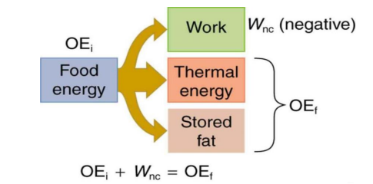
Energy consumed by humans is converted to work, thermal energy, and stored fat.
By far the largest fraction goes to thermal energy, although the fraction varies depending on the type of physical activity.
Metabolism:
The term used to describe – The interconversion of chemical compounds in the body – The pathways taken by individual molecules, – Their interrelationships, and the mechanisms that regulate the flow of metabolites through the pathways • It falls mainly in 2 categories: Anabolism and Catabolism.
• Anabolic pathways:
Involved in the synthesis of larger and more complex compounds from smaller precursors – Ex: Synthesis of protein from amino acids and the synthesis of reserves of tri-acylglycerol and glycogen. – Anabolic pathways are endothermic.

• Catabolic pathways :
Involved in the breakdown of larger molecules, commonly involving oxidative reactions; – They are exothermic, producing reducing equivalents, and, mainly via the respiratory chain.

الوحدة الخامسة عشر - المحاضرة الخامسة عشر - الزمن: 120 دقيقة

أهداف المحاضرة الخامسة عشر:

يتوقع في نهاية الجلسة أن يكون الطالب قادراً على معرفة اجزاء الجهاز العصبي داخل جسم الانسان ووظائف كل منها

موضوعات المحاضرة الخامسة عشر:

Electrical activity

الأساليب والأنشطة والوسائل التعليمية

م | الأساليب والأنشطة التدريبية | الوسائل التدريبية
1 | - نشاط التعارف (1/1/1)  - محاضرة  - مناقشة  - سؤال وجواب | - جهاز حاسوب  - جهاز عرض  - سبورة  - اوراق واقلام

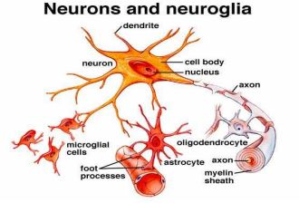

The nervous system can be divided into two parts:
- The central nervous system :-
It consists of the brain, the spinal cord, the nervous cells (neurons) which have a long extensions known as nerve fibers (axons) are propagated the nerve impulses a long it at speed of about to 100 ms-1. The neurons can be divided into parts:-
- Afferent nerves :-
The nerve fibers that transmit sensory information to the brain or spinal cord.
- Efferent nerves :-
The nerve fibers that transmit information from the brain or spinal cord to the appropriate muscles and glands.
- The autonomic nervous system :-
It controls various internal organs such as the heart, intestines, and glands. The control of the autonomic nervous system is essentially involuntary

Nerve Impulses: Action Potential
An axon consist of a central core, the fluid inside it (axoplasm) contains a large negatively charged, organic ions (most of which are proteins) and a high concentration of (k +) ions.

The central core is surrounding by a membrane through which a small ions can pass under certain circumstance. The fluid immediately outside the core (body tissue fluid) has a high concentration of (Na +) ions.

*When the nerve cell is not stimulated the membrane is said to be (polarized), and there is a potential difference (PD) a cross it of about 70 mv. The outside of the membrane having a potential of about zero and the potential inside which called ( membrane potential ) is -70 mv .
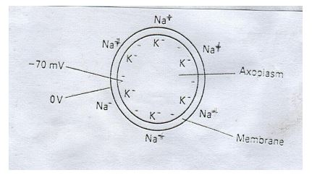

Ionic imbalance is the result of equilibrium between two processes
- Sodium – potassium pump:-
The pump moves (Na +) ions out of axon and (k+) ions into it.

- Diffusion:-
The diffusion return some of the (k +) ions to the outside (where their concentration is low), but is unable to return (Na +) ions to the inside. Why?
Because the membrane is relatively impermeable to the large Na + ions.
*When the nerve cell is stimulated, there are three operations need to be occurring:
1- Depolarization The membrane suddenly becomes permeable to (Na +) ions and they are able to move into the axon as a result of Both diffusion and the influence of the negative charge inside it. This increases the positive charge inside the axon and so increases the membrane potential to zero.
2-Reverse Polarization:-
The membrane potential increases to + 30 mv, then the membrane immediately becomes impermeable to (Na +) ions and so traps them inside the axon.
3-Repolarization:-
The (k +) ions continue to diffuse out and quickly restore the positive potential outside the membrane
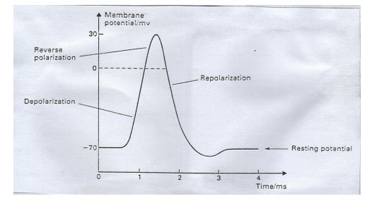
This sequence of events, which takes only about 2 ms, is known as an (action potential) .
When part of the membrane becomes depolarized it triggers the still polarized part next to it to go through the same sequence of events as itself (through the some action potential). This then triggers the next region, and so on so that nerve impulse propagates along the fiber.

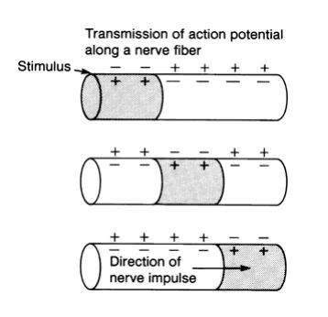
2-The Heart
The heart is a double pump consisting of four chambers the right and left (atria), and the right and left (ventricles). The right – hand chambers take oxygen – depleted blood and pass it to the lungs, the left – hand chambers take oxygen – rich blood from the lungs and pass it to the body. The heart like any muscle contracts when subjected to an electrical stimulus. 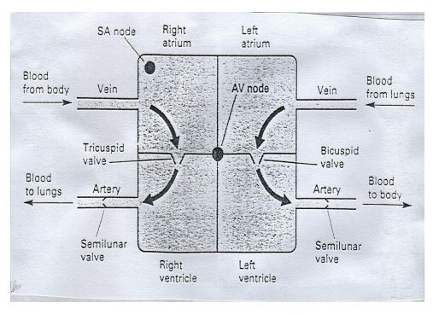

الوحدة السادسة عشر - المحاضرة السادسة عشر - الزمن: 120 دقيقة

أهداف المحاضرة السادسة عشر:

يتوقع في نهاية الجلسة أن يكون الطالب قادراً على معرفة اجزاء الجهاز العصبي داخل جسم الانسان ووظائف كل منها

موضوعات المحاضرة السادسة عشر:

Diffusion

الأساليب والأنشطة والوسائل التعليمية

م | الأساليب والأنشطة التدريبية | الوسائل التدريبية
1 | - نشاط التعارف (1/1/1)  - محاضرة  - مناقشة  - سؤال وجواب | - جهاز حاسوب  - جهاز عرض  - سبورة  - اوراق واقلام

- Diffusion:-
The diffusion return some of the (k +) ions to the outside (where their concentration is low), but is unable to return (Na +) ions to the inside. Why?
Because the membrane is relatively impermeable to the large Na + ions.
*When the nerve cell is stimulated, there are three operations need to be occurring:
1- Depolarization The membrane suddenly becomes permeable to (Na +) ions and they are able to move into the axon as a result of Both diffusion and the influence of the negative charge inside it. This increases the positive charge inside the axon and so increases the membrane potential to zero.
2-Reverse Polarization:-
The membrane potential increases to + 30 mv, then the membrane immediately becomes impermeable to (Na +) ions and so traps them inside the axon.
3-Repolarization:-
The (k +) ions continue to diffuse out and quickly restore the positive potential outside the membrane
This sequence of events, which takes only about 2 ms, is known as an (action potential) .
When part of the membrane becomes depolarized it triggers the still polarized part next to it to go through the same sequence of events as itself (through the some action potential). This then triggers the next region, and so on so that nerve impulse propagates along the fiber.

2-The Heart
The heart is a double pump consisting of four chambers the right and left (atria), and the right and left (ventricles). The right – hand chambers take oxygen – depleted blood and pass it to the lungs, the left – hand chambers take oxygen – rich blood from the lungs and pass it to the body. The heart

الوحدة السابعة عشر - المحاضرة السابعة عشر - الزمن: 120 دقيقة

أهداف المحاضرة السابعة عشر:

يتوقع في نهاية الجلسة أن يكون الطالب قادراً على معرفة ما هو الصوت والموجات الصوتية وطريقة انتقالة و وضائف الاذن البشرية

موضوعات المحاضرة السابعة عشر:

Sound

الأساليب والأنشطة والوسائل التعليمية

م | الأساليب والأنشطة التدريبية | الوسائل التدريبية
1 | - نشاط التعارف (1/1/1)  - محاضرة  - مناقشة  - سؤال وجواب | - جهاز حاسوب  - جهاز عرض  - سبورة  - اوراق واقلام

In physics, sound is a vibration that propagates as an acoustic wae, through a transmission medium such as a gas, liquid or solid, Sound is a wave.
A wave is some disturbance caused when energy is traveling from one object to another.
When sound travels, it moves the air around it, creating high and low pressure points, or waves.
Your ears can detect the waves, and you perceive this as sound.
Sound is a longitudinal mechanical wave that travels through an elastic medium.
Sound is a physical disturbance in an elastic medium. No sound exists without air molecules. In human physiology and psychology, sound is the reception of such waves and their perception by the brain.
Only acoustic waves that have frequencies between about 20 Hz and 20 kHz, the audio frequency range, elicit an auditory percept in humans. Sound waves above 20 kHz are known as ultrasound and are not audible to humans. Sound waves below 20 Hz are known as infrasound. Different animal species have varying hearing ranges.

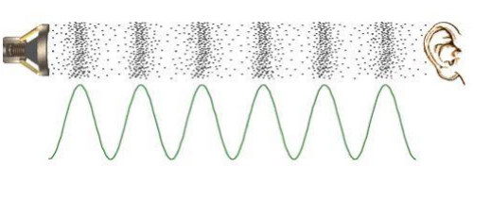

* The speed of sound in gas does not depend on the pressure, because both K& ρ are directly proportional to pressure. And also confirmed by experiment.
* For moderate pressure C α T 1/2 , where T is the Kelvin temperature of the gas.
*The speed(C), frequency (f), wavelength (ʎ)
C = f ʎ
Frequency response: The range of frequencies which the human ear can detect varies considerably from one individual to another.
The lower limit is typically around 20Hz; the upper limit decrease with age is about 20 kHz for young adult. The threshold of hearing depends very much on the frequency at which it measured, and has its minimum value about 3 kHz.
Threshold of feeling: The level at which the sensation changes from that of hearing to one of discomfort, it's close to 120dB at all frequencies.
Decibel: The intensity level of the threshold of hearing is 0dB at 1 kHz.
Frequency discrimination: The ears ability to distinguish different frequencies and is most acute at low frequencies.
Between 60Hz – 1 kHz frequencies close to 3Hz can be distinguished.
The ability decrease with increasing frequency and non-existent above 10 kHz.
Sensitivity: The ability of ear to detect small changes in intensity. It is strongly depending on frequency.

The structure and function of the ear:
The ear is divided into three main parts, the outer, middle, inner ears, by three thin membranes called tympanic membrane or ear-drum, between outer-middle and middleinner. The inner ear contains transducers that convert the mechanical vibrations transmitted to it from the Outer and middle ears into electrical impulses which then pass to the brain for interpretation.
The outer Ear:
The visible part of the ear pinna funnels sound through the auditory canal to the ear-drum. The canal is about 2.5Cm long and about 7mm in diameter. It is closed at one end by a thin ear-drum 0.1mm, membrane with an area of about 65mm, which vibrates with small 10 -11m amplitude when sound wave enter the ear. The auditory canal acts like a tiny organ pipe with a resonant frequency of about 3 kHz (the frequency at which the ear has its maximum response).
Q/ Who to reduce the likelihood of inner ear damage?
Tiny muscles attached to the hammer and stapes allows them to move in such a way as to reduce the amplitudes of oscillation of the ear-drum and the oval window.
Sudden change in pressure such as experiences in aero planes and lift impair hearing cause pain and rupture the ear-drum.
Q/ Who to prevent the pain and ear-drum rupture?
By narrow passage called the Eustachian tube connects the middle ear to the atmosphere by way of the throat. Its function is to equalize the ear pressures on the two sides of the eardrum. The tube is closed but it open during swallowing, yawning and chewing, so allows air to leave the middle ear as necessary.

The Inner Ear:
This contains the semicircular canals (which concerned with balance and plays no part in the hearing process) and a sensitive, liquid-filled organ called the cochlea which connected to the brain by auditory nerve. When the oval window vibrates, a pressure wave propagates through the fluids in the cochlea, stimulating nerve cells and creating the sensation of hearing. Different parts of the cochlea are responsive to different frequencies, and therefore the neurons activated by any particular frequency are specific to the frequency. This allows the brain to distinguish one frequency from another.
Note: The high frequency receptors are close to oval window, while the low frequency receptors are deep inside the cochlea.
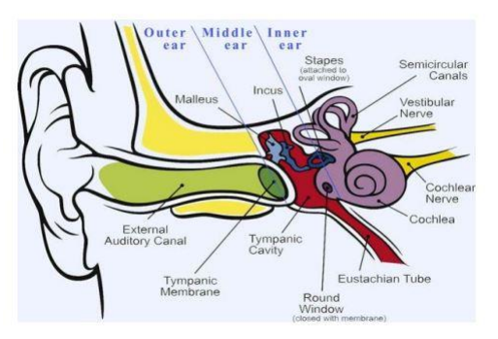
Eudiometry: A devices use to determined hearing threshold levels. By supplying pure-frequency which generated electronically to headphones worn by the patient.
The controls allow the operator to alter both the frequency and the intensity level. In a standard eudiometric examination, the patient is tested at 8 frequencies from 250Hz to 8 kHz. The audiometer is calibrated in such a way that a person with normal hearing would register 0dB at each of the frequencies tested. The volume is gradually increased and the intensity level (dB) at which the patient can just hear the sound is determined at each frequency in turn.
Age-related hearing loss: The loss in sensitivity across the whole spectrum but which is most marked at the higher frequency.
Noise-induced hearing loss: The marked dip in sensitivity around 4kHz, regardless of the frequencies of the sound to which the sufferer has been exposed.

الوحدة الثامنة عشر- المحاضرة الثامنة عشر - الزمن: 120 دقيقة

أهداف المحاضرة الثامنة عشر:

يتوقع في نهاية الجلسة أن يكون الطالب قادراً على معرفة ما هو الضوء وماهي الموجات الضوئية وتطبيقات الاشعة فوق البنفسجية والاشعة تحت الحمراء في الطب

موضوعات المحاضرة الثامنة عشر:
Light

الأساليب والأنشطة والوسائل التعليمية

م | الأساليب والأنشطة التدريبية | الوسائل التدريبية
1 | - نشاط التعارف (1/1/1)  - محاضرة  - مناقشة  - سؤال وجواب | - جهاز حاسوب  - جهاز عرض  - سبورة  - اوراق واقلام

Max Planck suggested that light could behave both as a wave and as particle. He drives an equation to explain the relationship between light energy and the frequency.
E = hf
Where
E = photon energy , f = frequency of light
H = Planck's constant
f = c /λ
Where
f= frequency , c = light velocity , λ = the wave length
E = hc /λ
So light with long wavelength range has a small energy , while light with short wave length range has a higher energy .
There are three operations occurs when light strikes any surface: Reflection ( R ), Refraction ( r), Absorption ( A )
R + r + A = 1 = 100%
Even though man is now very efficient at making artificial light, the sun is still the major source of light in the world. The sun is both beneficial and hazardous to our health.
Light has some interesting properties, many of which are used in medicine:
- The speed of light changes when it goes from material into another. The ratio of the speed of light in a vacuum to its speed in a given material is called the index of refraction. If a light beam meets a new material at an angle other than perpendicular, it bends, or is refracted.
- Light behaves both as a wave and as a particle. As a wave it produces interference and diffraction. As a particle it can be absorbed by a single molecule. When a light photon is absorbed its energy is used in various ways. It can cause a chemical change in the molecule that in turn can cause an electrical change. This is basically what happens when a light photon-is, absorbed in one of the sensitive cells of the retina. The chemical change in a particular point of the retina triggers an electrical signal to the brain to inform it that a light photon has been absorbed at that point.
- When light is absorbed, its energy generally appears as heat. This property is the basic for the use in medicine of lR light to heat tissues. Also, the heat produced by laser beams is used to "weld" a detached retina to the back of the eyeball and to coagulate small blood vessels in the retina.
- Sometimes when photon is absorbed, a lower energy light photon is emitted. This property is known as fluorescence, it is the basis of the fluorescent light bulb. The amount of fluorescence and the color of the emitted light depend on the chemical composition of the material that is fluorescing. Fluorescence is used in fluorescent microscopes as very important medical application.
- Light is reflected to some extent from all surfaces. There are two types of reflection. Diffuse reflection occurs when rough surfaces scatter the light in many directions. Specular reflection is more useful types of reflection; it is obtained from very smooth shiny surfaces such as mirrors where the light is reflected at an angle that is equal to the angle at which it strikes the surface. Mirrors are used in many medical instruments.
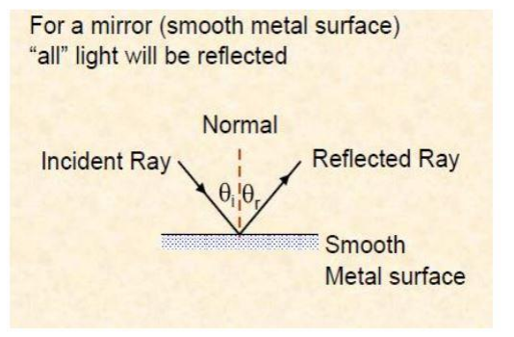
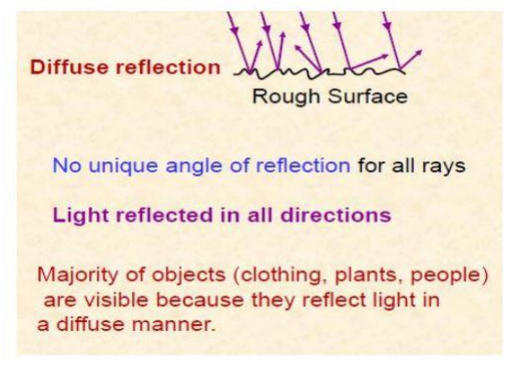

Visible light has an important therapeutic use. Since light is a form of energy and is selectively absorbed in certain molecules, it should not be surprising that it can cause important physiological effects. Many premature infants have jaundice, a condition in which an excess of bilirubin is excreted by the liver into the blood. Relatively recently (1958) it was discovered that most premature infants recover from jaundice if their bodies are exposed to visible light (phototherapy).
Applications of ultraviolet and infrared rays in medicine
The wavelengths adjacent to the visible spectrum also have important uses in medicine. Ultraviolet photons have energies greater than visible photons, while IR photons have lower energies, because of their higher energies, UV photons are more useful than IR photons.
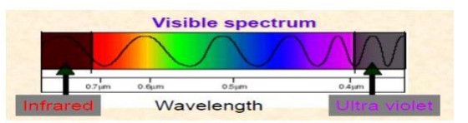
Ultraviolet light with wavelengths below about 290 nm is germicidal-that is, it can kill germs-and it is sometimes used to sterilize medical instruments. Ultraviolet light also produces more reactions in the skin than visible light. Some of these reactions are beneficial, and some are harmful. One of the major beneficial effects of UV light from the sun is the conversion of molecular products in the skin into vitamin D.
Ultraviolet light from the sun affects the melanin in the skin to cause tanning. However, UV can produce sunburn as well as tan the skin. The wavelengths that produce sunburn are around 300 nm. The amount of 300 nm light in the sun's spectrum depends on the amount of field that the sunlight must pass through. Ordinary window glass permits some near UV to be transmitted but absorbs the sunburn component.
Solar UV light is also the major cause of skin cancer in humans. The high incidence of skin cancer among people, who have been exposed to the sun a great deal, such as fishermen and agricultural workers, may be related to the fact that the UV wavelengths that produce sunburn are also very well absorbed by the DNA in the cells. Skin cancer usually appears on those portions of the body that have received the most sunlight, such as the tip of the nose, the tops of the ears, and the back of the neck.
About half of the energy from the sun is in the IR region. The warmth we feel from the sun is mainly due to the IR component. Heat lamps that produce a large percentage of IR light with wavelengths of 1000 to 2000 nm are often used for physical therapy purposes. Infrared light penetrates further into the tissues than visible light and thus is better able to heat deep tissues.

الوحدة التاسعة عشر - المحاضرة التاسعة عشر - الزمن: 120 دقيقة

أهداف المحاضرة التاسعة عشر:

يتوقع في نهاية الجلسة أن يكون الطالب قادراً على معرفة اجزاء العين وطريقة تشكيلها للصور والرؤية

موضوعات المحاضرة التاسعة عشر:
The eye, and the vision

الأساليب والأنشطة والوسائل التعليمية

م | الأساليب والأنشطة التدريبية | الوسائل التدريبية
1 | - نشاط التعارف (1/1/1)  - محاضرة  - مناقشة  - سؤال وجواب | - جهاز حاسوب  - جهاز عرض  - سبورة  - اوراق واقلام

Light or visible light is electromagnetic radiation within the portion of the electromagnetic spectrum that can be seen by the human eye.
Visible light is usually defined as having wavelengths in the range of 400– 700 nm, or 4.00 × to 7.00 × m, between the infrared (with longer wavelengths) and the ultraviolet (with shorter wavelengths). This wavelength means a frequency range of roughly 430–750 terahertz (THz).
The main source of light on Earth is the Sun. Sunlight provides the energy that green plants use to create sugars mostly in the form of starches, which release energy into the living things that digest them. This process of photosynthesis provides virtually all the energy used by living things.
The primary properties of visible light are intensity, propagation-direction, frequency or wavelength spectrum and polarization, while its speed in a vacuum, 299 792 458 m/s, is one of the fundamental constants of nature.
In physics, the term 'light' sometimes refers to electromagnetic radiation of any wavelength, whether visible or not.
In this sense, gamma rays, X-rays, microwaves and radio waves are also light.
Like all types of EM radiation, visible light propagates as waves.
However, the energy imparted by the waves is absorbed at single locations the way particles are absorbed.
The absorbed energy of the EM waves is called a photon and represents the quanta of light.
When a wave of light is transformed and absorbed as a photon, the energy of the wave instantly collapses to a single location and this location is where the photon "arrives."

THE EYE
The eye is perhaps the most interesting of all optical instruments.
The eye is remarkable in how it forms images and in the richness of detail and color it can detect.
However, our eyes commonly need some correction, to reach what is called ―normal‖ vision, but should be called ideal rather than normal.
Image formation by our eyes and common vision correction are easy to analyze with the optics.
Figure 1 shows the basic anatomy of the eye. The cornea and lens form a system that, to a good approximation, acts as a single thin lens. For clear vision, a real image must be projected onto the light-sensitive retina, which lies at a fixed distance from the lens. The lens of the eye adjusts its power to produce an image on the retina for objects at different distances. The center of the image falls on the fovea, which has the greatest density of light receptors and the greatest acuity in the visual field. The variable opening of the eye along with chemical adaptation allows the eye to detect light intensities from the lowest observable to 10¹⁰ times greater (without damage), Our eyes perform a vast number of functions, such as sense direction, movement, sophisticated colors, and distance. Processing of visual nerve impulses begins with interconnections in the retina and continues in the brain. The optic nerve conveys signals received by the eye to the brain.
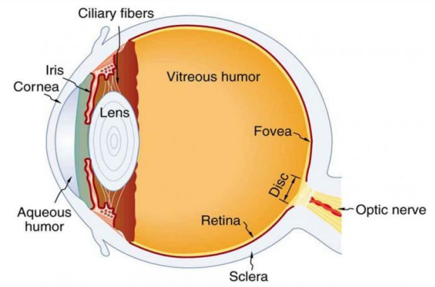
Figure 1. The cornea and lens of an eye act together to form a real image on the light-sensing retina, which has its densest concentration of receptors in the fovea and a blind spot over the optic nerve. The power of the lens of an eye is adjustable to provide an image on the retina for varying object distances. Layers of tissues with varying indices of refraction in the lens are shown here.
As noted, the image must fall precisely on the retina to produce clear vision—that is, the image distance di must equal the lens-to-retina distance. Because the lens-to-retina distance does not change, the image distance di must be the same for objects at all distances. The eye manages this by varying the power (and focal length) of the lens to accommodate for objects at various distances. The process of adjusting the eye’s focal length is called accommodation. A person with normal vision can see objects clearly at distances ranging from 25 cm to essentially infinity. However, although the near point (the shortest distance at which a sharp focus can be obtained) increases with age (becoming meters for some older people), we will consider it to be 25 cm in our treatment here.
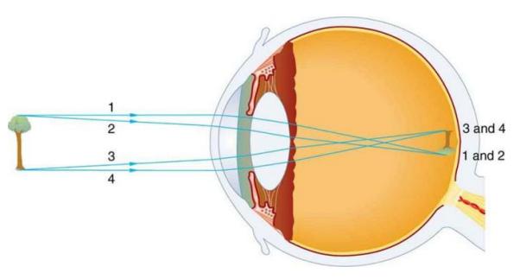
Figure 2. An image is formed on the retina with light rays converging most at the cornea and upon entering and exiting the lens. Rays from the top and bottom of the object are traced and produce an inverted real image on the retina. The distance to the object is drawn smaller than scale.
Figure 3 shows the accommodation of the eye for distant and near vision. Since light rays from a nearby object can diverge and still enter the eye, the lens must be more converging (more powerful) for close vision than for distant vision. To be more converging, the lens is made thicker by the action of the ciliary muscle surrounding it. The eye is most relaxed when viewing distant objects, one reason that microscopes and telescopes are designed to produce distant images. Vision of very distant objects is called totally relaxed, while close vision is termed accommodated, with the closest vision being fully accommodated.
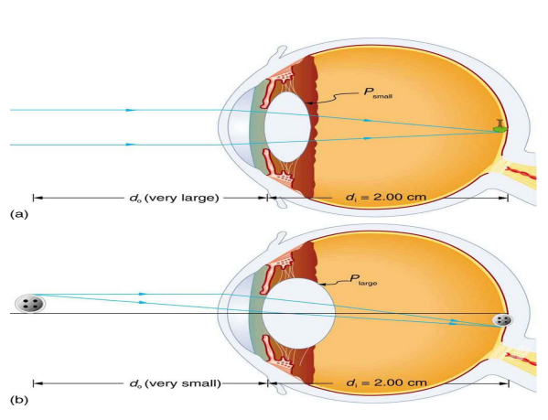
Figure 3. Relaxed and accommodated vision for distant and close objects. (a) Light rays from the same point on a distant object must be nearly parallel while entering the eye and more easily converge to produce an image on the retina. (b) Light rays from a nearby object can diverge more and still enter the eye. A more powerful lens is needed to converge them on the retina than if they were parallel.

الوحدة العشرون - المحاضرة العشرون - الزمن: 120 دقيقة

أهداف المحاضرة العشرون:

يتوقع في نهاية الجلسة أن يكون الطالب قادراً على معرفة اجزاء العين وطريقة تشكيلها للصور والرؤية

موضوعات المحاضرة العشرون:
The vision

الأساليب والأنشطة والوسائل التعليمية

م | الأساليب والأنشطة التدريبية | الوسائل التدريبية
1 | - نشاط التعارف (1/1/1)  - محاضرة  - مناقشة  - سؤال وجواب | - جهاز حاسوب  - جهاز عرض  - سبورة  - اوراق واقلام

The cornea and lens form a system that, to a good approximation, acts as a single thin lens. For clear vision, a real image must be projected onto the light-sensitive retina, which lies at a fixed distance from the lens. The lens of the eye adjusts its power to produce an image on the retina for objects at different distances. The center of the image falls on the fovea, which has the greatest density of light receptors and the greatest acuity in the visual field. The variable opening of the eye along with chemical adaptation allows the eye to detect light intensities from the lowest observable to 10¹⁰ times greater (without damage), Our eyes perform a vast number of functions, such as sense direction, movement, sophisticated colors, and distance. Processing of visual nerve impulses begins with interconnections in the retina and continues in the brain. The optic nerve conveys signals received by the eye to the brain.
Figure 1. The cornea and lens of an eye act together to form a real image on the light-sensing retina, which has its densest concentration of receptors in the fovea and a blind spot over the optic nerve. The power of the lens of an eye is adjustable to provide an image on the retina for varying object distances. Layers of tissues with varying indices of refraction in the lens are shown here.
As noted, the image must fall precisely on the retina to produce clear vision—that is, the image distance di must equal the lens-to-retina distance. Because the lens-to-retina distance does not change, the image distance di must be the same for objects at all distances. The eye manages this by varying the power (and focal length) of the lens to accommodate for objects at various distances. The process of adjusting the eye’s focal length is called accommodation. A person with normal vision can see objects clearly at distances ranging from 25 cm to essentially infinity. However, although the near point (the shortest distance at which a sharp focus can be obtained) increases with age (becoming meters for some older people), we will consider it to be 25 cm in our treatment here.
Figure 2. An image is formed on the retina with light rays converging most at the cornea and upon entering and exiting the lens. Rays from the top and bottom of the object are traced and produce an inverted real image on the retina. The distance to the object is drawn smaller than scale.
Figure 3 shows the accommodation of the eye for distant and near vision. Since light rays from a nearby object can diverge and still enter the eye, the lens must be more converging (more powerful) for close vision than for distant vision. To be more converging, the lens is made thicker by the action of the ciliary muscle surrounding it. The eye is most relaxed when viewing distant objects, one reason that microscopes and telescopes are designed to produce distant images. Vision of very distant objects is called totally relaxed, while close vision is termed accommodated, with the closest vision being fully accommodated.
Figure 3. Relaxed and accommodated vision for distant and close objects. (a) Light rays from the same point on a distant object must be nearly parallel while entering the eye and more easily converge to produce an image on the retina. (b) Light rays from a nearby object can diverge more and still enter the eye. A more powerful lens is needed to converge them on the retina than if they were parallel.

الوحدة الحادية والعشرون - المحاضرة الحادية والعشرون - الزمن: 120 دقيقة

أهداف المحاضرة الحادية والعشرون:

يتوقع في نهاية الجلسة أن يكون الطالب قادراً على معرفة ماهي الاشعة السينية والية انتاجها والتطبيقات العلاجية للأشعة السينية

موضوعات المحاضرة الحادية والعشرون:

X-Ray

الأساليب والأنشطة والوسائل التعليمية

م | الأساليب والأنشطة التدريبية | الوسائل التدريبية
1 | - نشاط التعارف (1/1/1)  - محاضرة  - مناقشة  - سؤال وجواب | - جهاز حاسوب  - جهاز عرض  - سبورة  - اوراق واقلام

Electromagnetic Radiation
- Electromagnetic radiation can be described in terms of a stream of photons, each traveling in a wave-like pattern at the speed of light. Each photon contains a certain amount of energy.
- The different types of radiation are defined by the amount of energy found in the photons. Radio waves have photons with low energies while gamma-rays the most energetic of all.
- Electromagnetic radiation can be expressed in terms of energy, wavelength, or frequency.
General Properties of all electromagnetic radiation
- Electromagnetic radiation can travel through empty space.
- They travel at speed of light (Speed of light : 2.99792458 x 10⁸ m s⁻¹ )
- Consist of photons which are uncharged and nearly massless.
- They all have wavelike characteristics
- λ = c/F where λ= wavelength, c=velocity of electromagnetic wave(3x108m/sec), and F= Frequency
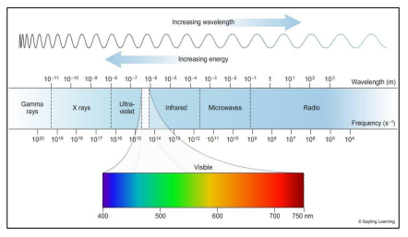
X - Ray: - It is an electromagnetic radiation with wavelength range (0.01 – 10 nm)

Fundamental units (Review)
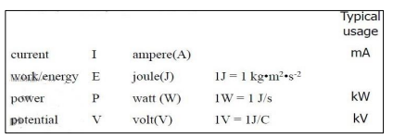
- Electron Volt (eV) : e- accelerated through 1 V attains an energy of 1eV. Used to describe energy of a single electron or photon or population of monoenergetic particles
X-rays
- X-rays are one of the main diagnostic tools in medicine since its discovery by Wilhelm Roentgen in 1895.
- Nowadays, X-rays with very high energy (around 10 MeV) is used for therapeutic applications
- X-rays are produced when high energetic electrons interact with matter.
- The kinetic energy of the electrons is converted into electromagnetic energy by atomic interactions
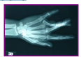

X-ray production
- Two types of electron interactions are responsible for x-rays production.
- Bremsstrahlung mechanism
- Characteristic mechanism

Bremsstrahlung “braking radiation”
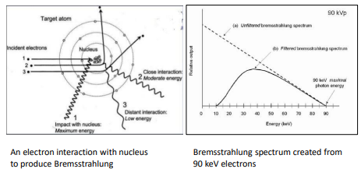

Bremsstrahlung “braking radiation”
- Incoming electron is both energetic (high kinetic energy) and charged (negative)
- This electron comes within the proximity of a positively charged nucleus in the target.
- Columbic forces attract and decelerate the electron, causing a significant loss of kinetic energy and a change in the electron's trajectory.
- An x-ray photon with energy equal to the kinetic energy lost by the electron is produced (conservation of energy). This radiation is termed Bremsstrahlung “braking radiation”
Bremsstrahlung “braking radiation”
- The X-ray energy depends on the interaction distance between the electron and the nucleus.
- A direct collision of an electron with the target nucleus results in loss of all of the electron’s kinetic energy the highest x-ray energy is produced ( very low probability)

Characteristic Radiation
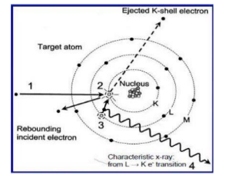
Characteristic Radiation
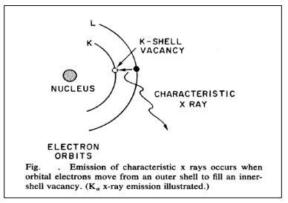
Characteristic Radiation
- Energetic electrons can also interact with other electrons occupying orbital shells, which results in X-ray photons (Characteristic Radiation)
- Generation of a Characteristic X-ray in a target atom occurs in the following sequence:
- The incident electron interacts with the K-shell electron via a repulsive electrical force
- The K-shell electron is removed (only if the energy of the incident electron is greater than the K-shell binding energy), leaving a vacancy in the K-shell.
- An electron from L- shell (or from a different shell) fills the vacancy.
- A characteristic X-ray photon is emitted with an energy equal to the difference between the binding energies of the two shells.
Characteristic Radiation
- Resultant X-ray energy is dependent on the difference in energy levels between electron orbits
- For a given target material (i.e. tungsten), the orbital energy levels are constant.
- Therefore, the emitted X-rays have discrete energies that are characteristic of the element (i.e. the characteristic x-ray photons can identify the target material
Characteristic Radiation
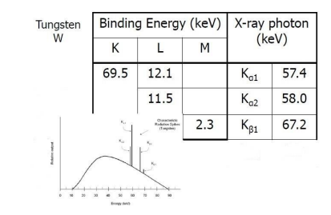

Typical x-ray Spectrum
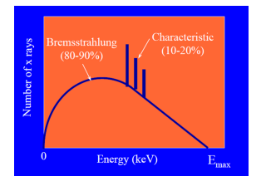
X-Ray production
- Not all of the lost kinetic energy is converted to photon energy
- Vast majority of energy is converted to thermal energy (heat)
- <1% of kinetic energy is converted to photons
- Conversion is more efficient at higher energy
- levels (i.e. therapy)
X-Ray Tube
- The X-ray tube provides an environment for Xray production via Bremsstrahlung and characteristic radiation mechanisms.
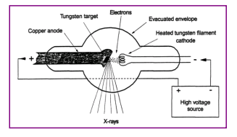

X-Ray Tube
- Major Components of an X-Ray Tube are
- Cathode (Electron Source)
- Anode (target for X-ray production)
- Glass or metal envelope
- Tube Housing
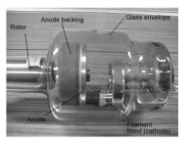
X-Ray Tube
- Cathode
- The source of electrons in the X-ray tube is the cathode, which is filament of tungsten wire
- The cathode is the negative pole of the tube potential
- Electrons are accelerated from the negative cathode to the positive anode (target)
- Anode (Target)
- What are the two primary considerations when considering target material?
- Characteristic X-ray energy
- Thermal properties of the target
- Remember, 99% of the imparted energy is dissipated as heat
- Tungsten has excellent thermal properties (high melting point, thermal dissipation)
- Tungsten has a high atomic number (74) producing useful characteristic x-rays
- Tube Envelope
- Maintains vacuum in electron pathway. The high vacuum prevents electrons from colliding with gas molecules.
- Typically made of glass, sometimes metal
- Specialized tube port is provided through which the useful x-rays emerge
- Tube Housing
- Supports, insulates, and protects tube envelope
- Tube enveloped is contained within a oil bath to assist in dissipating heat
- Micro-switches in the housing will shut down the unit in event of excessive heat
- Lead shielding attenuates x-ray photons not exiting through the port
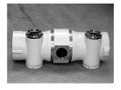
Filtration
- Large abundance of low energy x-rays will increase patient dose while not contributing to image quality.
- These lower energies are therefore filtered out by aluminum or copper absorbers of various thickness.
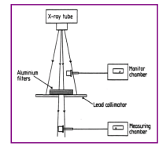
Attenuation of X-rays
- The intensity of X-Ray drops exponentially with the thickness x
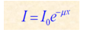
I = intensity of the transmitted beam
I0= intensity of incident beam
x = thickness of attenuator
μ = linear attenuation coefficient
- The linear attenuation coefficient is determined in terms of the Half-Value Layer (HVL)
- (HVL) is the thickness of a material necessary to reduce the intensity of radiation to 50% of its original value.
μ = ln(2) / HVL
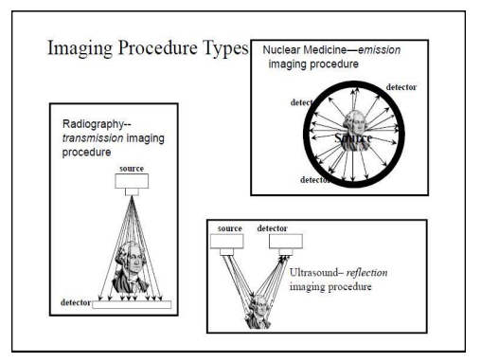
Radiography Imaging
- The radiographic image of the X-ray exposure is determined by the interaction of the X-rays, which are transmitted through the patient, with a photon detector (film, camera etc.) .
- As an x-ray beam passes through an object (patient), three possible fates await each photon.
- It can interact with the matter and be completely absorbed by depositing its energy.
- It can penetrate the section of matter without interacting. It is called primary X-ray photon (it carry useful information).
- It can interact and be scattered or deflected from its original direction and deposit part of its energy. It is called secondary photon. They create background noise which degrades the contrast of the image. Scattered photons are often absorbed in grids between the patient and the image receptor.

Radiography Imaging
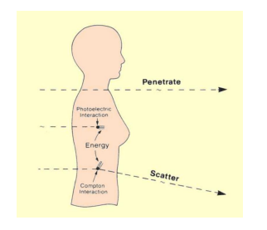
Radiography Imaging
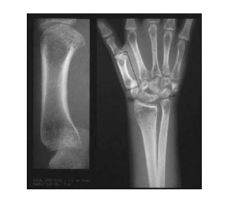
Radiation Protection
There are three principle methods by which radiation exposures to persons can be minimized.
This system is called AS Low As Reasonably Achievable (ALARA)
- Time (Should be reduced)
- Distance ( Should be increased), Apply inverse square law in which doubling the distance will reduce the radiation exposure by (1/2)*2
- Shielding: Shielding is used to reduce exposure to patients, staff, and the public
Homework
- X-rays used in a dental clinic typically have a wavelength of 0.03 nm. What is the frequency of these rays?
- The HVL for Pb for a particular energy x-ray is 0.1mm. By how much will an x-ray beam be reduced, if a lead sheet 1.5mm thick is placed in its path?
Homework
- X-rays used in a dental clinic typically have a wavelength of 0.03 nm. What is the frequency of these rays?
- 2- The HVL for Pb for a particular energy x-ray is 0.1mm. By how much will an x-ray beam be reduced, if a lead sheet 1.5mm thick is placed in its path?

الوحدة الثانية والعشرون - المحاضرة الثانية و العشرون - الزمن: 120 دقيقة

أهداف المحاضرة الثانية والعشرون:

يتوقع في نهاية الجلسة أن يكون الطالب قادراً على معرفة ماهي الاشعة السينية والية انتاجها والتطبيقات العلاجية للأشعة السينية

موضوعات المحاضرة الثانية والعشرون:

X-Ray Spectrum

الأساليب والأنشطة والوسائل التعليمية

م | الأساليب والأنشطة التدريبية | الوسائل التدريبية
1 | - نشاط التعارف (1/1/1)  - محاضرة  - مناقشة  - سؤال وجواب | - جهاز حاسوب  - جهاز عرض  - سبورة  - اوراق واقلام

Typical x-ray Spectrum
X-Ray production
- Not all of the lost kinetic energy is converted to photon energy
- Vast majority of energy is converted to thermal energy (heat)
- <1% of kinetic energy is converted to photons
- Conversion is more efficient at higher energy
- levels (i.e. therapy)
X-Ray Tube
- The X-ray tube provides an environment for Xray production via Bremsstrahlung and characteristic radiation mechanisms.

X-Ray Tube
- Major Components of an X-Ray Tube are
- Cathode (Electron Source)
- Anode (target for X-ray production)
- Glass or metal envelope
- Tube Housing
X-Ray Tube
- Cathode
- The source of electrons in the X-ray tube is the cathode, which is filament of tungsten wire
- The cathode is the negative pole of the tube potential
- Electrons are accelerated from the negative cathode to the positive anode (target)
- Anode (Target)
- What are the two primary considerations when considering target material?
- Characteristic X-ray energy
- Thermal properties of the target
- Remember, 99% of the imparted energy is dissipated as heat
- Tungsten has excellent thermal properties (high melting point, thermal dissipation)
- Tungsten has a high atomic number (74) producing useful characteristic x-rays
- Tube Envelope
- Maintains vacuum in electron pathway. The high vacuum prevents electrons from colliding with gas molecules.
- Typically made of glass, sometimes metal
- Specialized tube port is provided through which the useful x-rays emerge
- Tube Housing
- Supports, insulates, and protects tube envelope
- Tube enveloped is contained within a oil bath to assist in dissipating heat
- Micro-switches in the housing will shut down the unit in event of excessive heat
- Lead shielding attenuates x-ray photons not exiting through the port
Filtration
- Large abundance of low energy x-rays will increase patient dose while not contributing to image quality.
- These lower energies are therefore filtered out by aluminum or copper absorbers of various thickness.
Attenuation of X-rays
- The intensity of X-Ray drops exponentially with the thickness x
I = intensity of the transmitted beam
I0= intensity of incident beam
x = thickness of attenuator
μ = linear attenuation coefficient
- The linear attenuation coefficient is determined in terms of the Half-Value Layer (HVL)
- (HVL) is the thickness of a material necessary to reduce the intensity of radiation to 50% of its original value.
μ = ln(2) / HVL
Radiography Imaging
- The radiographic image of the X-ray exposure is determined by the interaction of the X-rays, which are transmitted through the patient, with a photon detector (film, camera etc.) .
- As an x-ray beam passes through an object (patient), three possible fates await each photon.
- It can interact with the matter and be completely absorbed by depositing its energy.
- It can penetrate the section of matter without interacting. It is called primary X-ray photon (it carry useful information).
- It can interact and be scattered or deflected from its original direction and deposit part of its energy. It is called secondary photon. They create background noise which degrades the contrast of the image. Scattered photons are often absorbed in grids between the patient and the image receptor.

Radiography Imaging
Radiography Imaging
Radiation Protection
There are three principle methods by which radiation exposures to persons can be minimized.
This system is called AS Low As Reasonably Achievable (ALARA)
- Time (Should be reduced)
- Distance ( Should be increased), Apply inverse square law in which doubling the distance will reduce the radiation exposure by (1/2)*2
- Shielding: Shielding is used to reduce exposure to patients, staff, and the public
Homework
- X-rays used in a dental clinic typically have a wavelength of 0.03 nm. What is the frequency of these rays?
- The HVL for Pb for a particular energy x-ray is 0.1mm. By how much will an x-ray beam be reduced, if a lead sheet 1.5mm thick is placed in its path?
Homework
- X-rays used in a dental clinic typically have a wavelength of 0.03 nm. What is the frequency of these rays?
- 2- The HVL for Pb for a particular energy x-ray is 0.1mm. By how much will an x-ray beam be reduced, if a lead sheet 1.5mm thick is placed in its path?

الوحدة الثالثة والعشرون - المحاضرة الثالثة والعشرون - الزمن: 120 دقيقة

أهداف المحاضرة الثالثة والعشرون:

يتوقع في نهاية الجلسة أن يكون الطالب قادراً على معرفة ما هو الاشعاع النووي والتفاعلات النووية وطرق انبعاثه

موضوعات المحاضرة الثالثة والعشرون:

Nuclear Radiation

الأساليب والأنشطة والوسائل التعليمية

م | الأساليب والأنشطة التدريبية | الوسائل التدريبية
1 | - نشاط التعارف (1/1/1)  - محاضرة  - مناقشة  - سؤال وجواب | - جهاز حاسوب  - جهاز عرض  - سبورة  - اوراق واقلام

Radiation
- Radiation is the emission or transmission of energy in the form of waves or particles.
- This includes: electromagnetic radiation, such as radio waves, microwaves, infrared, visible light, ultraviolet, x-rays, and gamma radiation (γ)
- Ionizing radiation is any type of particle or electromagnetic wave that carries enough energy to ionize or remove electrons from an atom (such as ultraviolet, x-rays, and gamma radiation (γ))
- Non-ionizing radiation is any type of electromagnetic radiation that does not carry enough energy to ionize atoms (to completely remove an electron from an atom). Such as radio waves, microwaves, infrared, and visible light
Radiation
- Radiation is the emission or transmission of energy in the form of waves or particles.
- This includes: electromagnetic radiation, such as radio waves, microwaves, infrared, visible light, ultraviolet, x-rays, and gamma radiation (γ)
- Ionizing radiation is any type of particle or electromagnetic wave that carries enough energy to ionize or remove electrons from an atom (such as ultraviolet, x-rays, and gamma radiation (γ))
- Non-ionizing radiation is any type of electromagnetic radiation that does not carry enough energy to ionize atoms (to completely remove an electron from an atom). Such as radio waves, microwaves, infrared, and visible light
- Nuclear radiation is defined as the particles or photons that are given off from a nucleus of the radioactive element.
- The particles and photons emitted by nuclear reactions are sufficiently energetic that they can remove electrons from atoms and molecules and ionize them.
- Therefore, Nuclear radiation is also known as ionizing radiation
Discovery of radioactivity
- In 1896, Henri Becquerel discovered that uraniumcontaining crystals emitted rays that could fog photographic plates.
- He found that these “rays” originated from changes within the atomic nuclei of the U atoms.
- He proposed that the uranium atoms were unstable. These atoms emitted particles and/or energy to become more stable.
- For his discovery of radioactivity, Becquerel was awarded Nobel prize in Physics in 1903
Discovery of radioactivity
- In 1898, Pierre and Marie Curie discovered two elements, polonium and radium, which emitted high levels of radioactivity.
- They shared the Nobel prize in physics with Becquerel for discovering the radioactivity
Atom
- All matters are made up of elements (e.g. carbon, hydrogen, etc.). The smallest part of an element is called an atom
- Every atom of any element has protons and neutrons in its nucleus.
- Atom of different elements contain different numbers of protons.
- The mass of an atom is almost entirely due to the number of protons and neutrons.
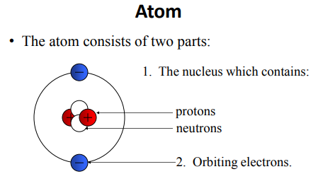
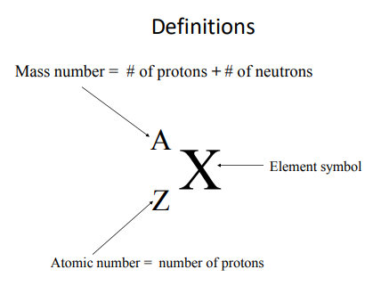
Definitions
Number of protons = atomic number = Z
Number of neutrons = N
Mass number = A
# of protons + # of neutrons = mass number= A
Z+N=A
According to Z, N, A, elements are classified to:
- Isotopes---- Same Z, Different N, Different A
Example:${}_{6}^{11}C$ , ${}_{6}^{13}C$ , ${}_{6}^{14}C$ ----------- Z=6
Note: Isotopes are variants of a particular chemical element which differ in neutron number. They have the same symbol and same chemical and physical properties.
- Isobars --------- Same A, different Z
Example: ${}_{19}^{40}K$ , ${}_{20}^{40}{Ca}$ ---------- A = 40
Note: Isobars are atoms (nuclides) of different chemical elements that have the same number of nucleons(P+N). They have different chemical and physical properties.
- Isotones ------Same N, different A and Z
Example: ${}_{19}^{39}K$ , ${}_{20}^{40}{Ca}$ -------- N=20
Note: Isotones are atoms (nuclides) of different chemical elements that have the same number of neutrons. They have different chemical and physical properties.
- Isomeric state -------Same Z, N, and A, different energy levels
- Example: ${}_{43}^{99m}{Tc}$ , ${}_{43}^{99}{Tc}$
Note: A nuclear isomer is a metastable state of an atomic nucleus caused by the excitation of one or more of its nucleons (protons or neutrons).
Stability of nuclides
- As mentioned previously, nucleus consists of protons and neutrons which are called nucleons. protons have positive charge while the neutrons have no charge (neutral).
- There are two forces work in nucleus
- Coulomb repulsive force between protons
- Nuclear force (attractive) between nucleons.
It is so strong that it cancel the effect of the force of repulsion between the protons and helps bind the nucleus together.

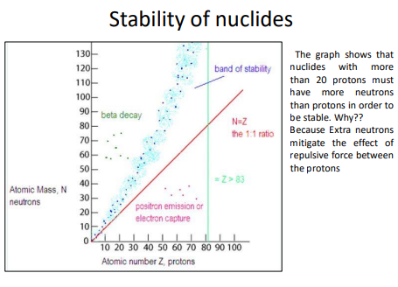
- If nucleus is stable, it does not spontaneously emit any kind of radioactivity (radiation).
- If the nucleus is unstable, it has the tendency of emitting some kind of radiation, (i.e., it is radioactive). Therefore the radioactivity is associated with unstable nucleus:
Stable nucleus – non-radioactive
Unstable nucleus – radioactive
- Unstable nuclides can become stable by releasing different types of particles
- This process is called radioactive decay and the elements which undergo this process are called radioisotopes/radionuclides.

Radioactive Decay
Types of radioactive decay
- alpha decay (a)
- beta minus decay (-b)
- positron decay (+b)
- gamma decay(g)
- electron capture
- Fission
Alpha decay (a)
- Radioactive nuclei eject alpha particles in order to reach the stable state. This decay occurs only in heavy nuclei (Z > 83).
- Characteristics of alpha particle(α) :
- a helium nucleus ( )
- two protons and two neutrons
- charge +2e
- can travel a few inches through air
- can be stopped by a sheet of paper, clothing.
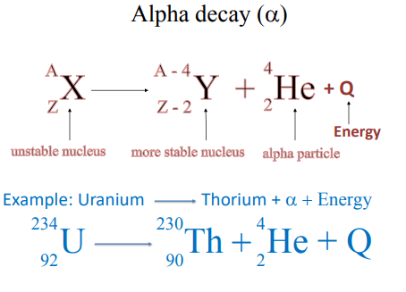
Beta decay (-b)
- This type of decay occurs in neutron rich nuclei. one neutron converts to proton and electron, then the electron (beta particle) will be ejected from the radioactive nucleus.
- Characteristics of Beta particles (- b)
- Beta particles have the same charge (-e) and mass as "normal" electrons.
- Can be stopped by glass plate, aluminum foil or a block of wood.
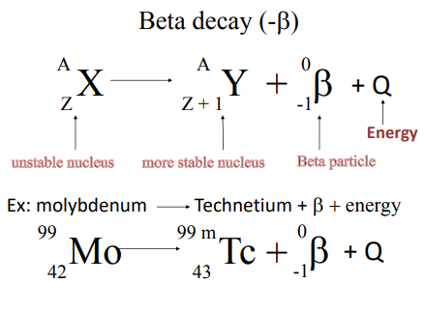
Positron decay (+b)
- This type of decay occurs in proton rich nuclei only if Q >1.02 Mev. If Q less, Electron capture will occur
- One proton converts to neutron and positron, then the positron (Beta plus particle) will be ejected from the radioactive nucleus.
- Characteristics of positron particles (+ b)
- Positron is antiparticle of an electron/beta
- Has same size as an electron but with a positive charge.
- It will collide with any electron. The result of the collision is the annihilation of the electron and positron, and the creation of gamma ray photons
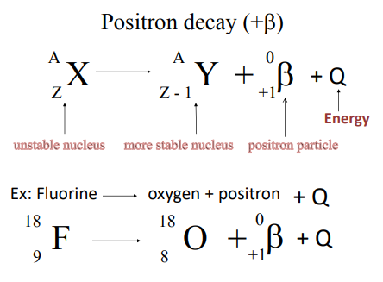
Gamma decay(g)
- Gamma decay is an emission of nuclear photon from excited nucleus. The unstable nucleus has excess of energy. It expels this energy as Gamma ray in order to be stable
- The nuclide retains its identity.
- Characteristics of gamma ray (g)
- Gamma rays are electromagnetic radiation with high frequency. (have NO mass and NO charge)
- Most Penetrating, can be stopped by 1m thick concrete or a several cm thick sheet of lead
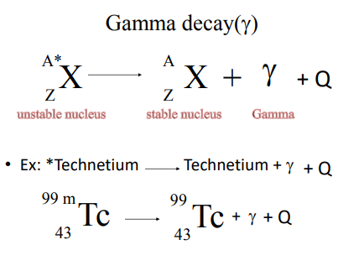
Gamma decay(g)
- Note: Both Gamma and X-rays are electromagnetic radiation. But they come from different sources
- Gamma photons are ejected from the excited nucleus while X-ray is result of the transition of orbital electrons.
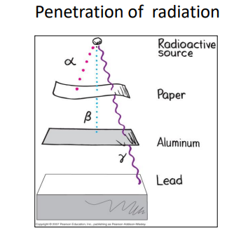
- Which one is more penetrating? Why ?Beta, Alpha, Gamma
- The answer would be Gamma because
- it has no charge
- it has speed of light
The range of charged particles (Alpha, Beta, positron)
- The range of charged particles at a given energy is defined as “the average distance they travel before they come to rest”.
- The range of a 4 MeV alpha particle in air is about 3 cm, and they can be stopped by a thin piece of paper
- 4 MeV beta particles have a maximum range of about 1,700 cm in air whereas they have a maximum range of about 2 cm in water and about 0.26 cm in lead

Conservation of Energy
- The law of conservation of energy states that the total energy of an isolated system remains constant— (it is said to be conserved over time). Energy can neither be created nor destroyed; rather, it transforms from one form to another.

- Einstein’s equation : E = mc²
E: energy, C: speed of light(3 x10⁸ m/s),m: mass
Conservation of Energy in nuclear reactions
- In nuclear reactions, matter changes to energy, but the total amount of mass and energy together does not change.
- When the radionuclide undergoes radioactive decay, it loses a tiny amount of mass (mass of daughter is less than the mass of its parent.
- What happens to the lost mass?. It is converted to energy.
- How much energy? The energy could be estimated from the E = Δmc2
- The change in mass is tiny, but it results in a great amount of energy.
Conservation of Energy in nuclear reactions
E = Δmc2
- E: energy,
- C: speed of light(3 x10⁸ m/s)
- Δm: mass difference between the parent nucleus and the daughter.
- The equation gives the energy released
- In a nuclear reaction, mass decreases and energy increases. However, the sum of mass and energy is always conserved in a nuclear reaction. Mass changes to energy, but the total amount of mass and energy combined remains the same.

الوحدة الرابعة والعشرون - المحاضرة الرابعة والعشرون - الزمن: 120 دقيقة

أهداف المحاضرة الرابعة والعشرون:

يتوقع في نهاية الجلسة أن يكون الطالب قادراً على معرفة ما هو الاشعاع النووي والتفاعلات النووية وطرق انبعاثه

موضوعات المحاضرة الرابعة والعشرون:

Physics of Radioactive Therapy

الأساليب والأنشطة والوسائل التعليمية

م | الأساليب والأنشطة التدريبية | الوسائل التدريبية
1 | - نشاط التعارف (1/1/1)  - محاضرة  - مناقشة  - سؤال وجواب | - جهاز حاسوب  - جهاز عرض  - سبورة  - اوراق واقلام

A therapy using ionizing radiation, generally provided as part of cancer treatment to control or kill malignant cells and normally delivered by a linear accelerator. Radiation therapy may be curative in a number of types of cancer if they are localized to one area of the body. It may also be used as part of adjuvant therapy, to prevent tumor recurrence after surgery to remove a primary malignant tumor (for example, early stages of breast cancer). Radiation therapy is synergistic with chemotherapy, and has been used before, during, and after chemotherapy in susceptible cancers. The subspecialty of oncology concerned with radiotherapy is called radiation oncology. A physician who practices in this subspecialty is a radiation oncologist.
Radiation therapy is commonly applied to the cancerous tumor because of its ability to control cell growth. Ionizing radiation works by damaging the DNA of cancerous tissue leading to cellular death. To spare normal tissues (such as skin or organs which radiation must pass through to treat the tumor), shaped radiation beams are aimed from several angles of exposure to intersect at the tumor, providing a much larger absorbed dose there than in the surrounding healthy tissue. Besides the tumour itself, the radiation fields may also include the draining lymph nodes if they are clinically or radiologically involved with the tumor, or if there is thought to be a risk of subclinical malignant spread. It is necessary to include a margin of normal tissue around the tumor to allow for uncertainties in daily set-up and internal tumor motion. These uncertainties can be caused by internal movement (for example, respiration and bladder filling) and movement of external skin marks relative to the tumor position.
Radiation oncology is the medical specialty concerned with prescribing radiation, and is distinct from radiology, the use of radiation in medical imaging and diagnosis. Radiation may be prescribed by a radiation oncologist with intent to cure ("curative") or for adjuvant therapy. It may also be used as palliative treatment (where cure is not possible and the aim is for local disease control or symptomatic relief) or as therapeutic treatment (where the therapy has survival benefit and can be curative). It is also common to combine radiation therapy with surgery, chemotherapy, hormone therapy, immunotherapy or some mixture of the four. Most common cancer types can be treated with radiation therapy in some way.
The precise treatment intent (curative, adjuvant, neoadjuvant therapeutic, or palliative) will depend on the tumor type, location, and stage, as well as the general health of the patient. Total body irradiation (TBI) is a radiation therapy technique used to prepare the body to receive a bone marrow transplant. Brachytherapy, in which a radioactive source is placed inside or next to the area requiring treatment, is another form of radiation therapy that minimizes exposure to healthy tissue during procedures to treat cancers of the breast, prostate and other organs. Radiation therapy has several applications in non-malignant conditions, such as the treatment of trigeminal neuralgia, acoustic neuromas, severe thyroid eye disease, pterygium, pigmented villonodular synovitis, and prevention of keloid scar growth, vascular restenosis, and heterotopic ossification. The use of radiation therapy in non-malignant conditions is limited partly by worries about the risk of radiation-induced cancers.

الوحدة الخامسة والعشرون - المحاضرة الخامسة والعشرون - الزمن: 120 دقيقة

أهداف المحاضرة الخامسة والعشرون:

يتوقع في نهاية الجلسة أن يكون الطالب قادراً على معرفة ما هو الاشعاع النووي والتفاعلات النووية وطرق انبعاثه

موضوعات المحاضرة الخامسة والعشرون:

Application of electricity and magnetism in medicine

الأساليب والأنشطة والوسائل التعليمية

م | الأساليب والأنشطة التدريبية | الوسائل التدريبية
1 | - نشاط التعارف (1/1/1)  - محاضرة  - مناقشة  - سؤال وجواب | - جهاز حاسوب  - جهاز عرض  - سبورة  - اوراق واقلام

Magnetic therapy is a pseudoscientific alternative medicine practice involving the weak static magnetic field produced by a permanent magnet which is placed on the body. It is similar to the alternative medicine practice of electromagnetic therapy, which uses a magnetic field generated by an electrically powered device. Magnet therapy products may include wristbands, jewelry, blankets, and wraps that have magnets incorporated into them.
Practitioners claim that subjecting certain parts of the body to weak electric or magnetic fields has beneficial health effects. These physical and biological claims are unproven and no effects on health or healing have been established. Although hemoglobin, the blood protein that carries oxygen, is weakly diamagnetic (when oxygenated) or paramagnetic (when deoxygenated), the magnets used in magnetic therapy are many orders of magnitude too weak to have any measurable effect on blood flow. This is not to be confused with transcranial magnetic stimulation, a scientifically valid form of therapy, or with pulsed electromagnetic field therapy.

Suggested mechanisms of action

Perhaps the most common suggested mechanism is that magnets might improve blood flow in underlying tissues. The field surrounding magnet therapy devices is far too weak and falls off with distance far too quickly to appreciably affect hemoglobin, other blood components, muscle tissue, bones, blood vessels, or organs. A 1991 study on humans of static field strengths up to 1 T found no effect on local blood flow. Tissue oxygenation is similarly unaffected. Some practitioners claim that the magnets can restore the body's hypothetical "electromagnetic energy balance", but no such balance is medically recognized. Even in the magnetic fields used in magnetic resonance imaging, which are many times stronger, none of the claimed effects are observed. If the body were meaningfully affected by the weak magnets used in magnet therapy, MRI would be impractical.

Efficacy

Several studies have been conducted in recent years to investigate what role, if any, static magnetic fields may play in health and healing. Unbiased studies of magnetic therapy are problematic, since magnetisation can be easily detected, for instance, by the attraction forces on ferrous (iron-containing) objects; because of this, effective blinding of studies (where neither patients nor assessors know who is receiving treatment versus placebo) is difficult, Incomplete or insufficient blinding tends to exaggerate treatment effects, particularly where any such effects are small. Health claims regarding longevity and cancer treatment are implausible and unsupported by any research. More mundane health claims, most commonly about anecdotal pain relief, also lack any credible proposed mechanism and clinical research is not promising.

الوحدة السادسة والعشرون – السادسة والعشرون - الزمن: 120 دقيقة

أهداف المحاضرة السادسة العشرون:

يتوقع في نهاية الجلسة أن يكون الطالب قادراً على معرفة ما هو الاشعاع النووي والتفاعلات النووية وطرق انبعاثه

موضوعات المحاضرة السادسة والعشرون:

Radioactive Decay

الأساليب والأنشطة والوسائل التعليمية

م | الأساليب والأنشطة التدريبية | الوسائل التدريبية
1 | - نشاط التعارف (1/1/1)  - محاضرة  - مناقشة  - سؤال وجواب | - جهاز حاسوب  - جهاز عرض  - سبورة  - اوراق واقلام

Radioactive Decay
Types of radioactive decay
- alpha decay (a)
- beta minus decay (-b)
- positron decay (+b)
- gamma decay(g)
- electron capture
- Fission
Alpha decay (a)
- Radioactive nuclei eject alpha particles in order to reach the stable state. This decay occurs only in heavy nuclei (Z > 83).
- Characteristics of alpha particle(α) :
- a helium nucleus ( )
- two protons and two neutrons
- charge +2e
- can travel a few inches through air
- can be stopped by a sheet of paper, clothing.
Beta decay (-b)
- This type of decay occurs in neutron rich nuclei. one neutron converts to proton and electron, then the electron (beta particle) will be ejected from the radioactive nucleus.
- Characteristics of Beta particles (- b)
- Beta particles have the same charge (-e) and mass as "normal" electrons.
- Can be stopped by glass plate, aluminum foil or a block of wood.
Positron decay (+b)
- This type of decay occurs in proton rich nuclei only if Q >1.02 Mev. If Q less, Electron capture will occur
- One proton converts to neutron and positron, then the positron (Beta plus particle) will be ejected from the radioactive nucleus.
- Characteristics of positron particles (+ b)
- Positron is antiparticle of an electron/beta
- Has same size as an electron but with a positive charge.
- It will collide with any electron. The result of the collision is the annihilation of the electron and positron, and the creation of gamma ray photons
Gamma decay(g)
- Gamma decay is an emission of nuclear photon from excited nucleus. The unstable nucleus has excess of energy. It expels this energy as Gamma ray in order to be stable
- The nuclide retains its identity.
- Characteristics of gamma ray (g)
- Gamma rays are electromagnetic radiation with high frequency. (have NO mass and NO charge)
- Most Penetrating, can be stopped by 1m thick concrete or a several cm thick sheet of lead
Gamma decay(g)
- Note: Both Gamma and X-rays are electromagnetic radiation. But they come from different sources
- Gamma photons are ejected from the excited nucleus while X-ray is result of the transition of orbital electrons.
- Which one is more penetrating? Why ?Beta, Alpha, Gamma
- The answer would be Gamma because
- it has no charge
- it has speed of light
The range of charged particles (Alpha, Beta, positron)
- The range of charged particles at a given energy is defined as “the average distance they travel before they come to rest”.
- The range of a 4 MeV alpha particle in air is about 3 cm, and they can be stopped by a thin piece of paper
- 4 MeV beta particles have a maximum range of about 1,700 cm in air whereas they have a maximum range of about 2 cm in water and about 0.26 cm in lead

Conservation of Energy
- The law of conservation of energy states that the total energy of an isolated system remains constant— (it is said to be conserved over time). Energy can neither be created nor destroyed; rather, it transforms from one form to another.

- Einstein’s equation : E = mc²
E: energy, C: speed of light(3 x10⁸ m/s),m: mass
Conservation of Energy in nuclear reactions
- In nuclear reactions, matter changes to energy, but the total amount of mass and energy together does not change.
- When the radionuclide undergoes radioactive decay, it loses a tiny amount of mass (mass of daughter is less than the mass of its parent.
- What happens to the lost mass?. It is converted to energy.
- How much energy? The energy could be estimated from the E = Δmc2
- The change in mass is tiny, but it results in a great amount of energy.
Conservation of Energy in nuclear reactions
E = Δmc2
- E: energy,
- C: speed of light(3 x10⁸ m/s)
- Δm: mass difference between the parent nucleus and the daughter.
- The equation gives the energy released
- In a nuclear reaction, mass decreases and energy increases. However, the sum of mass and energy is always conserved in a nuclear reaction. Mass changes to energy, but the total amount of mass and energy combined remains the same.
الوحدة السابعة والعشرون - المحاضرة السابعة والعشرون - الزمن: 120 دقيقة

أهداف المحاضرة السابعة والعشرون:

يتوقع في نهاية الجلسة أن يكون الطالب قادراً على معرفة النشاط الاشعاعي والمواد المشعة والعلاج الاشعاعي

موضوعات المحاضرة السابعة والعشرون:

Radioactivity

الأساليب والأنشطة والوسائل التعليمية

م | الأساليب والأنشطة التدريبية | الوسائل التدريبية
1 | - نشاط التعارف (1/1/1)  - محاضرة  - مناقشة  - سؤال وجواب | - جهاز حاسوب  - جهاز عرض  - سبورة  - اوراق واقلام

Decay process (Activity )
- Radioactive decay is a random process. We cannot predict when an individual nucleus will decay but with large numbers of nuclei we can use a statistical approach
- One of the most important quantities associated with a sample of radioactive material is its activity
- Activity is the rate at which the nuclei within the sample undergo decay (disintegrations) and can be expressed in terms of the number of disintegrations per second (dps).
Activity
- Activity : It is the average number of disintegrations per second (dps)
- The SI unit of activity is the becquerel:
1 becquerel (1 Bq ) = 1 disintegration/second ( 1dis/sec). 1 Bq= 1dis/sec= 1dps
- Another unit of activity is the curie (Ci):
1 curie = 1 Ci = 3.7x10¹⁰ dis/s
1 Ci = 3.7x10¹⁰ Bq
Radioactive Decay Laws
- Experimental measurements show that the activities of radioactive samples fall off exponentially with time. As the sample decays, less of the radioactive sample remains, so the activity decreases.
- The following equations can be used to calculate the activity of a radioactive material at any time.
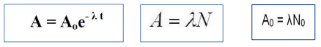
A = Activity remaining in the radioactive material after time (t)
A₀ = Initial Activity of the radioactive material
N = Number of radioactive nuclei present at a time t
N₀ = the initial number of radioactive nuclei present at time
t=0 λ = Decay constant
t = Time
We can also calculate the number of remaining radioactive nuclei in the radioactive sample after period of time from the following equation
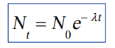
N = Number of radioactive nuclei present at a time t
N₀ = the initial number of radioactive nuclei present at time
t=0 λ = Decay constant (s -1 )
t = Time (s)
- Decay constant (λ ): The probability that a nucleus will decay per unit of time. Its unit is s ⁻¹ , min⁻¹ , h ⁻¹ , day⁻¹
- Half-Life (t_{1/2} ): The time for half of the radioactive nuclei in a given sample to undergo decay. (i.e. the time it takes for the activity to drop by ½)
- • Each radioactive nuclide has a particular decay constant and half-life. The relationship between λ and t½ is
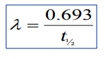
a plot of the activity of a radionuclides versus time.
The initial activity was chosen to be 1000 for this plot.
The half-life is 10 (in whatever time units we are using).
Note: All decay curves look like this; only the numbers on the axes will differ, depending on the radionuclide (which determines the half-life) and the amount of radioactive material (which determines the initial activity).
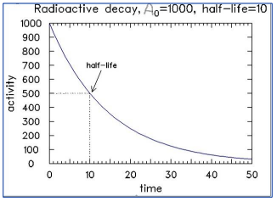
A plot of number of a radionuclides versus half-life.
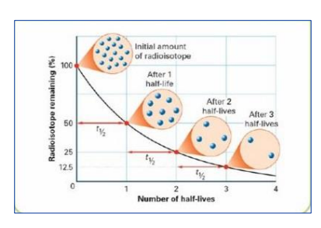
Common Radioactive Isotopes
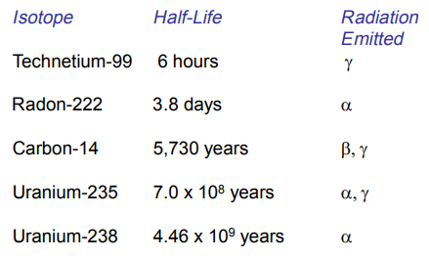
Examples
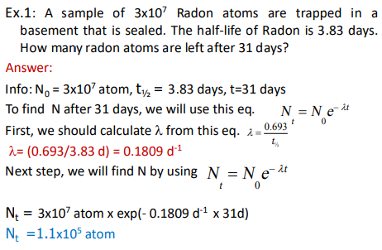
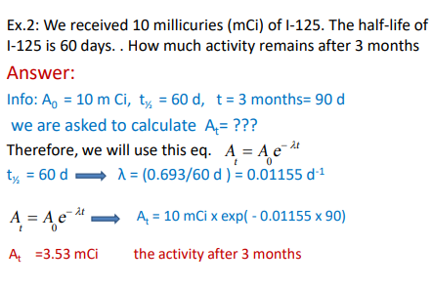
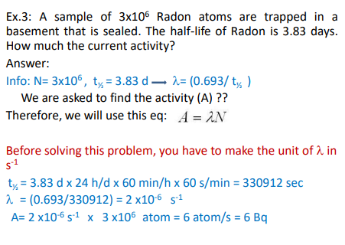
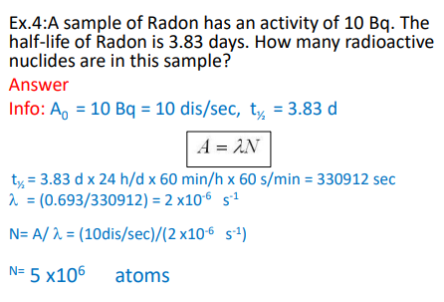
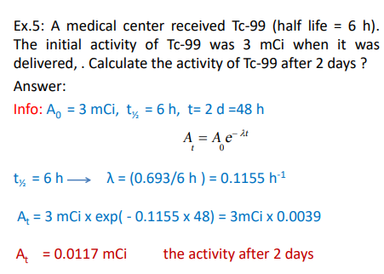
1-Radiation Dose
- The magnitude of radiation exposures is specified in terms of the radiation dose.
- There are two important categories of dose:
- Absorbed dose
- Dose equivalent
Absorbed dose
- Absorbed dose: the amount of energy deposited in a unit mass in human tissue or other media.
- SI unit used to measure absorbed dose is the gray (Gy)
1 Gy = 1 J/kg
- another unit used to measure absorbed dose is rad
1 Gy = 100 rad
Absorbed dose can be calculated from the following formula
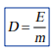
Where: D=dose (Gy), E =energy(J), m= mass(Kg)
Example: 0.1 J of radiation energy was deposited in 30 g of tissue. Find the absorbed dose in Gy and in rad
Answer
Info: E=0.1 J, m=30g =30/1000 =0.03 Kg
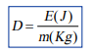
D = 0.1J/0.03Kg = 3.3 Gy
Since 1 Gy = 100 rad
D = 3.3 Gy x 100 rad/Gy
D= 330 rad

2-Dose equivalent
Dose equivalent: A measure of the biological damage to living tissue as a result of radiation exposure. Also known as the " biological dose”.
- SI unit used to measure Dose equivalent is sievert (Sv)
- another unit used to measure Dose equivalent is rem
1 Sv = 100 rem
Dose equivalent can be calculated from the following formula
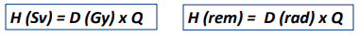
Where: H = Dose equivalent , D= absorbed dose
Q= weighting factors(previously called quality factor)

- Weighting factor (Q): is dimensionless factor used to convert physical dose (Gy) to equivalent dose (Sv).
- Example: If the absorbed dose is 20 rad and Q is 10. What is Dose equivalent in rem and in Sv
Answer:
H (rem) = D( rad) × Q = 20 rad × 10 = 200 rem
Since 1 Sv = 100 rem 1 rem = (1/100) Sv = 0.01 Sv
H (Sv) = 200 rem × 0.01 Sv/rem= 2 Sv
Or, we can solve it by this:
H (Sv) = D (Gy) ×Q =20 rad ×(1/100) Gy/rad x10
H = 0.2 Gy × 10 = 2 Sv
Factors Affecting Radiation Dose
- Target organ/tissue, i.e., radiation sensitivity of the tissue
- Type and energy of the radiation
- Rate of Delivery
- Interaction Volume
- Biological status: difference between young/old, male/female, population/individual, healthy/diseased
Radiation Interaction In Cells
- There are two principle ways to characterize the ways in which radiation interacts with cells. These ways are through direct effects and indirect effects.
- Direct Effect - Direct ionization of DNA or other structure by radiation. The result may lead to the break-up or chemical change in the molecule.
- Indirect Effect - Ionization of water molecules within the cell creates very chemically active agents (free radicals) which can chemically attack other molecules in their immediate vicinity. If a DNA molecule is located in this area, alteration to the DNA molecule could occur.
Radiation Safety and ALARA
- What is ALARA ?
- ALARA is an acronym for “As Low As Reasonably Achievable”. This is a radiation safety principle for minimizing radiation doses and releases of radioactive materials by employing all reasonable methods.
- ALARA is not only a sound safety principle, but is a regulatory requirement for all radiation safety programs.
- Three of the most basic and easy to follow principles of radiation protection are time, distance, and shielding. We can greatly reduce our exposure by following these principles.
- Time: As the length of time a person is exposed increases, the dose received increases.
- Distance: The most effective of the principles is distance. The further a person is from the source the less intense the radiation source is.
- Shielding: When the use of the time and distance principles are not possible shielding should always be used. Wearing protective lead shielding and thyroid collars can protect the radiosensitive areas of the body when it is required for the technologist to be near the source of radiation.
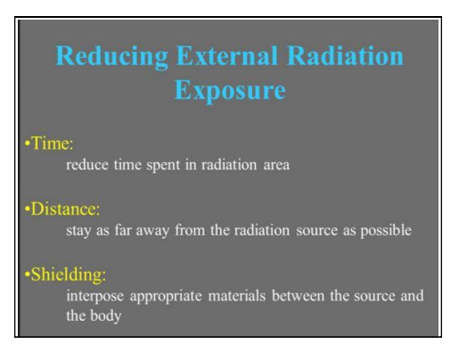

Inverse square law applied in radiation
Inverse Square law: The radiation Intensity is inversely proportional to the square of the distance from the source. The radiation source must be a point source
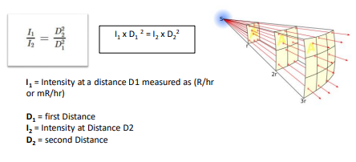
Example 1: If the intensity of point source = 100 IU at 1cm, what is its intensity at 10 cm?
Answer:
Given Information: I₁=100 IU, D₁=1 cm, D₂=10 cm, I₂=?
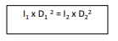
100 x (1)² = I₂ x (10)²
100 = I₂ x 100
I₂ = 1 IU
IU= Intensity Unit
Example 2: A reading of 100 mR/hr is obtained at a distance of 1 cm from a point source. What would be the reading at a distance of 1 mm?

Given information
I₁= 100 mR/hr, D₁= 1 cm, D₂=1 mm =0.1 cm, I₂=?
100 × (1)² = I₂ x (0.1)²
100 = I₂ × 0.01
I₂ = 100/0.01
I₂ = 10000 mR/hr

الوحدة الثامنة والعشرون - المحاضرة الثامنة والعشرون - الزمن: 120 دقيقة

أهداف المحاضرة الثامنة و العشرون:

يتوقع في نهاية الجلسة أن يكون الطالب قادراً على معرفة النشاط الاشعاعي والمواد المشعة والعلاج الاشعاعي

موضوعات المحاضرة الثامنة و العشرون:

Radioactive Isotopes

الأساليب والأنشطة والوسائل التعليمية

م | الأساليب والأنشطة التدريبية | الوسائل التدريبية
1 | - نشاط التعارف (1/1/1)  - محاضرة  - مناقشة  - سؤال وجواب | - جهاز حاسوب  - جهاز عرض  - سبورة  - اوراق واقلام

Common Radioactive Isotopes
Examples
1-Radiation Dose
- The magnitude of radiation exposures is specified in terms of the radiation dose.
- There are two important categories of dose:
- Absorbed dose
- Dose equivalent
Absorbed dose
- Absorbed dose: the amount of energy deposited in a unit mass in human tissue or other media.
- SI unit used to measure absorbed dose is the gray (Gy)
1 Gy = 1 J/kg
- another unit used to measure absorbed dose is rad
1 Gy = 100 rad
Absorbed dose can be calculated from the following formula
Where: D=dose (Gy), E =energy(J), m= mass(Kg)
Example: 0.1 J of radiation energy was deposited in 30 g of tissue. Find the absorbed dose in Gy and in rad
Answer
Info: E=0.1 J, m=30g =30/1000 =0.03 Kg
D = 0.1J/0.03Kg = 3.3 Gy
Since 1 Gy = 100 rad
D = 3.3 Gy x 100 rad/Gy
D= 330 rad

2-Dose equivalent
Dose equivalent: A measure of the biological damage to living tissue as a result of radiation exposure. Also known as the " biological dose”.
- SI unit used to measure Dose equivalent is sievert (Sv)
- another unit used to measure Dose equivalent is rem
1 Sv = 100 rem
Dose equivalent can be calculated from the following formula
Where: H = Dose equivalent , D= absorbed dose
Q= weighting factors(previously called quality factor)

- Weighting factor (Q): is dimensionless factor used to convert physical dose (Gy) to equivalent dose (Sv).
- Example: If the absorbed dose is 20 rad and Q is 10. What is Dose equivalent in rem and in Sv
Answer:
H (rem) = D( rad) × Q = 20 rad × 10 = 200 rem
Since 1 Sv = 100 rem 1 rem = (1/100) Sv = 0.01 Sv
H (Sv) = 200 rem × 0.01 Sv/rem= 2 Sv
Or, we can solve it by this:
H (Sv) = D (Gy) ×Q =20 rad ×(1/100) Gy/rad x10
H = 0.2 Gy × 10 = 2 Sv
Factors Affecting Radiation Dose
- Target organ/tissue, i.e., radiation sensitivity of the tissue
- Type and energy of the radiation
- Rate of Delivery
- Interaction Volume
- Biological status: difference between young/old, male/female, population/individual, healthy/diseased
Radiation Interaction In Cells
- There are two principle ways to characterize the ways in which radiation interacts with cells. These ways are through direct effects and indirect effects.
- Direct Effect - Direct ionization of DNA or other structure by radiation. The result may lead to the break-up or chemical change in the molecule.
- Indirect Effect - Ionization of water molecules within the cell creates very chemically active agents (free radicals) which can chemically attack other molecules in their immediate vicinity. If a DNA molecule is located in this area, alteration to the DNA molecule could occur.
Radiation Safety and ALARA
- What is ALARA ?
- ALARA is an acronym for “As Low As Reasonably Achievable”. This is a radiation safety principle for minimizing radiation doses and releases of radioactive materials by employing all reasonable methods.
- ALARA is not only a sound safety principle, but is a regulatory requirement for all radiation safety programs.
- Three of the most basic and easy to follow principles of radiation protection are time, distance, and shielding. We can greatly reduce our exposure by following these principles.
- Time: As the length of time a person is exposed increases, the dose received increases.
- Distance: The most effective of the principles is distance. The further a person is from the source the less intense the radiation source is.
- Shielding: When the use of the time and distance principles are not possible shielding should always be used. Wearing protective lead shielding and thyroid collars can protect the radiosensitive areas of the body when it is required for the technologist to be near the source of radiation.

Inverse square law applied in radiation
Inverse Square law: The radiation Intensity is inversely proportional to the square of the distance from the source. The radiation source must be a point source
Example 1: If the intensity of point source = 100 IU at 1cm, what is its intensity at 10 cm?
Answer:
Given Information: I₁=100 IU, D₁=1 cm, D₂=10 cm, I₂=?
100 x (1)² = I₂ x (10)²
100 = I₂ x 100
I₂ = 1 IU
IU= Intensity Unit
Example 2: A reading of 100 mR/hr is obtained at a distance of 1 cm from a point source. What would be the reading at a distance of 1 mm?

Given information
I₁= 100 mR/hr, D₁= 1 cm, D₂=1 mm =0.1 cm, I₂=?
100 × (1)² = I₂ x (0.1)²
100 = I₂ × 0.01
I₂ = 100/0.01
I₂ = 10000 mR/hr

الوحدة التاسعة والعشرون - المحاضرة التاسعة والعشرون - الزمن: 120 دقيقة

أهداف المحاضرة التاسعة والعشرون:

يتوقع في نهاية الجلسة أن يكون الطالب قادراً على معرفة ما هو الليزر وأنواعه وطرق العلاج باستخدام الليزر

موضوعات المحاضرة التاسعة والعشرون:

Laser

الأساليب والأنشطة والوسائل التعليمية

م | الأساليب والأنشطة التدريبية | الوسائل التدريبية
1 | - نشاط التعارف (1/1/1)  - محاضرة  - مناقشة  - سؤال وجواب | - جهاز حاسوب  - جهاز عرض  - سبورة  - اوراق واقلام

A laser is a device that emits light through a process of optical amplification based on the stimulated emission of electromagnetic radiation. The word "laser" is an acronym, for "light amplification by stimulated emission of radiation". The first laser was built in 1960 by Theodore H. Maiman at Hughes Research Laboratories, based on theoretical work by Charles Hard Townes and Arthur Leonard Schawlow.
A laser differs from other sources of light in that it emits light which is coherent. Spatial coherence allows a laser to be focused to a tight spot, enabling applications such as laser cutting and lithography. Spatial coherence also allows a laser beam to stay narrow over great distances (collimation), enabling applications such as laser pointers and lidar (light detection and ranging). Lasers can also have high temporal coherence, which allows them to emit light with a very narrow spectrum. Alternatively, temporal coherence can be used to produce ultrashort pulses of light with a broad spectrum but durations as short as a femtosecond.
Lasers are used in optical disc drives, laser printers, barcode scanners, DNA sequencing instruments, fiber-optic and free-space optical communication, semiconducting chip manufacturing (photolithography), laser surgery and skin treatments, cutting and welding materials, military and law enforcement devices for marking targets and measuring range and speed, and in laser lighting displays for entertainment. Semiconductor lasers in the blue to near-UV have also been used in place of light-emitting diodes (LEDs) to excite fluorescence as a white light source. This permits a much smaller emitting area due to the much greater radiance of a laser and avoids the droop suffered by LEDs; such devices are already used in some car headlamps.

Stimulated emission
1:16CC
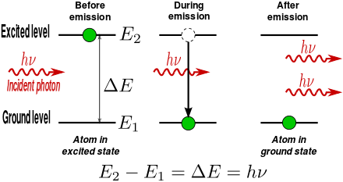
An electron in an atom can absorb energy from light (photons) or heat (phonons) only if there is a transition between energy levels that matches the energy carried by the photon or phonon. For light, this means that any given transition will only absorb one particular wavelength of light. Photons with the correct wavelength can cause an electron to jump from the lower to the higher energy level. The photon is consumed in this process.
When an electron is excited from one state to that at a higher energy level with energy difference ΔE, it will not stay that way forever. Eventually, a photon will be spontaneously created from the vacuum having energy ΔE . Conserving energy, the electron transitions to a lower energy level which is not occupied, with transitions to different levels having different time constants. This process is called "spontaneous emission". Spontaneous emission is a quantum-mechanical effect and a direct physical manifestation of the Heisenberg uncertainty principle. The emitted photon has random direction, but its wavelength matches the absorption wavelength of the transition. This is the mechanism of fluorescence and thermal emission.
A photon with the correct wavelength to be absorbed by a transition can also cause an electron to drop from the higher to the lower level, emitting a new photon. The emitted photon exactly matches the original photon in wavelength, phase, and direction. This process is called stimulated emission.

Gain medium and cavity
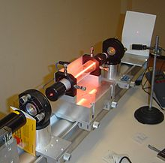
The gain medium is put into an excited state by an external source of energy. In most lasers this medium consists of a population of atoms which have been excited into such a state by means of an outside light source, or an electrical field which supplies energy for atoms to absorb and be transformed into their excited states.
The gain medium of a laser is normally a material of controlled purity, size, concentration, and shape, which amplifies the beam by the process of stimulated emission described above. This material can be of any state: gas, liquid, solid, or plasma. The gain medium absorbs pump energy, which raises some electrons into higher-energy ("excited") quantum states. Particles can interact with light by either absorbing or emitting photons. Emission can be spontaneous or stimulated. In the latter case, the photon is emitted in the same direction as the light that is passing by. When the number of particles in one excited state exceeds the number of particles in some lower-energy state, population inversion is achieved. In this state, the rate of stimulated emission is larger than the rate of absorption of light in the medium, and therefore the light is amplified. A system with this property is called an optical amplifier. When an optical amplifier is placed inside a resonant optical cavity, one obtains a laser.

الوحدة الثلاثون - المحاضرة الثلاثون - الزمن: 120 دقيقة

أهداف المحاضرة الثلاثون:

يتوقع في نهاية الجلسة أن يكون الطالب قادراً على معرفة ما هو الليزر وأنواعه وطرق العلاج باستخدام الليزر

موضوعات المحاضرة الثلاثون:

Laser in Medicine

الأساليب والأنشطة والوسائل التعليمية

م | الأساليب والأنشطة التدريبية | الوسائل التدريبية
1 | - نشاط التعارف (1/1/1)  - محاضرة  - مناقشة  - سؤال وجواب | - جهاز حاسوب  - جهاز عرض  - سبورة  - اوراق واقلام

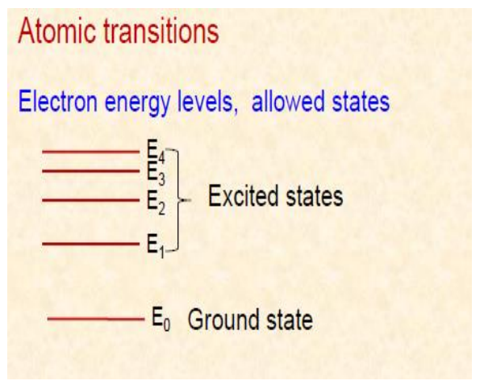
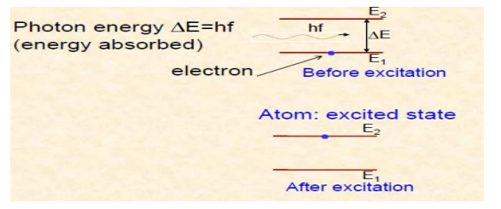
Population inversion
Ordinarily more atoms in the ground state than excited state
Population inversion
happens if there are more atoms in the excited state than the ground state
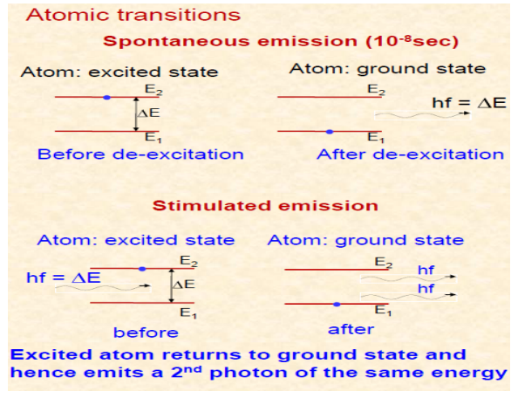
Both photons are in phase and have the same energy (color) (wavelength)
Both photons can stimulate other atoms to emit photons that in turn stimulate the emission of more photons.
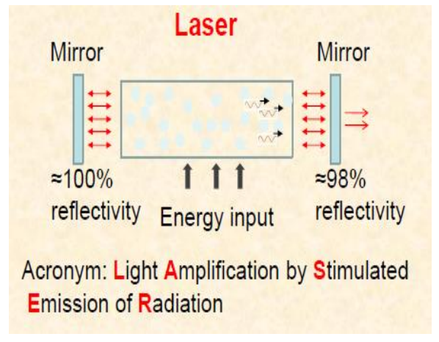
Laser Typical Characteristics
- Uni-directional; same direction
- Single wavelength in visible region; same frequency
- same phase
- Intense beam
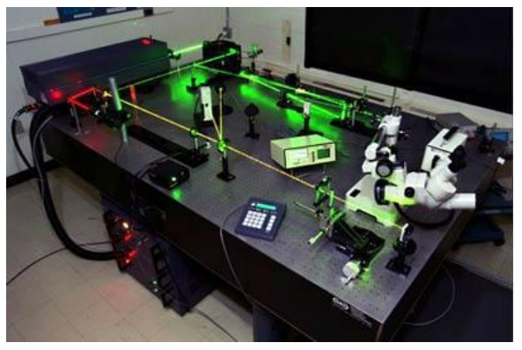
General Applications
- CD players
- Pointers
- Printers
- Eye surgery (reshaping cornea)
- Cuts tissue (burns tumours)
- Cuts metal
- Cuts patterns (many layers of cloth at once)
- Telecommunications (sent down optical fibers)

Laser Dental Applications
- Reshape gum tissue (reduce prominence)
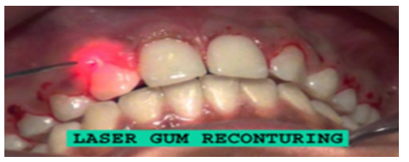
- Laser aided teeth whitening
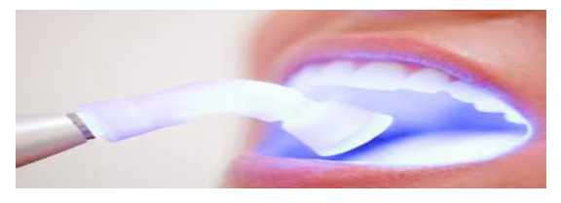
- Laser Drill
- Preparation for fillings
- Capable of killing bacteria located in a cavity
- No vibration

Laser: Erbium Yag (Er: YAG) Wavelength 2940 nm, light of this wavelength highly absorbed by water
Laser beam absorbed by decayed tissue because of large water content compared with healthy enamel
Result:
- selective ablation of decay,
- conservation of healthy tooth
- no increase in pulp temperature
