Clinical Pharmacy

Lec. 10 Dr. Laith G. Shareef

Minor Eye Disorders Part 2:
Dry Eye

Dry eye is among the most common disorders affecting the anterior eye ⁽⁵⁾.the condition is chronic with no cure ⁽¹⁾.
Essentially, a reduction in tear volume or alteration in tear composition causes dry eyes. Underproduction of tears can be the result of increased evaporation from the eye, increased tear drainage and a decrease in tear production by the lacrimal gland ⁽¹⁾.

Patient Assessment with Dry Eye:
A-Age: Dry eye is most often associated with aging process, especially postmenopausal women ⁽⁵⁾. Dry eye is rare in children and required referral ⁽¹⁾.

B-Symptoms: Usually affecting both eyes. Symptoms that are frequently reported are eyes that burn, feel tired , itchy, irritated (decreased tear production results in irritation and burning) or gritty and feel as if something is in the eyes ^{(1, 6)}.

C-Clarifying questions: Have you had daily, persistent, troublesome dry eyes for more than 3 months? Do you have a recurrent sensation of sand or gravel in the eyes?
A positive response to at least one of these questions would indicate dry eye syndrome ⁽¹⁾.
D-Associated Symptoms: Normally no other symptoms are present in dry eye. If the patient complains of a dry mouth, check for medication that can cause dry mouth (table -4). If medication is not implicated, then symptoms could be due to an autoimmune disease ⁽¹⁾.
Sometimes the lower eyelid turns outward (a condition called Ectropion), this will over expose the conjunctiva to atmosphere leading to eye dryness. Referral is required ⁽¹⁾.
Table -4: Medication that can cause dry eye ⁽¹⁾.
-Diuretics
-Drugs that have an anticholinergic effect – e.g., tricyclic antidepressants (TCAs) and antihistamines
-Isotretinoin
-HRT (particularly oestrogen alone)
-Androgen antagonists
-Cardiac arrhythmic drugs, beta-blockers
-Selective serotonin reuptake inhibitors (SSRIs)

Management:
1-Dry eye are managed by instillation of artificial tear preparations. They act by stabilizing the tear film and decreasing tear evaporation) ⁽⁵⁾.

2-Drops can be divided into those which contain a preservative and those which do not ( i.e. preservative free).
The preservative is nearly always benzalkonium chloride,
When to refer ⁽¹⁾
-Associated dryness of mouth and other mucous membranes
-Outward turning lower eyelid
usually present at 0.01 per cent. Preservatives can damage the corneal epithelium. If a patient is likely to be using artificial tears for a long time, a preservative-free preparation should be considered ⁽⁶⁾.

Also: benzalkonium chloride itself can cause eye irritation. If symptoms persist, or are worsened by the eye drops, it may be worth trying a preservative-free formulation or single-dose unit preparations ⁽¹⁾.

3-The dosage of all products marketed for dry eye is largely dependent on the patient’s need for lubrication, and is therefore given on an as-needed basis ⁽¹⁾.

4-All products are pharmacologically inert and none are known to interact with any
medicine, only cause minimal and transient side effects and can be given to all patient groups ⁽¹⁾.

Examples of the compound used are:

1-Hypromellose (hydroxypropylmethylcellulose): (Tears Naturale ® eye drop)
2-Polyvinyl alcohol (Liquifilm Tears® eye drop)
Patients with mild dry eye may benefit from instillation of one of these artificial tear drops up to four times a day. However, in moderate to severe cases, these preparations need to be instilled more frequently ⁽⁷⁾.

3-Carbomers: (Liquivisc ® Gel : Viscotears ® gel): To overcome the problem of frequent instillation , preparations containing a longer-acting polymer, known as carbomer , have been introduced. Such preparations have a much longer retention time in the eye and symptom relief is obtained with significantly fewer instillations ⁽⁷⁾.

Due to the products’ viscosity properties, carbomer should be used last if other eye drops need to be instilled ⁽¹⁾.

4-Lubricating ointments: Ophthalmic lubricating ointments contain white soft paraffin (Lubri-Tears ®Eye ointment), lanolin and liquid paraffin. These preparations melt at the temperature of the ocular tissue and are retained longer than other ophthalmic vehicles. They are not generally recommended as tear substitutes during the day because the vision is blurred after instillation. They are, however, a useful adjunct to artificial tears if used at bedtime ⁽⁷⁾.

5-Sodium hyaluronate
The dosage for all products containing sodium hyaluronate is on an as needed basis ⁽¹⁾.

3-Eyelid Disorders:
A-(Stye and Chalazion):
Styes are caused by bacterial infection and can either be external (outside the surface of the eyelid) or internal (in the inner surface of the eyelid) ⁽¹⁾. Internal stye generally has a more prolonged course than external ⁽⁸⁾.
Occasionally, internal stye can evolve into Chalazion (a granulomatous inflammation that develops into a painless lump) ⁽¹⁾.
A chalazion can be confused with a stye. Stye often has a head of pus at the lid margin and will be tender and sore, whereas a chalazion presents as painless lump ⁽¹⁾.
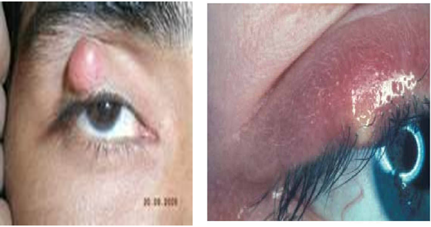
Although styes are caused by bacterial pathogens the use of antibiotic therapy is not usually needed. Topical application of ocular antibiotics does not result in speedier symptom resolution ⁽¹⁾.

Patient with stye should avoid touching the eyes and wash the hands after any contact with infected eye ⁽⁸⁾. Without treatment, a stye will usually resolve within seven to 14 days ⁽⁸⁾.
A warm compress applied for 5–10 minutes three or four times a day might bring to a head an external stye, and once it bursts the pain will subside and the symptoms will resolve ⁽¹⁾ (External stye usually drains spontaneously, but warm compress will hasten resolution which usually occurs within 48 hours). Internal stye generally resolves within 1-2 weeks ⁽⁸⁾.

A chalazion is self-limiting, although it might take a few weeks to resolve completely ⁽¹⁾. Initial treatment for chalazion is similar to that of stye especially for small chalazion (warm compress applied several times a day. About 25-50% resolves with this treatment. If the lesion does not begin to resolve within few days, referral is required ⁽⁸⁾)

If the patient complains that it is particularly bothersome and is affecting vision or associated with eye pain. Referral in these circumstances is needed for surgical removal ^{(1, 8)}.

B-Blepharitis:
Blepharitis is chronic inflammation of the lid margins, affecting both eyes ⁽⁹⁾.

Signs and symptoms:
1- Typically Blepharitis is bilateral ⁽¹⁾.The lid margins appear red, with irritation, burning and itching ⁽⁹⁾.
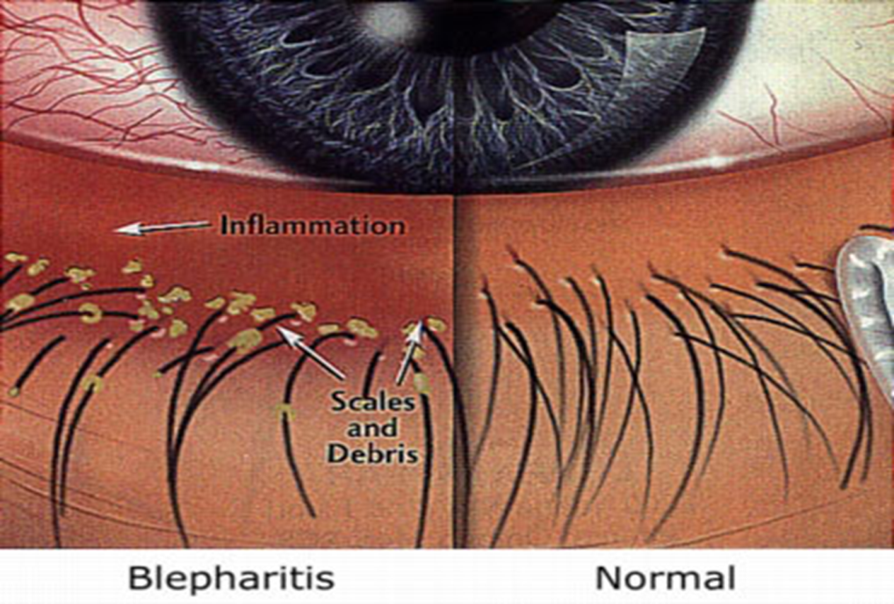
2-Scales are frequently seen on the lashes of both upper and lower lids, which tend to be greasy in seborrhoeic blepharitis ⁽⁹⁾. (excessive crusty debris or skin flakes around the eyelash) ⁽¹⁾.

3-Lashes are frequently lost or may be distorted, turn inwards and rub on the cornea; this in turn can cause conjunctivitis ⁽⁹⁾.
Patient Assessment with blepharitis
A-Other existing conditions:
Patients who suffer from blepharitis often have a co-existing skin condition, such as seborrhoeic dermatitis or rosacea ⁽¹⁾.

Patients with swollen eyelid and associated feeling of being unwell required referred ⁽¹⁾.

B-Duration:
A long standing history of sore eye is indicative of blepharitis or dry eye syndrome ⁽¹⁾.

C-Eye involvement:
Conjunctivitis is a common complication of blepharitis ⁽¹⁾.

D-Recent use of products:
Many products (especially cosmetics) can results in itching and flaking skin that mimics blepharitis ⁽¹⁾.

E-Medication:
Failed medication required referred ⁽¹⁾.

Management
The goals of treatment are to reduce the discomfort and inflammation associated with blepharitis and to reduce the risk of recurrence of severe symptoms ⁽⁸⁾.
The mainstay of treatment for blepharitis is improved lid hygiene ⁽¹⁾.

1-First, the eyelids should be cleaned using a warm compress applied to closed eyelids for 5-10 minutes ^{(1, 8)} (This step softens gland secretions and promotes evacuation and cleansing of secretory passages) ⁽¹⁰⁾. A diluted mixture of baby shampoo (1:10) with warm water should then be applied to the eyelids using a cotton bud. This should be done twice a day initially and can be reduced to once a day if symptoms improve ⁽¹⁾.

2-Failure to respond to hygiene measures requires referral ⁽¹⁾ (an improvement would be expected after four weeks) ⁽⁶⁾.

4-Subconjunctival hemorrhage
The rupture of a blood vessel under the conjunctiva causes Subconjunctival hemorrhage. A segment or even the whole eye will appear bright red. Most subconjunctival hemorrhages are idiopathic (It occurs spontaneously) but can be precipitated by coughing, straining or lifting ⁽¹⁾. The patient will wake up with the hemorrhage, which is not noticed until he or she looks in a mirror ⁽¹¹⁾.
The condition appears alarming but is usually harmless ⁽¹¹⁾. There is no pain and the patient should be reassured that symptoms will resolve in 10 -14 days without treatment. However, a patient with history of trauma should be referred to exclude ocular injury ⁽¹⁾.
Hypertension is also a possible cause so pharmacists can advise patients to have their blood pressure checked. Anticoagulant or antiplatelet drugs (e.g. warfarin, aspirin, clopidogrel) can also cause a hemorrhage so patients should be asked about their medicines and those taking warfarin should have their international normalized ratio ( INR ) measured ⁽¹¹⁾

References:
1-Paul Rutter. Community Pharmacy. Symptoms, Diagnosis and Treatment. 4th edition. 2017. And 5th edition 2021.
2-Practice guidance: OTC Chloramphenicol eye drop. Royal Pharmaceutical Society of Great Britain June 2005
3-Conjunctivitis and Chloramphenicol. The Pharmaceutical Journal (Vol 274) 11 June 2005 page 725-728.
4-Nathan A. Non-prescription medicines. 4th edition. London: Pharmaceutical Press. 2010.
5-American pharmacists association. Handbook of Non-prescription drugs: An Interactive Approach to Self-Care. 18th edition. 2016.
6-Marvyn Elton .Ocular conditions from A to Z (i). The Pharmaceutical Journal .17 February 2007 (Vol 278) 195-198.
7-Lucy C. Titcomb .Eye disorders : Over-the-counter ophthalmic preparations. The Pharmaceutical Journal .Vol 264 No 7082 p212-218 February 5, 2000 .
8-Canadian American pharmacists association (CPhA). CTMA: Compendium of Therapeutics for Minor Ailments. 2014.
9-Nathan A. fasttrack. Managing Symptoms in the Pharmacy. Pharmaceutical Press. 2008.
10-Jeannette Y. Wick. Treating Blepharitis: Annoying Condition for Patients, Vocabulary Builder for Pharmacists. Pharmacy times. February 19, 2012.
11-Marvyn Elton .Ocular conditions from A to Z (ii). The Pharmaceutical Journal. 3 March 2007 (Vol 278) 255-258.
12-Alison Blenkinsopp, Paul Paxton and John Blenkinsopp. Symptoms in the pharmacy . A guide to the managements of common illness. 8th edition. 2018.

د. ليث غضنفر

