College of Pharmacy
Fourth year. Clinical Pharmacy
Gastrointestinal disorders
Peptic Ulcer Disease

Introduction
1-Peptic ulcer disease (PUD) refers to ulcerative disorders of the upper gastrointestinal (GI) tract that require acid and pepsin for their formation.

2-The three common etiologies include (1) Helicobacter pylori infection, (2) nonsteroidal anti-inflammatory drug (NSAID) use, and (3) stress-related mucosal damage (SRMD).

Pathophysiology
1-Most duodenal ulcers occur in the first part of the duodenum (duodenal bulb).

2-Pathophysiology is determined by the balance between aggressive factors (gastric acid and pepsin) and protective factors (Mucus and bicarbonate secretion, mucosal blood flow normally).

3-Increased acid secretion may be involved in duodenal ulcers, but patients with gastric ulcers usually have normal or reduced acid secretion (hypochlorhydria).

4-Nonselective NSAIDs (including aspirin) cause gastric mucosal damage by two mechanisms: (1) direct or topical irritation of the gastric epithelium, and (2) systemic inhibition of endogenous mucosal PG synthesis (the primary mechanism).

5-COX-2 selective inhibitors have a lower risk of ulcers and related GI complications than nonselective NSAIDs. Addition of aspirin to a selective COX-2 inhibitor reduces its ulcer-sparing benefit and increases ulcer risk.

6-Use of corticosteroids alone does not increase risk of ulcer or complications, but ulcer risk is doubled in corticosteroid users taking NSAIDs concurrently.

7-Cigarette smoking has been linked to PUD, impaired ulcer healing, and ulcer recurrence. Risk is proportional to amount smoked per day.

8-Psychological stress has not been shown to cause PUD, but ulcer patients may be adversely affected by stressful life events.

9-Carbonated beverages, coffee, tea, beer, milk, and spices may cause dyspepsia but do not appear to increase PUD risk. Ethanol ingestion in high concentrations is associated with acute gastric mucosal damage and upper GI bleeding but is not clearly the cause of ulcers.

Clinical presentation
1-Abdominal pain is the most frequent PUD symptom. Pain is often epigastric and described as burning but can present as vague discomfort, abdominal fullness, or cramping.

2-Nocturnal pain may awaken patients from sleep, especially between 12 AM and 3 AM.

3-Pain from duodenal ulcers often occurs 1–3 hours after meals and is usually relieved by food, whereas food may precipitate or accentuate ulcer pain in gastric ulcers. Antacids provide rapid pain relief in most ulcer patients.

4-Presence or absence of epigastric pain does not define an ulcer, and ulcer healing does not necessarily render the patient asymptomatic. Conversely, absence of pain does not preclude an ulcer diagnosis, especially in older persons, who may present with a “silent” ulcer complication.

5-Ulcer complications include upper GI bleeding, perforation into the peritoneal cavity, penetration into an adjacent structure (eg, pancreas, biliary tract, or liver), and gastric outlet obstruction.

6-Bleeding may be occult or present as melena or hematemesis. Perforation is associated with sudden, sharp, severe pain.

7-Symptoms of gastric outlet obstruction typically occur over several months and include early satiety, bloating, anorexia, nausea, vomiting, and weight loss.

Diagnosis

1-Routine blood tests are not helpful in establishing a diagnosis of PUD. Hematocrit, hemoglobin, and stool guaiac tests are used to detect bleeding.

2-Diagnosis of PUD depends on visualizing the ulcer crater; upper GI endoscopy has replaced radiography as the procedure of choice because it provides a more accurate diagnosis and permits direct visualization of the ulcer.

3-Diagnosis of H. pylori infection can be made using endoscopic or nonendoscopic (urea breath test [UBT], serologic antibody detection, and fecal antigen) tests.

4-Endoscopic biopsy-based tests, UBT, and fecal antigen tests are the recommended tests to verify H. pylori eradication but must be delayed until at least 4 weeks after completion of antibiotic treatment and after proton pump inhibitor (PPI) therapy has been discontinued for 2 weeks to avoid confusing bacterial suppression with eradication.

Treatment
1-Goals of Treatment: Overall goals are to relieve ulcer pain, heal the ulcer, prevent ulcer recurrence, and reduce ulcer-related complications.

2-In H. pylori-positive patients with an ulcer, goals are to eradicate H. pylori, heal the ulcer, and cure the disease with a cost-effective drug regimen.

3-The primary goal for a patient with an NSAID-induced ulcer is to heal the ulcer as rapidly as possible.

Nonpharmacologic Therapy
1-Lifestyle modifications including stress reduction and smoking cessation should be implemented. NSAIDs should be avoided if possible, and alternative agents such as acetaminophen should be used for pain relief when feasible.

2-There is no specific recommended diet, but patients should avoid foods and beverages that cause dyspepsia or exacerbate ulcer symptoms (e.g., spicy foods, caffeine, and alcohol).

3-Emergent surgery may be required for patients with ulcer related complications (e.g., bleeding, perforation, or obstruction).

Pharmacologic Therapy

1-Treatment of H. pylori infection should be effective, well tolerated, convenient, and cost-effective. Drug regimens to eradicate H. pylori are shown in Table 1.

2-Clarithromycin triple therapy (PPI, clarithromycin, amoxicillin) is no longer recommended in areas where H. pylori resistance exceeds 15%. This regimen given for 14 days remains an option in regions where clarithromycin resistance is <15% and no prior macrolide exposure is documented.

3-Bismuth quadruple therapy (PPI or H2RA, bismuth subsalicylate, metronidazole, tetracycline) for 10–14 days is the preferred first-line therapy to eradicate H. pylori infection. PPIs generally produce higher H. pylori eradication rates and are preferred over H2RA. All medications except the PPI should be taken with meals and at bedtime. The PPI should be taken 30–60 minutes before a meal. The mean eradication rate for a 10-day course is ∼90%, but limitations include the need for four-times-daily therapy (which can impair adherence), and frequent minor side effects.

4-Non-bismuth quadruple (or “concomitant”) therapy (PPI, clarithromycin, amoxicillin, metronidazole) for 10–14 days is another recommended first-line therapy. “Concomitant” therapy means that all four drugs are given at the same time twice daily for the entire duration of therapy.

5-Sequential therapy involves a PPI plus antibiotics given in sequence rather than together. The rationale is to treat initially with antibiotics that rarely promote resistance (eg, amoxicillin) to reduce bacterial load and preexisting resistant organisms and then to follow with different antibiotics (eg, clarithromycin and metronidazole) to kill any remaining organisms.

6-Hybrid therapy combines the strategies of concomitant and sequential therapy; it involves 7 days of dual therapy (PPI and amoxicillin) followed by 7 days of quadruple therapy (PPI, amoxicillin, clarithromycin, metronidazole).

7-Levofloxacin-based regimens include (1) triple therapy with amoxicillin and a PPI, (2) modified sequential therapy with 5–7 days of amoxicillin plus a PPI followed by 5–7 days of levofloxacin, and (3) quadruple therapy with levofloxacin, omeprazole or another PPI, nitazoxanide (Alinia), and doxycycline (“LOAD” therapy).

8-The LOAD regimen is not currently recommended due to high cost and lack of efficacy data. In addition, concerns with fluoroquinolone use include development of resistance and adverse effects (eg, tendonitis, hepatotoxicity).

Table 1:Drug Regimens Used to Eradicate Helicobacter pylori

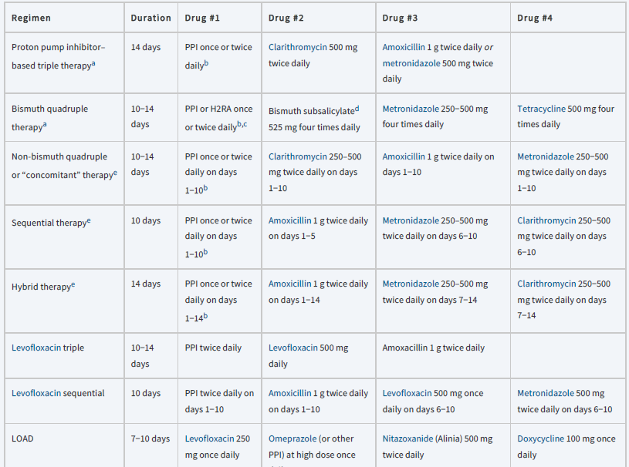

aAlthough treatment is minimally effective if used for 7 days, 10−14 days is recommended. The antisecretory drug may be continued beyond antimicrobial treatment for patients with a history of a complicated ulcer, for example, bleeding, or in heavy smokers.
bStandard PPI peptic ulcer healing dosages given once or twice daily.
cStandard H2RA peptic ulcer healing dosages may be used in place of a PPI.
dBismuth subcitrate potassium (biskalcitrate) 140 mg, as the bismuth salt, is contained in a prepackaged capsule (Pylera), along with metronidazole 125 mg and tetracycline 125 mg; three capsules are taken with each meal and at bedtime; a standard PPI dosage is added to the regimen and taken twice daily. All medications are taken for 10 days.
e Requires validation as first-line therapy in the United States.
H2RA, H2>-receptor antagonist; PPI, proton pump inhibitor.

9-If initial treatment fails to eradicate H. pylori, second-line (salvage) treatment should: (1) use antibiotics that were NOT included in the initial regimen, (2) be guided by region-specific or individual antibiotic resistance testing, and (3) use an extended treatment duration of 10–14 days.

10-Patients failing clarithromycin triple therapy can be treated with either bismuth quadruple therapy or the levofloxacin triple regimen for 14 days.

11-Other salvage regimens may also be successful. Penicillin allergy testing is recommended for patients who report penicillin allergy because many patients are not truly allergic.

12-Patients with NSAID-induced ulcers should be tested to determine H. pylori status. If they are H. pylori positive, start treatment with a recommended first-line regimen. If patients are H. pylori negative, discontinue the NSAID and treat with a PPI, H2RA, or sucralfate. PPIs are generally preferred due to more rapid symptom relief and ulcer healing.

13-If the NSAID must be continued, implement cotherapy with a PPI or misoprostol. Patients at highest risk of recurrent ulcers or ulcer-related complications should be switched to a COX-2 inhibitor.

14-Limit maintenance therapy with a PPI or H2RA to high-risk patients with ulcer complications, patients who fail H. pylori eradication, and those with H. pylori-negative ulcers.

15-Patients with ulcers refractory to treatment should undergo upper endoscopy to confirm a nonhealing ulcer, exclude malignancy, and assess H. pylori status.
H. pylori-positive patients should receive eradication therapy. Refractory ulcers despite a complete standard PPI course should be retreated with double-dose of PPI, or consideration can be given to using a different PPI.

Evaluation of therapeutic outcomes
1-Monitor patients for symptomatic relief of ulcer pain, potential adverse drug effects, and drug interactions.

2-Ulcer pain typically resolves in a few days when NSAIDs are discontinued and within 7 days upon initiation of antiulcer therapy. Patients with uncomplicated PUD are usually symptom free after treatment with any of the recommended antiulcer regimens.

3-Persistent or recurrent symptoms within 14 days after the end of treatment suggests failure of ulcer healing or H. pylori eradication or presence of an alternative diagnosis such as gastroesophageal reflux disease.

4-Eradication of H. pylori should be confirmed after treatment in all patients, particularly those who are at risk for complications.

Reference: Joseph T. DiPiro, Robert L. Pharmacotherapy: A Pathophysiologic Approach, 12th Edition. 2023.

