College of Pharmacy
Fourth year. Clinical Pharmacy
Infectious Diseases
Tuberculosis

Introduction
1-Tuberculosis (TB) is a communicable infectious disease caused by Mycobacterium tuberculosis. It can produce silent, latent infection, as well as progressive, active disease.

2-In 2019, there were about 10 million new cases and 1.2 million deaths from TB reported.

Pathophysiology and etiology
1-M. tuberculosis is transmitted from person to person by coughing or other activities that cause the organism to be aerosolized. Close contacts of TB patients are most likely to become infected.

2-Human immunodeficiency virus (HIV) is the most important risk factor for progressing to active TB. An HIV-infected individual with TB infection is over 100-fold more likely to develop active disease than an HIV-seronegative patient.

3-Occasionally, a massive inoculum of organisms may be introduced into the bloodstream, causing widely disseminated disease and granuloma formation known as miliary TB.

Clinical presentation
1-Patients with TB typically present with cough, weight loss, fatigue, fever, and night sweats. Symptom onset may be gradual.

2-Frank hemoptysis usually occurs late in the course of disease but may present earlier.

3-Sputum smear is done to detect mycobacteria. Chest radiograph is also important.

4-Clinical features associated with extrapulmonary TB vary depending on the organ system(s) involved but typically consist of slowly progressive decline of organ function with low-grade fever and other constitutional symptoms.

5-Patients with HIV may have atypical presentation. HIV-positive patients are less likely to have positive skin tests, or fever. They have a higher incidence of extrapulmonary TB and are more likely to present with progressive primary disease.

6-The most widely used screening method for tuberculous infection is the tuberculin skin test, which uses purified protein derivative (PPD).

7-When active TB is suspected, attempts should be made to isolate M. tuberculosis from the infected site. Daily sputum collection over 3 consecutive days is recommended.

8-Tests to measure release of interferon-γ in the patient’s blood in response to TB antigens may provide quick and specific results for identifying M. tuberculosis.

Treatment
1-Goals of Treatment: (1) Rapid identification of a new TB case; (2) Initiation of specific anti-TB treatment; (3) Eradicating M. tuberculosis infection; (4) Achievement of a noninfectious state in the patient, thus ending isolation; (5) Preventing the development of resistance; (6) Adherence to the treatment regimen by the patient; and (7) Cure of the patient as quickly as possible (generally at least 6 months of treatment).

2-Patients with active disease should be isolated to prevent spread of the disease.

3-Drug treatment is the cornerstone of TB management. A minimum of two drugs, and generally three or four drugs, must be used simultaneously.

4-Directly observed therapy (DOT) by a healthcare worker is a cost-effective way to ensure completion of treatment and is considered the standard of care.

5-Drug treatment is continued for at least 6 months, and 18–24 months for cases of multidrug-resistant TB (MDR-TB).

6-Surgery may be needed to remove destroyed lung tissue, space-occupying lesions, and some extrapulmonary lesions.

Pharmacologic Therapy

Latent Infection
1-Chemoprophylaxis should be initiated in patients to reduce the risk of progression to active disease.

2-There are three recommended treatment regimens for latent tuberculosis infection (LTBI): 3 months of once weekly isoniazid plus rifapentine, 4 months of daily rifampin, or 3 months of daily isoniazid plus rifampin.

3-The Centers for Disease Control and Prevention (CDC) recommends the 12week isoniazid/rifapentine regimen as an equal alternative to 9 months of daily isoniazid for treating LTBI in otherwise healthy patients aged 12 years or older who have greater likelihood of developing active TB.

4-Pregnant women, alcoholics, and patients with poor diets who are treated with isoniazid should receive pyridoxine, 10–50 mg daily, to reduce the incidence of central nervous system (CNS) effects or peripheral neuropathies.

Treating Active Disease

1-Table 1 lists options for treatment of culture-positive pulmonary TB caused by drug-susceptible organisms.

2-The standard TB treatment regimen is isoniazid, rifampin, pyrazinamide, and ethambutol for 2 months, followed by isoniazid and rifampin for 4 months (a total of 6 months of treatment). Ethambutol can be stopped if susceptibility to isoniazid, rifampin, and pyrazinamide is shown.

3-Appropriate samples should be sent for culture and susceptibility testing prior to initiating therapy for all patients with active TB. The data should guide the initial drug selection for the new patient.

Table 1: Drug Regimens for Microbiologically Confirmed Pulmonary Tuberculosis Caused by Drug Susceptible Organisms

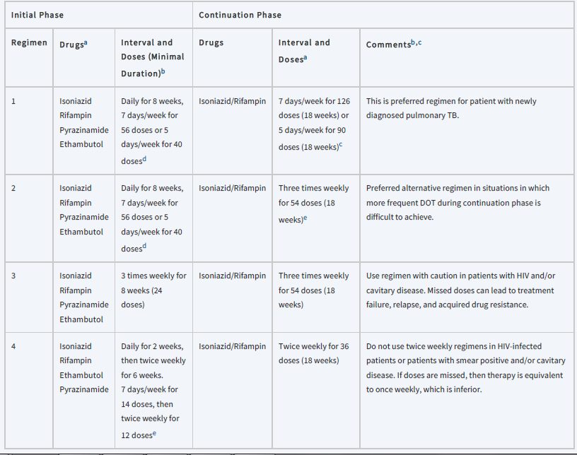
DOT, directly observed therapy; EMB, ethambutol; HIV, human immunodeficiency virus; INH, isoniazid; PZA, pyrazinamide; RIF, rifampin.
aWhen DOT is used, drugs may be given 5 days/week and the necessary number of doses adjusted accordingly. Although there are no studies that compare 5 with 7 daily doses, extensive experience indicates this would be an effective practice. DOT should be used when drugs are administered <7 days/week.
bBased on expert opinion, patients with cavitation on initial chest radiograph and positive cultures at completion of 2 months of therapy should receive a 7month (31week) continuation phase.
cPyridoxine (vitamin B6), 25–50 mg/day, is given with INH to all persons at risk of neuropathy (eg, pregnant women; breastfeeding infants; persons with HIV; patients with diabetes, alcoholism, malnutrition, or chronic renal failure; or patients with advanced age). For patients with peripheral neuropathy, experts recommend increasing pyridoxine dose to 100 mg/day.
dFive‐day‐a‐week administration is always given by DOT.

4-If the patient is being evaluated for the retreatment of TB, it is imperative to know what drugs were used previously and for how long.

Drug Resistance
1-If the organism is drug resistant, the aim is to introduce two or more active agents that the patient has not received previously. With MDR-TB, no standard regimen can be proposed.

2-It is critical to avoid monotherapy or adding only a single drug to a failing regimen.

3-Drug resistance should be suspected in the following situations:
- Patients who have received prior therapy for TB
- Patients from geographic areas with a high prevalence of resistance (South Africa, Mexico, Southeast Asia, the Baltic countries, and the former Soviet states)
- Patients who are homeless, institutionalized, IV drug abusers, and/or infected with HIV
- Patients who still have acid-fast bacilli–positive sputum smears after 2 months of therapy
- Patients who still have positive cultures after 2–4 months of therapy
- Patients who fail therapy or relapse after retreatment
- Patients known to be exposed to MDR-TB cases

Special Populations

Tuberculous Meningitis and Extrapulmonary Disease
1-In general, isoniazid, pyrazinamide, ethionamide, cycloserine and linezolid penetrate the cerebrospinal fluid readily.

2-Patients with CNS TB are often treated for longer periods (9–12 months).

3-Extrapulmonary TB of the soft tissues can be treated with conventional regimens. TB of the bone is typically treated for 9 months, occasionally with surgical debridement.

Children
1-TB in children may be treated with regimens similar to those used in adults, although some physicians still prefer to extend treatment to 9 months.

2-Pediatric doses of drugs should be used.

Pregnant Women
1-The usual treatment of pregnant women is isoniazid, rifampin, and ethambutol for 9 months.

2-Women with TB should be cautioned against becoming pregnant, as the disease poses a risk to the fetus as well as to the mother.

3-Isoniazid or ethambutol is relatively safe when used during pregnancy. Supplementation with B vitamins is particularly important during pregnancy.

4-Rifampin has been rarely associated with birth defects, but those seen are occasionally severe, including limb reduction and CNS lesions.

5-Pyrazinamide has not been studied in a large number of pregnant women, but anecdotal information suggests that it may be safe.

6-Ethionamide may be associated with premature delivery, congenital deformities, and Down syndrome when used during pregnancy, so it cannot be recommended in pregnancy.

7-Cycloserine is not recommended during pregnancy. Fluoroquinolones should be avoided in pregnancy and during nursing.

Renal Failure
In nearly all patients, isoniazid and rifampin do not require dose modifications in renal failure. Pyrazinamide and ethambutol typically require a reduction in dosing frequency from daily to three times weekly.

Evaluation of therapeutic outcomes
1-The most serious problem with TB therapy is nonadherence to the prescribed regimen. The most effective way to ensure adherence is with DOT.

2-Patients should have blood urea nitrogen, serum creatinine, aspartate transaminase or alanine transaminase, and a complete blood count determined at baseline and periodically, depending on the presence of other factors that may increase the likelihood of toxicity (advanced age, alcohol abuse, and possibly pregnancy).

3-Hepatotoxicity should be suspected in patients whose transaminases exceed five times the upper limit of normal or whose total bilirubin exceeds 3 mg/dL. At this point, the offending agent(s) should be discontinued and alternatives selected.

Reference
Joseph T. DiPiro, Robert L. Pharmacotherapy: A Pathophysiologic Approach,
12th Edition. 2023.

