DISORDERS OF LIPID METABOLISM
The study of hyperlipidaemias is of considerable importance, mainly because of the involvement of lipids in cardiovascular disease. The Fredrickson’s classification helped to put lipidology on the clinical map, it was not a diagnostic classification. It gives little clue as to the aetiology of the disorder; indeed, all of the phenotypes can be either primary or secondary. Furthermore, the Fredrickson type can change as a result of dietary or drug intervention. Nowadays, a more descriptive classification is used for the primary hyperlipidaemias, as follows.
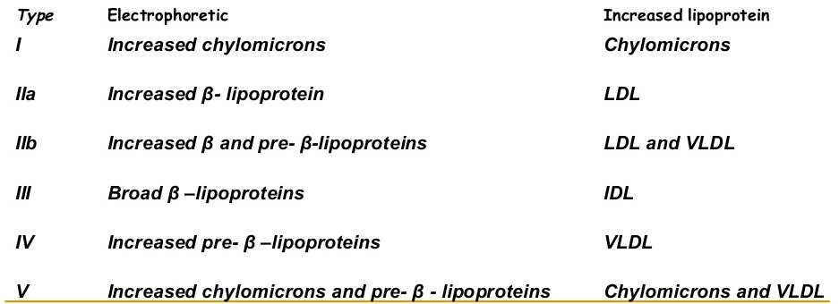

Chylomicron syndrome
This can be due to familial lipoprotein lipase deficiency. Lipoprotein lipase is involved in the exogenous lipoprotein pathway by hydrolysing chylomicrons to form chylomicron remnants, and also in the endogenous pathway by converting VLDL to IDL particles. Presentation as a child with abdominal pain (often with acute pancreatitis) is typical. There is probably no increased risk of coronary artery disease. Gross elevation of plasma triglycerides due to the accumulation of uncleared chylomicron particles occurs .Lipid stigmata include eruptive xanthomata, hepatosplenomegaly and lipaemia retinalis .
Other variants of the chylomicron syndrome include circulating inhibitors of lipoprotein lipase and deficiency of its physiological activator apoC2 . Treatment of the chylomicron syndrome involves a low- fat diet. In cases of apoC2 deficiency, fresh plasma may temporarily restore plasma apoC2 levels.
To confirm the diagnosis of familial lipoprotein lipase deficiency: Plasma lipoprotein lipase can be assayed after the intravenous administration of heparin, which releases the enzyme from endothelial sites. Patients may show a type I or type V Fredrickson’s phenotype. Family members should be investigated Chylomicron syndrome

Familial hypercholesterolaemia
This condition is characterized by high plasma cholesterol concentrations that are present from early childhood and do not depend upon the presence of environmental factors . It is inherited as an autosomal dominant characteristic . Familial defective apo B-100, in which a mutation in the apo B gene decreases the avidity of LDL for its receptor, causes a similar phenotype. In all cases there is a defect in the uptake and catabolism of LDL, and its plasma concentration is increased.
The diagnosis is based on the presence of hypercholesterolaemia together with tendon xanthomata in the subject or tendon xanthomata or hypercholesterolaemia in a close relative. These individuals develop coronary artery disease in childhood . Using Fredrickson’s classification, this condition has also been termed familial type IIa hyperlipoproteinaemia, although some patients may show a type IIb phenotype.

Familial defective apoB3500
This condition is due to a mutation in the apoB . Apolipoprotein B is the ligand upon the LDL particle for the LDL receptor. It may be indistinguishable clinically from FH and is also associated with hypercholesterolaemia and premature coronary artery disease. The treatment is similar to that for heterozygote FH.

Familial combined hyperlipidaemia
In familial combined hyperlipidaemia(FCH), elevated plasma cholesterol and plasma triglyceride . The Fredrickson’s phenotypes seen in this condition include IIa, IIb and IV ,there is an increased incidence of coronary artery disease in family members. The IIa and IIb phenotypes are not usually found in familial hypertriglyceridaemia, although they are in FCH. Children with FCH usually show hypertriglyceridaemia and not the type IIa phenotype (unlike the situation found in FH). Unlike familial hypertriglyceridaemia, plasma VLDL particles are usually smaller in FCH. Dietary measures and, if indicated, either a statin or a ﬁbrate are sometimes used.

Familial hypertriglyceridaemia
It is often observed with low HDL cholesterol concentration. The condition usually develops after puberty and is rare in childhood. The exact metabolic defect is unclear, although overproduction of VLDL or a decrease in VLDL conversion to LDL is likely. There may be an increased risk of cardiovascular disease. Acute pancreatitis may also occur,Some patients show hyperinsulinaemia and insulin resistance. Omega-3 fatty acids used to treat the condition.

Type III hyperlipoproteinaemia
This condition is also called familial dysbeta-lipoproteinaemia or broad β-hyperlipidaemia. It is characterized clinically by the presence of fat deposits in the palmar creases and by tuberous xanthomata; the latter tend to occur over bony prominences and, unlike tendon xanthomata, are reddish in colour. However, neither of these cutaneous stigmata is invariably present. In some patients eruptive xanthomata are present. Biochemically, the condition is characterized by the presence of an excess of IDL and chylomicron remnants; chylomicrons are sometimes also present. An alternative name is remnant hyperlipoproteinaemia.
Total cholesterol and triglyceride concentrations are elevated typically to approximately equal values. This condition used to be called 'broad beta disease', because the remnant particles give rise to a broad band extending between the pre-β (corresponding to VLDL) and β (LDL) positions on serum lipoprotein electrophoresis. Patients with remnant hyperlipoproteinaemia have an increased risk not only of coronary artery disease but also of peripheral and cerebral vascular disease.
Type III hyperlipoproteinaemia Apo E shows polymorphism. The commonest phenotype is termed E3/E3. Familial dysbetalipoproteinaemia is associated with the E2/E2 phenotype, which can result in impaired IDL uptake by the liver.

Polygenic hypercholesterolaemia
This is one of the most common causes of a raised plasma cholesterol concentration. This condition is the result of a complex interaction between multiple environmental and genetic factors. There is usually either an increase in LDL production or a decrease in LDL catabolism. The plasma lipid phenotype is usually either IIa or IIb Fredrickson’s phenotype.The plasma cholesterol concentration is usually either mildly or moderately elevated. An important negative clinical finding is the absence of tendon xanthomata, the presence of which would tend to rule out the diagnosis. There may also be a family history of premature coronary artery disease.

Hyperalphalipoproteimianae
Hyperalphalipoproteinaemia results in elevated plasma HDL cholesterol concentration and can be inherited as an autosomal dominant condition or, in some cases, may show polygenic features. The total plasma cholesterol concentration can be elevated, with normal LDL cholesterol concentration. There is no increased prevalence of cardiovascular disease in this condition; in fact, the contrary probably applies, with some individuals showing longevity. Plasma HDL concentration is thought to be cardio protective, and individuals displaying this should be reassured.
Some causes of raised HDL are Primary Hyperalphalipoproteinaemia & Cholesterol ester transfer protein deficiency
Secondary High ethanol intake ,Exercise & Certain drugs, e.g. estrogens & ﬁbrates.
Secondary hyperlipidaemias Some of the causes :- Predominant hypercholesterolaemia , Hypothyroidism , Nephrotic syndrome & Cholestasis
Predominant hypertriglyceridaemia dueto Alcohol excess , Obesity , Diabetes mellitus and metabolic syndrome
Other lipid abnormalities Inherited disorders of low plasma HDL ,The causes are Primary Familial hypoalphalipoproteinaemia , ApoA abnormalities , Tangier’s disease & Lecithin–cholesterol acyltransferase(LCAT) deficiency .
Defects of apoB metabolism have also been described. In abetalipoproteinaemia or LDL deficiency there is impaired chylomicrons and VLDL synthesis. This results in a failure of lipid transport from the liver and intestine. Transport of fat-soluble vitamins is impaired and steatorrhoea, progressive ataxia, retinitis pigmentosa and acanthocytosis (abnormal erthyrocyte shape) can result. In hypo –beta lipoproteinaemia, a less severe syndrome occurs, sometimes due to a truncated form of apoB. In LCAT deficiency, the accumulation of free unesterified cholesterol in the tissues results in corneal opacities, renal damage, premature atherosclerosis and haemolytic anaemia. The enzyme LCAT catalyses the esteriﬁcation of free cholesterol. Another condition that is probably due to a defect of LCAT is ﬁsh- eye disease, in which there may be low HDL cholesterol concentrations and eye abnormalities.

