كلية الرشيد الجامعة
قسم تقنيات المختبرات الطبية
المرحلة الثانية
Microbiology practical

Lab 4
Methods of culture
Presented by
M.Sc Hawraa D. Salman

Lab -4- Methods of Culturing
Methods of culturing used to:
1-Isolation of M.O. from sample.
2-For culturing M.O. in the sample.
3-Obtain pure culture.
The methods of culturing are :-
1-Pipetting by pipette (in broth medium)
2-Inoculation by loop (in broth medium)
3-Streaking by loop (on solid medium)
4-Stabbing by needle (on solid or semi-solid medium)
5-Swabbing by swab (on solid medium)
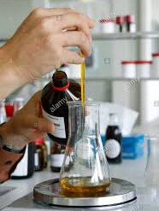
6-Pouring plate method (on solid medium)
7-Spreading by spreader (on solid medium)

1-Pipetting by pipette or micropipette
This method was suitable in the dilution to extinction
laboratory, the purpose from this method is to count
the M.O, (viable plate count).

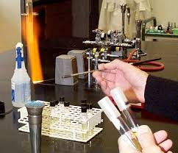
2-Inoculation by loop
This method was used to increase the number of M.O.
in liquid media
Method
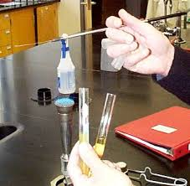
1-Hold the tube that contain the broth culture
in your hand .
2-Mix the tube that contain the culture to spread
the bacteria through the broth
3-Hold the other tube that contain the sterile broth
in the same hand that carrying the broth culture .
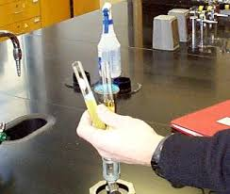
4-Sterile the loop.
5-Remove the two cotton plugs of the tubes by the
hand that carrying the loop.
6-Sterile the upper of the tubes by flame.
7-By the sterile loop , transfer drop from broth
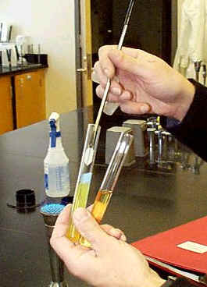
culture to sterile broth.
8-sterile the upper of the tubes and close them .
9- Sterile the contaminated
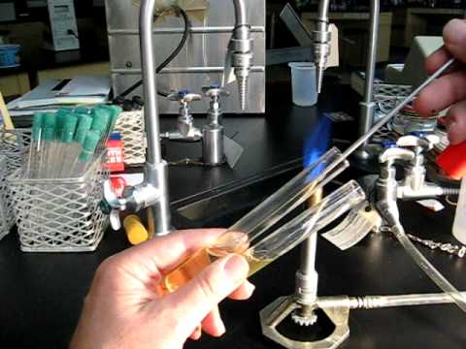
loop with flame.
10-Put the new cultured tube
in the incubator
at 37C˚ for 24 hr.
3-Streaking by loop
Streaking on agar plate in order to isolate bacteria , this will enable you to isolate pure cultures of bacteria by obtaining isolated pure colony.
A-Streaking on plates
-ABCD method:
1-Transfer by sterile loop colony from solid medium or drop from broth medium to solid medium in petri dish near the edge , spread it to become point A
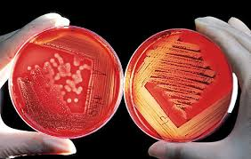
2-Sterile the loop and cool it in the edge of solid medium.
3-Rotate the dish , then touch the A area by
sterile loop ,vertically draw several parallel lines
to form in their end point B .
4-Repeat step 2.
5- Rotate the dish in the same direction, and touch
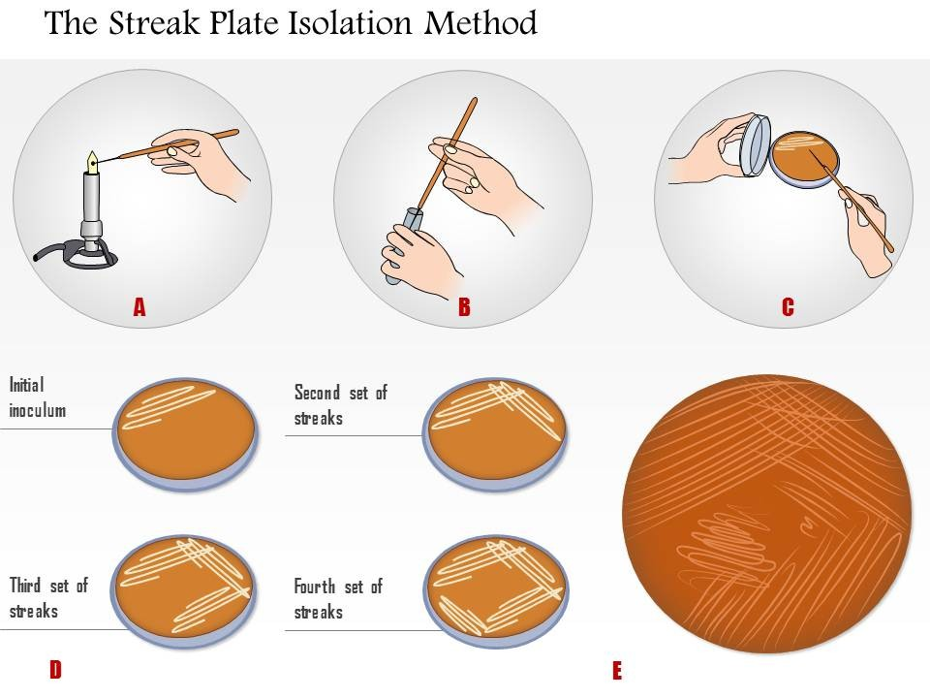
the B point by sterile loop , vertically draw several
parallel lines to form in their end point C .
6-Repeat step 2.
7- Rotate the dish in the same direction,
and touch the C point by sterile loop ,
vertically draw several parallel lines to
form in their end point D .
8- From D draw one zigzag line to the
middle of dish.
9-Repeat step 2.
10-Put petri dish in the incubator
at 37 C˚ for 24hr.
-Continuous streaking
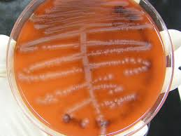
1- Sterile the loop and cool it in the edge of solid medium.
2-transfer the culture to the solid media
3-spraed the culture as continuous parallel
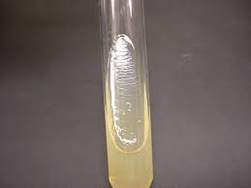
lines to the end of the dish.
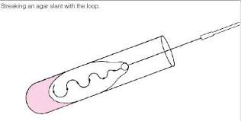
4-Sterile the loop.
5-Incubate at 37C˚ for 24 hr as inverted dish.
B-Streaking on slant
1-By sterile loop , take a colony from
solid medium or drop from cultured
broth medium.
2-Remove the cover of slant tube
and sterile the upper part.
3-cultivate on the slant medium by
streaking , then sterile the tube and
close it.
4-sterile the loop by flame and then put the slant in the incubator at 37C˚ for 24 hr.

4-Stabbing by needle
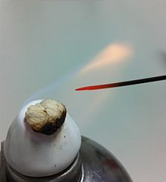
This method is used to study the ability of bacteria to:-
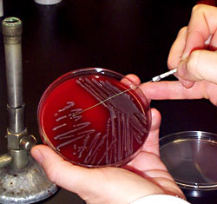
1-Grow with presence O₂ or not.
2-Motility.
3-Production of some chemical
compounds during the metabolism.
Method
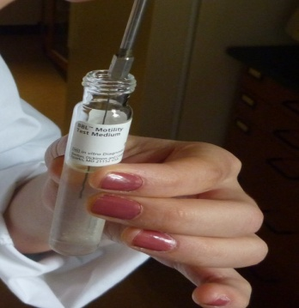
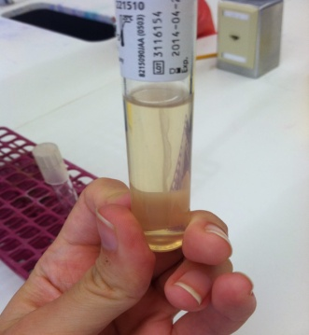
1-Sterile the loop by flame .
2-Hold one colony or part from bacterial
growth from solid medium by needle.
3-Open the tube that contain sterile semisolid
medium and sterile the upper of tube.
4-Stab the needle that contain bacteria in the
medium vertically ,then hold it directly.
5-Sterile the upper of the tube again and close it.
6-Sterile the needle by flame.
7-Incubate the tube at 37C˚ for 24 hr

5-Swabbing by swab
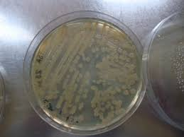
Used to obtain heavy growth for some biochemical tests such as sensitivity test and for colony counting
Method
1-Submerge the sterile cotton swab in bacterial
broth culture.
2-Swab on the sterile solid medium parallel
lines over the medium.
3-Rotate the plate and repeat step 2
4-Put the swab on alcohol (used for one time).
5-Incubate the tube at 37C˚ for 24 hr

6-Pouring plate method
This method is used for counting the colonies
Method
1-Prepare serial dilutions from 10⁻¹ to 10⁻⁵ of sample
2-Transfer by sterile pipette 0.1 ml of each dilution to sterile petri-plate
3-Prepare sterile solid culture medium and cooled it to 45-50 C˚ in water bath
4-Aseptically pour agar into each petri-plate , swirl the plate to mix the sample with the agar.
5-Allow the agar to cool and solidify.
6-Incubate the inverted plate at 37C˚ for 24 hr

7-Spreading by spreader
Used to spread the bacteria on the surface of the solid medium for colony counting
Method
1-Prepare 3 dilutions (10⁻¹ , 10⁻² , 10⁻³) from sample.
2-Prepare nutrient agar plates and label them.
3-Using sterile pipette , transfer 0.1 ml from each of dilution tubes and the original sample to agar plates
4-Sterilize the glass spreader by putting it in alcohol and burn it by burner.
5-After the cooling of spreader , spread the sample over the surface of the plate.
6-Incubate inverted plates at 37C˚ for 24 hr
