Al-Rasheed University College Second year
Medical Lab Technology Medical Bacteriology (Practical)
Asist.Lec : Hawraa Dawood 18\4\2022

Antibiotic Susceptibility
Testing
Antibiotic susceptibility tests measure the ability of an antibiotic or other antimicrobial agent to inhibit bacterial growth.

- Type of antibiotic susceptibility testing.
- Dilution methods.
- Disc Diffusion Methods.
- Automated methods.

- The dilution method:
Dilution is the process of decreasing the concentration of a solute in a solution, usually simply by mixing with more solvent like adding more water to the solution. To dilute a solution means to add more solvent without the addition of more solute.
Dilution methods include
1) Broth Micro-Dilution
2) Agar Dilution.
The most widely used method in North America is broth micro-dilution,
whereby two fold dilutions of antimicrobials are made in a broth medium in a microtiter plate
- Disc Diffusion Methods.
The Kirby-Bauer method is usually used for antimicrobial susceptibility testing, with the Kirby-Bauer method being recommended by the NCCLS (National Committee for Clinical Laboratory Standards guidelines).

Procedure:
1. Mueller-Hinton plates have been prepared sterilized according to manufacturer guidelines.
2. Inoculums were prepared and used within 30 minutes of preparation by adding 3-5 colonies into a 5 ml tube of normal saline to obtain culture with 1.5x10⁸CFU/ml and adapting to the McFarland 0.5 turbidity standard.
3. By immersing a sterile swab into the inoculums, the plates have been inoculated.
4. The inoculum was left to dry for a few minutes at room temperature with the lid closed.
5. The chosen antibiotic disc was placed on the inoculated plate using some sterile forceps (each plate with 5 discs).
6. The plates were marked. The plates were incubated at 37º C for18-24 hrs.
7. The diameter of the inhibition zone was measured by a ruler with mm.
8. This repeated in duplicate, and any isolates that resisted one or more antibiotics from the aminoglycosides class were selected.
9. The antibiotic inhibition zones compared to the established standards by Clinical and Laboratory Standards Institute (CLSI)
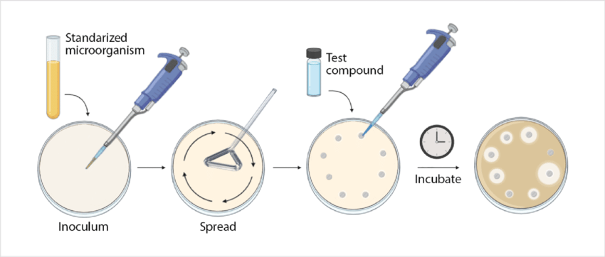
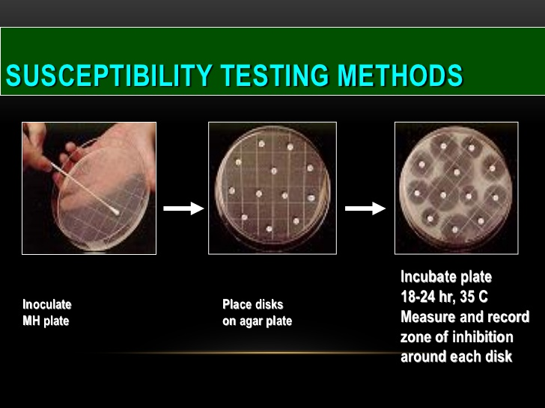

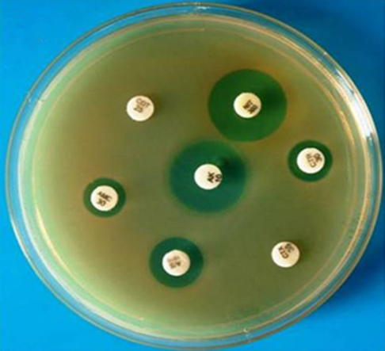
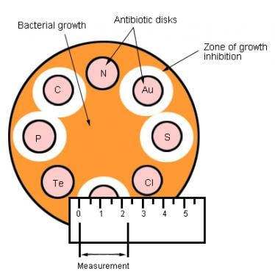
- Finally result will be as follow: (Resistance, Sensitive, medium)

What are the types and classifications of antibiotics and their actions?
- Antibiotics can be divided into two classes based on their mechanism of action. Bactericidal antibiotics kill bacteria; bacteriostatic antibiotics inhibit their growth or reproduction

Mode of action of antibiotics?
Antimicrobial action through of inhibition | Examples
- Cell wall synthesis | Bacitracin, cephalosporins, cycloserines, penicillin and vancomycin
- Cell membrane function | Amphotericin B, colistin, imidazole,triazoles and polymyxins
- Protein synthesis | Chloramphinicol, erythromycin, lincomycins, tetracyclines Aminoglycosides
- Nucleic acid synthesis | Quinolones, pyrimethamine, rifampin, sulfonamides and trimethoprim

