Al-Rasheed University College Second year
Medical Lab Technology Medical Analysis
Aisst.Lec: Hawraa dawood Microbiology (Practical)
THE GRAM POSITIVE COCCI \4\2022
Streptococci
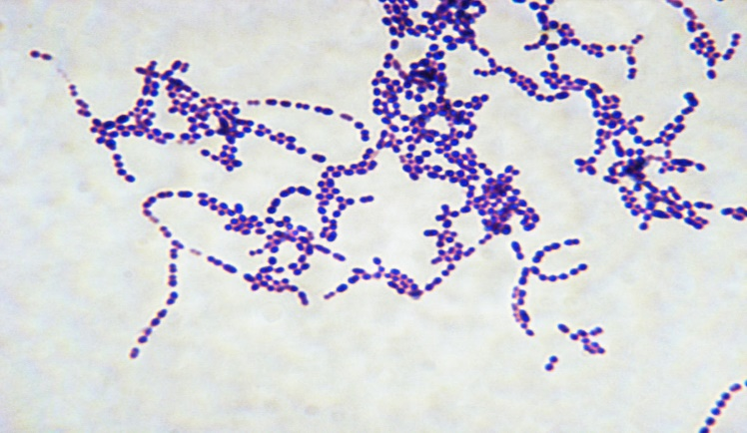
- PATHOGENIC SPECIES:
1. Streptococcus pyogenes
2. Streptococcus agalactia
3. Streptococcus faecalis
4. Streptococcus pneumonia
5. The viridans group (Streptococcus viridans)
General Characteristics of streptococci
1. Gram positive cocci arranged in long chains
2. Includes 100 species (Normal flora & pathogens)
3. Colonies are gray to white in color
4. Catalase test Negative
4. Streptococci could be classified based on their hemolytic activity into:
A. Alpha hemolytic: Greenish zone around colonies due to degradation of hemoglobin, e.g., S. pneumonia and Viridians streptococci.
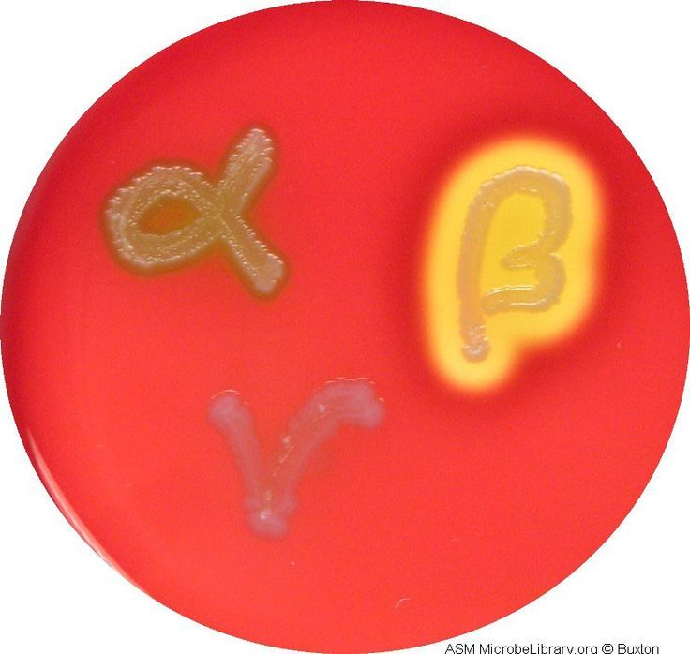
B. Beta hemolytic: Complete hemolysis around the colonies. e.g., S. pyogenes and S. agalactiae.
C. Gamma hemolytic (Non hemolytic): e.g., S. faecalis (Enterococcus faecalis)
5. Lancefield grouping (on the basis of C-carbohydrate antigen in cell wall of
Streptococci)
Group A = S. pyogenes, Group B = S. agalactiae, Group D = Enterococci
The difference between Streptococcus and Staphylococcus:
Comparison | Staphylococcus species | Streptococcus species
Gram stain | appear spherical (cocci), and form in grape-like clusters | 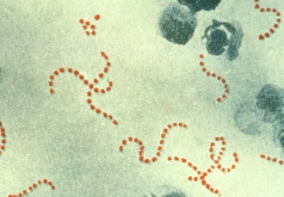  That live in pairs or chains of varying length
Catalase test | Positive result | Negative result
Growth | Can grow in any types of media: in low or much nuterints,simple&Enriched | Fastidious Microorganism: cannot be easily cultivated in media. Enriched media  Ex: Blood, serum

- Diseases:
1. Erysipelas (red skin) 7. Streptococcal sore throat
2. Otitis media 8. Osteomyelitis
3. Septicemia 9. Endocarditis
4. Wound infection 10. Meningitis
5. Sepsis (Scarlet fever) 11. Bronchitis
6. Sinusitis 12. Rheumatic fever

Streptococcus pyogenes Group a beta-hemolytic Streptococci
Diagnostic Procedures:
- Gram stain: Gram positive cocci in long chain and single cell
- Culture of specimen: Beta-hemolytic colony on Blood agar plates
- Biochemical and Other tests:
- Catalase test (negative)
- Bacitracin sensitivity test: Streak colony on blood agar plate over its surface and Place bacitracin disk in the center of the streaked area, Incubate overnight
    - RESULT: An inhibition zone of 5mm or greater is considered sensitive.
- ASOT: Anti-Streptolysin O Titer: The test is done by performing a serum serial dilutions and reacting these dilutions with the specific antigen suspension and determining the lowest concentration or the highest dilution (Titer) that produces a positive results.

Streptococcus agalactia: Group B, beta-hemolytic streptococci
DIAGNOSTIC PROCEDURES:
- Gram stain: Gram positive cocci in long chain
- Culture of specimen: On blood agar produces larger colonies and more translucent to opaque colonies surrounded by a zone of Beta-hemolysis.
- Biochemical and Other tests:
- Catalase negative.
- Bacitracin resistant:
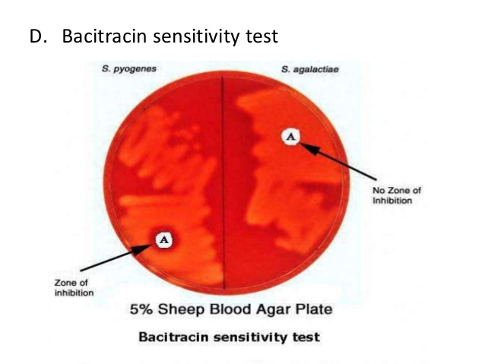
- CAMP test: This test is done by making a single streak of Streptococcus (to be identified) on sheep blood agar perpendicular to a strain of Staphylococcus aureus. The two streak lines must not touch one another. The plate is incubated for 24 hours.
The positive result is expressed by a zone of increased lysis assuming the shape of an arrow-head at the junction of the two streak lines.

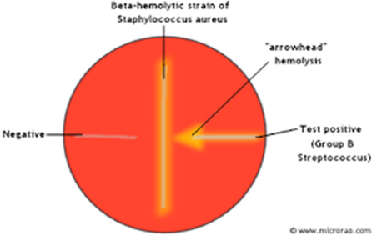

GROUP D STREPTOCOCCI
Non-haemolytic or alpha-haemolytic colonies
Two types:
1. Enterococci (E. faecalis)
. Normal flora of colon
. Can grow in presence of 7.5% NaCl and bile salts
Diseases
° Opportunistic UTI
° Wound infections
2. Non-Enterococci (S. bovis)
. Can grow in presence of bile salts (not NaCl)
. May cause endocarditis

