كلية الرشيد الجامعة
قسم تقنيات المختبرات الطبية
المرحلة الثانية
Microbiology practical

Lab 2
Sterilization and disinfection
Presented by
M.Sc Hawraa D. Salman

Methods of sterilizations
- Physical methods (Heat sterilization, radiation, gases)
- Chemical methods
- Mechanical method
Physical methods of sterilization
A/ Heat sterilization
- Dry heat sterilization:
- Red heat used to sterilize wire loop , point end of forceps 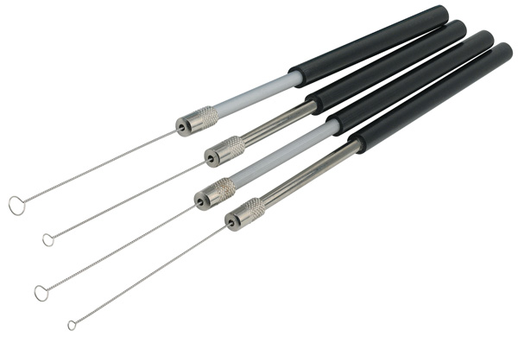
- Flaming : used to sterilize tip of tubes , spreaders (which are flamed in ethanol)
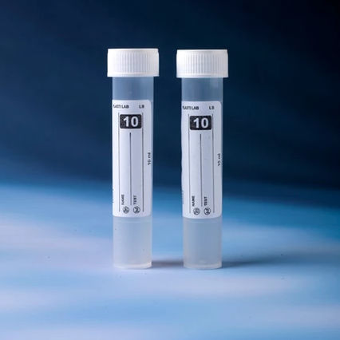

- Incineration: used in pathological fuming materials.
- Hot air oven :( 160-180 Cº for 2-4 hr.) used to sterilize glass petri dishes , flask
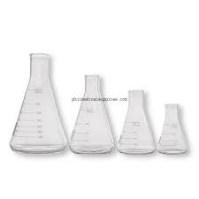
2) Moist heat sterilization
- Temperature below 100Cº,
• Pasteurization (63Cº for 30 min), to sterilize milk.
- Temperature at 100Cº
- Boiling (5_10min) to sterilize rubber tube, glass syringes
- Steaming (tyndalilzation ) steam 30 min for 3 days, used to sterilize gelation media, sugar media.
C) Temperature above 100Cº (autoclave)
-The condition in this instrument (121Cº, 15 min, 15poun/inch²), used for sterilization of:
- surgical tools and clothes
- culture media and to sterilize inoculated media
- swab
- Distil water ,solution sealed in containers

B) Radiation sterilization like X-rays Gamma rays.
Used in:
- Sterilize cabinet
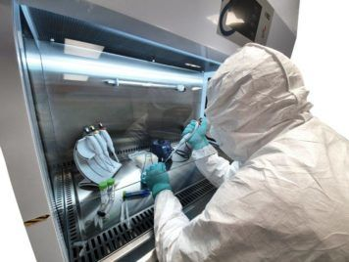
- Sterile operation rooms.

C) Gases sterilization
- Formaldehyde (Room)
- Ethylene oxide ( disposable syringes and petri dish)
Mechanical method: by filtration
The material is effect by heat (Heat sensitive solution)
EX :( serum protein, sugar, vaccine, antibiotics, toxins) are sterilized by filtration.

Chemical methods of sterilization
- Antiseptics : it is chemical substance that kills micro-organisms living tissue
EX: 70% alcohol, 10% Dettol to sterilize hand.
- Disinfectant : it is a chemical substances used to sterilize non-living tissue objects
EX: phenol, 5% formalin to sterilize refrigerator, bench, floor.

The disinfectant may be describe either as:
Bactericidal: any chemicals substance which kills the bacteria and their spores.
Bacteriostatic: any chemical substance which inhibits the growth and multiplication of bacteria but do not necessarily kill them.

