Blood gases and acid base balance
An acid : -is a substance that can yield a hydrogen ion (H) or hydronium ion when dissolved in water.
A base:- is a substance that can yield hydroxyl ions (OH) ion when dissolved in water .
A buffer:- is a system that resists changes in pH , It is the combination of a weak acid or weak base and its salt.

ACID-BASE BALANCE
The normal concentration of H in the extracellular body fluid ranges from 36–44 nmol/L (pH, 7.34–7.44).
Through metabolism, the body produces much greater quantities of H. Through the lungs and kidneys, the body controls and excretes H in order to maintain pH homeostasis.
Any H value outside this range will cause alterations in the rates of chemical reactions within the cell and affect the many metabolic processes of the body and can lead to alterations in consciousness, neuromuscular irritability, tetany, coma, and death.
The reference value for arterial blood pH is 7.40 and is equivalent to an H concentration of 40 nmol/L.
Because pH is the negative log of the H concentration , an increase in H concentration decreases the pH (called acidosis ), whereas a decrease in H concentration increases the pH (called alkalosis ).
The arterial pH is controlled by systems that regulate the production and retention of acids and bases. These include :
1-chemical buffers
2- respiratory center and lungs
3- kidneys.

Chemical buffers
1- bicarbonate–carbonic acid H2CO3 dissociates into CO2 and H2O,allowing CO2 to be eliminated by the lungs and H as Water system has low buffering capacity, it still is an important buffer

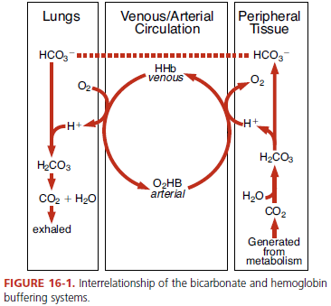

2- The phosphate buffer system (Na2HPO4, NaH2PO4) plays a role in plasma and red blood cells and is involved in the exchange of sodium and H ion in the urine filtrate.
3- Plasma protein buffer (Amino acid buffers, Hb buffers, Plasma Protein buffers) especially the imidazole groups of histidine, also forms an important buffer system in plasma.
*Most of circulating proteins have a net negative charge and are capable of binding H.
*The dissociation of H2CO3 causes the HCO3 concentration to increase in the red cells and diffuse into the plasma.
*To maintain electroneutrality chloride diffuses into the cell. This is known as the chloride shift. Plasma proteins and plasma buffers combine with the freed H to maintain a stable pH.

Physiological Buffers
-In the lungs, the process is reversed. Inspired O2 diffuses from the alveoli into the blood and is bound to Hb, forming oxyHb. The H that was carried on the (reduced) Hb in the venous blood is released to recombine with HCO3 to form H2CO3, which dissociates into H2O and CO2. The CO2 diffuses into the alveoli and is eliminated through ventilation.
Decreased ventilation or disease cause CO2 accumulation in the blood, causing an increase in [H ] . If, however, CO2 removal is faster than production (hyperventilation), the [H ] will be decreased. A change in the [H ] of blood that results from nonrespiratory disturbances causes the respiratory center to respond by altering the rate of ventilation in an effort to restore the blood pH to normal.
*The lungs, by responding within seconds, together with the buffer systems, provide the first line of
-The kidneys regulate pH by excreting acid, primarily the by reclaiming HCO3 and NH4+ from the proximal tubules. Without this reclamation, the loss of HCO3 in the urine would result in an excessive acid gain in the blood.
The sodium (Na) in the glomerular filtrate is exchanged for H in the tubular cell. The H combines with HCO3 in the filtrate to form H2CO3, which is converted into H2O and CO2 by carbonic anhydrase. The CO2 easily diffuses into the tubule and reacts with H2O to reform H2CO3 and then HCO3, which is reabsorbed into the blood along with sodium. With alkalotic conditions, the kidney excretes HCO3 to compensate for the elevated blood pH. The exchange between H and Na suggests, in part, why clinicians order pH and blood gases together, along with electrolytes (Na, K, and Cl), to assess the patient.

factors affect the reabsorption of HCO3
-chronic lung disease with kidney failure . When the blood or plasma HCO3 level is higher than 26–30 mmol/L, HCO3 will be excreted. It is unlikely that the plasma will exceed an HCO3 value of 30 mmol/L unless these excretory capabilities fail (e.g.,kidney failure occurs).
-excessive amount of lactate, acetate, or HCO3 is intravenously infused.
-Excessive loss of chloride without replacement (as occurs with sweating, vomiting, or prolonged nasogastric suction) because the HCO3 will be retained by the tubule to preserve electroneutrality.

To restore acid-base homeostasis whenever an imbalance occurs. Is called compensation—For example:
* if the imbalance is of nonrespiratory origin, the body compensates by altering ventilation.
* In disturbances of the respiratory component, the kidneys compensate by selectively excreting or reabsorbing anions and cations.
*The lungs can compensate immediately, but the response is short term and often incomplete. The kidneys are slower to respond (2–4 days),however, but the response is long term and potentially complete.
* Fully compensated implies that the pH has returned to the normal range (the 20:1 ratio has been restored)
* partially compensated implies that the pH is approaching normal. While compensation may successfully return the ratio to the normal 20:1, the primary abnormality is not corrected.

Arterial Blood Gases (ABG)
Uses blood from an arterial puncture .Three test results relate to acid-base balance
1-pH
2-PaCO2
3-HCO3
If a change is seen in BOTH PaCO2 and bicarbonate, the body is trying to compensate (Example: for metabolic acidosis, compensation shows respiratory alkalosis and vice versa)
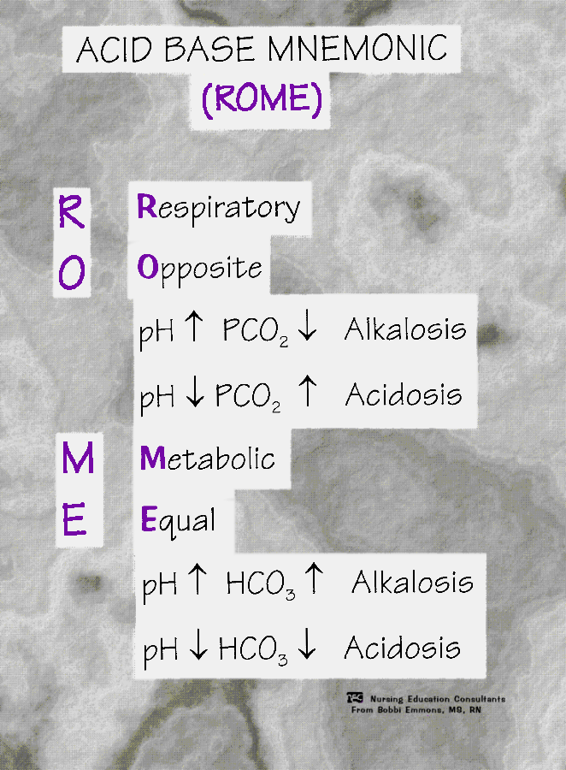
Causes of Respiratory Acidosis
- A: Inadequate Alveolar Ventilation includes :-
1- Central Respiratory Depression like Drug depression of resp. center
2- Nerve or Muscle Disorders like Guillain-Barre syndrome
3- Lung or Chest Wall Defects like Pulmonary oedema
4- Airway Disorders like Upper Airway obstruction

Acid-Base Disorders
*Respiratory Acidosis : Will cause: Hypoventilation ⇒CO2 buildup and drop in pH
- To compensate: Kidney function=increase excretion of H+ or by increased reabsorption of HCO₃- , pH < 7.35 and paCO2 > 45 mm Hg
Characterizes by: Apprehension, restlessness ,Confusion, tremors and Diaphoresis
Uncompensated :- *pH < 7.35
*PaCO2 >45
*HCO3 Normal
Compensated :- *pH Normal
*PaCO2 >45
*HCO3 > 26
*Respiratory Alkalosis:- increased rate of alveolar ventilation causes excessive elimination of CO2 by the lungs .The causes of respiratory alkalosis Hypoxemia , chemical stimulation of the respiratory center by drugs, such as salicylates , an increase in the environmental temperature and fever .
-To compensate kidneys compensate by excreting HCO3 in the urine and reclaiming H to the blood.
Uncompensated:-*pH > 7.45
*PaCO2 < 35
*HCO3 Normal
Compensated:- *pH Normal
*PaCO2 < 35
*HCO3 < 22
*Nonrespiratory acidosis (Metabolic Acidosis) :- Decreased HCO₃⁻=increased H⁺=decreased pH Characterized by gain of acid or loss of bicarb .Causes :-
1-the direct administration of an acid-producing substance, such as ammonium chloride or calcium chloride
2-Excessive formation of organic acids as seen with diabetic ketoacidosis and starvation.
3-reduced excretion of acids, as in renal tubular acidosis
4-excessive loss of bicarbonate from diarrhea or drainage from a biliary, pancreatic, or intestinal fistula
Clinical features:- Confusion , dull headache ,decreased deep tendon reflexes (DTRs) ,Signs and symptoms of hyperkalemia (abdominal cramps, diarrhea, muscle weakness, ECG changes) Hypotension, respirations ,Lethargy, warm and dry skin
-To compensate :- Uncompensated *pH < 7.35
*PaCO2 Normal
*HCO3 < 22
Compensated *pH Normal
*PaCO2 < 35
*HCO3 < 22
Nonrespiratory Alkalosis (Metabolic Alkalosis) :- Increased HCO₃⁻ =decreased H⁺=increased pH
pH > 7.45, bicarbonate > 26 mEq/L . Causes :-
1-the excess administration of sodium bicarbonate or through ingestion of bicarbonate- producing salts, such as Na lactate, citrate, or acetate
2-Excessive loss of acid through vomiting, nasogastric suctioning .
3-prolonged use of diuretics that augment renal excretion of H (Commonly associated with hypokalemia from diuretic use, hypochloremia and hypocalcemia) can produce an apparent increase in HCO3.
4-Cushing’s disease
Signs And Symptoms Anorexia ,Apathy ,Confusion ,Cyanosis and Hypotension
To compensate: Hypoventilation and kidney function
Uncompensated :- *pH > 7.45
*PaCO2 Normal
*HCO3 >26
Compensated :-*pH Normal
*PaCO2 > 45
*HCO3 > 26

